**APPENDIX**

**THE CHAT SCREENSHOT**

**Chat 1**

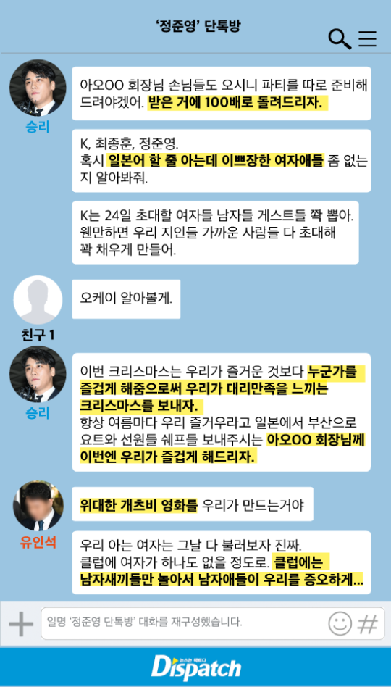

**Korean**

승리 : 아오 회장님 손님들도 오시니 파티를 따로 준비해 드려야겠어. 받은거에 100배로 들려드리자.

K. 최종훈, 정준영. 혹시 일본어 할 줄 아는데 이쁘장한 여자애들 좀 없는 지 알아봐줘.

K는 24일 초대할 여자들 남자들 게스트들 쫙 뽑아. 웬만하면 우리 지인들 가까운 사람들 다 초대해 꽉 채우게 만들어.

친구 1 : 오케이 알아볼게.

승리 : 이번 크리스마스는 우리가 즐거운 것보다 누군가를 즐겁게 해줌으로써 우리가 대리만족을 느끼는 크리스마스를 보내자.

항상 여름마다 우리 즐거우라고 일본에서 부산으로 요트와 선원들 쉐프들 보내주시는 아오00 회장님께 이번엔 우리가 즐겁게 해드리자.

유인석 : 위대한 개츠비 영화를 우리가 만드는거야

우리 아는 여자는 그날 다 불러보자 진짜 클럽에 여자가 하나도 없을 정도로 클럽에는 남자새끼들만 놀아서 남자애들이 우리를 증오하게.....

**English**

Seungri : President 'A' and his guests will also be coming, so we'd better arrange a separate party for them. Let's repay them 100 times for what they did for us in the past.

K, Jonghun, and Joon Young. You guys check and see if there are some pretty girls who can speak Japanese.

K, get a list of all the male and female guests who are invited on the 24th. If you can, invite everyone we know, and get all our guys to invite their guys so we can fill the party up with people.

K : Okay, I'll look into it.

Seungri : For this Christmas, rather than worrying about our own entertainment, let's entertain our guests and give them Christmas satisfaction. Every summer, president 'A' treated us from Japan and sent us yachts and crews and chefs so we could enjoy ourselves, so let's give president 'A' a really good time this year.

Yoo In Suk : Let's make 'The Great Gatsby' come to life. Let's get all the girls we know that day to come. To the point that there won't be any girls left at the other clubs. Let's make it so that the men are all partying at the club by themselves, so they all hate us afterward.

**Table 1.1**

|  |  |  |  |  |  |  |  |  |
| --- | --- | --- | --- | --- | --- | --- | --- | --- |
| 아오OO | 회장님  (hwejang-nim) | 손님들  (son-nim deul) | 도  (do) | 오시니  (oshini) | 파티를  (pati-reul) | 따로  (ddaro) | 준비해  (junbihae) | 드려야겠어  (deuryeoya gess-eo) |
| Ao OO | President | guests | too | Come | Party | Separate | Prepare | To give (offer) |
| Since President Ao OO’s guests are also coming, we’ll have to prepare a separate party | | | | | | | | |

**Table 1.2**

|  |  |  |  |  |
| --- | --- | --- | --- | --- |
| 받은거에  (badeungeo-e) | 100(백)  (baek) | 배로  (baero) | 돌려  (dol-교대) | 드리**자**  (deuri**ja**) |
| Received | 100 | Times/ Multiplied | Turn | To give **(suggestive)** |
| Let's repay them 100 times from what we were received | | | | |

**Table 1.3**

|  |  |  |  |  |  |  |  |  |
| --- | --- | --- | --- | --- | --- | --- | --- | --- |
| 혹시  (Hokshi) | 일본어  (ilbon-eo) | 할줄  (haljul) | 아는데  (aneunde) | 이쁘장한  (ippeujanghan) | 여자애**들**  (yeoja**deul**) | 좀  (jom) | 없는 지  (eobneunji) | 알아봐**줘**  (arabwa**jwo**) |
| Perhaps | Japanese | Can | Know | Pretty | The girl**s** | some | whether | Find out  **(imperative)** |
| You guys should find if there are some pretty girls who can speak Japanese | | | | | | | | |

**Table 1.4**

|  |  |  |  |  |  |  |  |  |
| --- | --- | --- | --- | --- | --- | --- | --- | --- |
| K는  (kei-neun) | 24**일**  (i-ship-sa **il**) | 초대할  (chodaehal) | 여자들  (yeojadeul) | 남자들  (namjadeul) | 게스트들  (geseuteudeul) | 쫙 뽑아  (jjwak bbob-a) | 웬만하면  (wenmanhamyeon) | 우리  (uri) |
| K | 24 days | invite | The females | The males | The guests | select | If it’s ok | we |
| 지인들  (ji-indeul) | 가까운  (gakka-un) | 사람들  (saramdeul) | 다  (da) | 초대해  (chodaehae) | 꽉  (kkwak) | 채우게  (chae-uge) | 만들어  (mandeur-eo) |  |
| acquaintances | close | people | all | Invite | full | fill | Make |  |
| K, select the female and male guests to be invited on the 24th. If you can, invite all of our acquaintances’ close friends to fill the party | | | | | | | | |

**Table 1.5**

|  |  |
| --- | --- |
| 오케이 | 알아**볼게** |
| Okay | **I’ll** find out |
| Okay, I’ll find out | |

**Table 1.6**

|  |  |  |  |  |  |  |
| --- | --- | --- | --- | --- | --- | --- |
| 이번  (ibeon) | 크리스마스는  (keuriseumaseu-neun) | 우리가  (uriga) | 즐거운  (jeulgeo-un) | 것보다  (geotboda) | 누군가를  (nugungareul) | 즐겁게  (jeulgeobke) |
| This | Christmas | We | pleasant | Rather than | Someone | Pleasantly |
| 해**줌으로써**  (haejum-eurosseo) | 우리가  (uriga) | **대리**만족을  (daerimanjok-eul) | 느끼는  (neukkineun) | 크리스마스를  (keuriseumaseureul) | 보내**자**  (bonaeja) |  |
| **Let’s** do | We | **Vicarious** satisfaction | Feel | Christmas | Let’s give |  |
| This Christmas, rather than worrying about our pleasant, let’s give our guests the pleasant and make them feel Christmas satisfication. | | | | | | |

**Table 1.7**

|  |  |  |  |  |  |  |  |
| --- | --- | --- | --- | --- | --- | --- | --- |
| 항상  (hangsang) | 여름**마다**  (yeoreum-**mada**) | 우리  (uri) | 즐거우라고  (jeulgeo-urago) | 일본**에서**  (ilbon-**eseo**) | 부산으로  (busan-euro) | 요트**와**  (yoteuwa) | 선원들  (seonwondeul) |
| always | **Every** summer | we | pleasant | **From** Japan | In Busan | Yacht and | crews |
| 쉐프들  (swepeudeul) | 보내주시는  (bonaejushineun) | 아오00  (Ao 00) | 회장님**께**  (hwejangnim-**kke**) | 이번엔  (ibeon-en) | 우리가  (uriga) | 즐겁게  (jeulgeobkke) | **해**드리자  (haedeurija) |
| Chefs | Send | Ao 00 | **From** President | This time | we | pleasant | Let’s **do** |
| Every summer, President Ao 00 treats us from Japan and sends us yacht and the crews and chefs, so this time, let’s give President Ao the pleasant | | | | | | | |

**Table 1.8**

|  |  |  |  |  |
| --- | --- | --- | --- | --- |
| 위대한  (widaehan) | 개츠비  (gaecheubi) | 영화를  (yeonghwareul) | 우리가  (uriga) | 만드는거야  (mandeuneungeoya) |
| The great | Gatsby | Film | We | Make |
| Let’s make the film “The Great Gatsby.” | | | | |

**Table 1.9**

|  |  |  |  |  |  |  |
| --- | --- | --- | --- | --- | --- | --- |
| 우리  (uri) | 아는  (aneun) | 여자는  (yeojaneun) | **그**날  (**geu**nal) | 다  (da) | 불러**보자**  (bulleoboja) | 진짜  (jinjja) |
| we | know | girls | **That** day | all | **Let’s** call (suggestive) | Really |
| 클럽에  (keulleob-e) | 여자가  (yeojaga) | 하나도  (hanado) | 없을  (eobseul) | 정도로  (jeongdoro) | 클럽에는  (keulleob-eneun) | 남자**새끼**들  (namja**saekki**deul) |
| Club | The girl | none | Don’t exist | To that extent | Club | Those **bastards** (males) |
| 만  (man) | 놀아서  (nolaseo) | 남자애들이  (namja-aedeur-i) | 우리를  (urireul) | 증오하게  (jeung-ohage) |  |  |
| just | play | The boys | We | hate |  |  |
| Let’s call all the girl we know that day so there won’t be any girl left in the club and make those bastards partying by themselves and hate us afterward. | | | | | | |

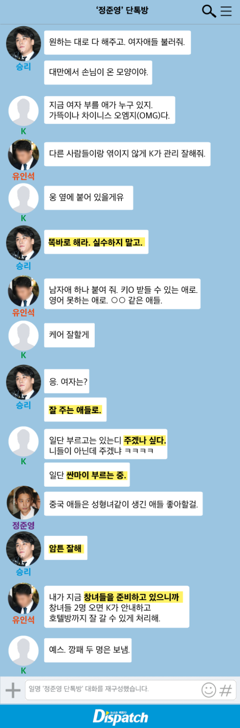**Chat 2**

**Korean**

승리 :원하는 대로 다 해주고, 여자애들 불러줘.

대만에서 손님이 온 모양이야.

K :지금 여자 부를 애가 누구 있지. 가뜩이나 차이니스 오엠지(OMG)다.

유인석 :다른 사람들이랑 엮이지 않게 K가 관리 잘해줘.

K :웅 옆에 붙어 있을게유

승리 :똑바로 해라. 실수하지 말고.

유인석 :남자애 하나 붙여 줘. 키ㅇ 받들 수 있는 애로 영어 못하는 애로. ㅇㅇ 같은 애들.

K :케어 잘할게

승리 :응. 여자는?

잘 주는 애들로.

K :일단 부르고는 있는디 주겠나 싶다. 니들이 아닌데 주겠냐 ㅋㅋㅋㅋ

일단 싼마이 부르는 중.

정준영 :중국 애들은 성형녀같이 생긴 애들 좋아할걸.

승리 :암튼 잘해

유인석 :내가 지금 창녀들을 준비하고 있으니까 창녀들 2명 오면 K가 안내하고 호텔방까지 잘 갈 수 있게 처리해

K :예스. 깡패 두 명은 보냄.

**English**

Seungri : Make sure to give them everything they want. Call the girls. It looks like there are guests from Taiwan.

K : Who are some girls we can call right now? Why does it have to be Chinese [guests]? OMG.

Yoo In Suk : K, take care, so they don't get mixed up with other people.

K : Yessir, I'll stay right next to them.

Seungri : Do it right. Don't screw up.

Yoo In Suk : Put a man with them too. One who can handle 'Q'. Not one who can speak English. Guys like 'xx'.

K : I'll take care of it.

Seungri : Okay. What about the girls? Go with the ones that give good service.

K : I'm contacting them, but I don't know if they want to give it to them. Will the girls want to do it with them when it's not you guys kekekeke. For now, I'm getting the low-grade girls.

Jung Junyoung : Chinese guys probably prefer plastic girls.

Seungri : Well, make sure to do it right.

Yoo In Suk : I'm arranging some prostitutes, so when the two prostitutes get there, K, you lead them to the hotel.

K : Yes. The two gang guys, I sent them away.

**Table 2.1**

|  |  |  |  |  |  |
| --- | --- | --- | --- | --- | --- |
| 원하는  (wonhaneun) | 대로  (daero) | 다  (da) | 해주고  (haejugo) | 여자애들  (yeoja-aedeul) | 불러**줘**  (bulleo**jwo**) |
| want | all | all | Do it | The girls | Call **(imperative)** |
| **대만**에서  (**daeman**-eseo) | 손님이  (son-nim) | 온  (on) | 모양이야  (moyangiya) |  |  |
| From **Taiwan** | guests | come | Shape |  |  |
| Do everything that they want, call the girls. It looks like the guests come from Taiwan. | | | | | |

**Table 2.2**

|  |  |  |  |  |  |  |  |  |
| --- | --- | --- | --- | --- | --- | --- | --- | --- |
| 지금  (jigeum) | 여자  (yeoja) | 부를  (bureul) | 애가  (ae-ga) | 누구  (nugu) | 있지  (itji) | 가뜩이나  (gaddeuk-I na) | 차이니스  (chainiseu) | 오엠지다  (o-em-ji da) |
| Now | girls | call | kids | who | exist | What is worse | Chinese | OMG |
| Who are the girls we can call now? Besides, it’s Chinese. OMG | | | | | | | | |

**Table 2.3**

|  |  |  |  |  |  |  |  |
| --- | --- | --- | --- | --- | --- | --- | --- |
| 다른  (dareun) | 사람들이  (saramdeur-i) | 랑  (rang) | 엮이지  (yeokkiji) | 않게  (anhke) | K가  (kei-ga) | 관리  (gwanli) | 잘해줘  (jalhaejwo) |
| different | people | with | Tangled up | Don’t let | K | manage | Do well |
| K, don’t get them mixed up with other people, so manage it well | | | | | | | |

**Table 2.4**

|  |  |  |
| --- | --- | --- |
| 옆에  (yeope) | 붙어  (buteo) | 있을게유  (isseulkeyu) |
| Beside | Stick | Be there |
| I will stay right next to them | | |

**Table 2.5**

|  |  |  |  |  |
| --- | --- | --- | --- | --- |
| 똑바로  (ddokbaro) | 해**라**  (haera) | 실수  (silsu) | 하  (ha) | 지말고  (ji malgo) |
| correctly | Do **(imperative)** | mistake | do | Don’t |
| Do it right. Don’t make mistake | | | | |

**Table 2.6**

|  |  |  |  |  |  |  |  |  |  |
| --- | --- | --- | --- | --- | --- | --- | --- | --- | --- |
| 남자애  (namja-ae) | 하나  (hana) | 붙여줘  (butyeojwo) | 키ㅇ  (ki O) | 받들 수  (baddeulsu) | 있는  (itneun) | 애로  (ae-ro) | 영어  (yeong-o) | 못하는  (mothaneun) | 애로  (ae-ro) |
| Boy | one | Stick it | Ki O (person name) | Accept | be | kid | English | Can not | kid |
| ㅇㅇ 같은  (oo gateun) | 애들  (ae-deul) |  |  |  |  |  |  |  |  |
| Like oo (person name) | kid |  |  |  |  |  |  |  |  |
| Put a man with them too. The one who can handle Ki 0. The kid who can’t speak English. The kid likes oo | | | | | | | | | |

**Table 2.7**

|  |  |
| --- | --- |
| 잘  (jal) | 할게  (halke) |
| well | I’ll do it |
| I will do it well | |

**Table 2.8**

|  |  |  |  |
| --- | --- | --- | --- |
| 여자는?  (yeojaneun?) | 잘  (jal) | 주는  (juneun) | 애들로  (ae-deurro) |
| The girls? | well | give | Kids |
| What about the girls? The one with good service. | | | |

**Table 2.9**

|  |  |  |  |  |  |  |  |
| --- | --- | --- | --- | --- | --- | --- | --- |
| 일단  (ildan) | 부르고는  (bureugoneun) | 있는디  (itneundi) | 주**겠나**  (jugenna) | 싶다  (shipda) | 니들이  (nideur-i) | 아닌데  (aninde) | 주**겠냐**  (jugennya) |
| First | call | There | Give **(don’t think)** | Want | You guys | not | Will give **(negative)** |
| I’m calling them for now, but I don’t think they want to give it to them if it is not you guys. ㅋㅋㅋㅋ (laughing) | | | | | | | |

**Table 2.10**

|  |  |  |  |  |  |  |  |
| --- | --- | --- | --- | --- | --- | --- | --- |
| 일단  (ildan) | 부르고는  (bureugoneun) | 있는디  (itneundi) | 주**겠나**  (jugenna) | 싶다  (shipda) | 니들이  (nideur-i) | 아닌데  (aninde) | 주**겠냐**  (jugennya) |
| First | call | There | Give **(don’t think)** | Want | You guys | not | Will give **(negative)** |
| I’m calling them for now, but I don’t think they want to give it to them if it is not you guys. ㅋㅋㅋㅋ (laughing) | | | | | | | |

**Table 2.11**

|  |  |  |  |  |  |  |
| --- | --- | --- | --- | --- | --- | --- |
| 중국  (jungkuk) | 애들은  (ae-deureun) | 성형**녀**  (seonghyeong nyeo) | 같이  (gatchi) | 생긴  (saeng-gin) | 애들  (ae-deul) | 좋아**할걸**  (joh-a **halgeol**) |
| Chinese | The kids | Plastic **girl** | Look like | Look (adnominal) | kids | **Probably** like |
| The Chinese guys probably like plastic girls | | | | | | |

**Table 2.12**

|  |  |
| --- | --- |
| 암튼 (아무튼)  (amteun) (amuteun) | **잘**해  (jalhae) |
| anyway | Do **well** |
| Anyway, do well | |

**Table 2.13**

|  |  |  |  |  |  |  |  |
| --- | --- | --- | --- | --- | --- | --- | --- |
| 내가  (naega) | 지금  (jigeum) | 창녀들을  (changnyeodeureul) | 준비하고  (junbihago) | 있으니까  (isseunikka) | 창녀들  (changnyeodeul) | 2(두)명  (du myeong) | 오**면**  (o myeon) |
| I | Now | The prostitutes | prepare | because | prostitutes | Two people | **When** come |
| K가  (kei-ga) | 안내하고  (annaehago) | 호텔방  (hotel bang) | 까지  (kkaji) | 잘  (jal) | 갈 수 있게  (kalsu-itge) | 처리해  (cheorihae) |  |
| K | Guide | Hotel room | Until | properly | Can go there | handle |  |
| Because I’m preparing some prostitutes now, K, when the two prostitutes come, make sure you lead them to the hotel room. | | | | | | | |

**Table 2.14**

|  |  |  |  |
| --- | --- | --- | --- |
| 예스  (yeseu) | 깡패  (kkangpae) | 두 명은  (du myeongeun) | 보냄  (bonaem) |
| Yes | Thug | Two people | send |
| Yes, I sent two thugs there. | | | |

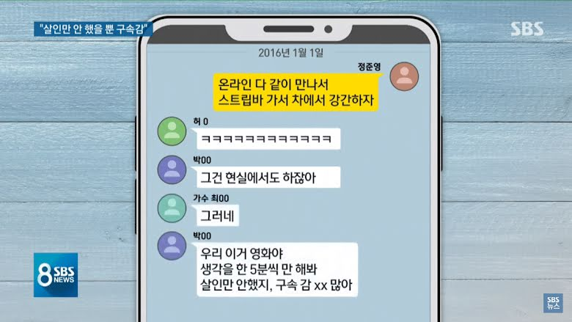**Chat 4**

**Korean**

정준영 :온라인 다 같이 만나서 스트립바 가서 차에서 강간하자

허00 : kekekekeke

박00 : 그건 현실에서도 하잖아

가수 최 :그러네

박00 :우리 이거 영화야 생각을 한 5분씩만 해봐 살인만 안했지, 구속 감xx많아

**English**

Jung Junyoung : Let's meet girls online, bring them to a strip bar, dan rape them in the car

Heo 00 : kekekekekeke

Park 00 : We’ve done it in real life

Singer Choi00 : You’re right

Park 00 : We’re in the movie

Let’s just think about it for 5 minutes

Except for killing, we’ve done many thing to jail us

**Table 4.1**

|  |  |  |  |  |  |  |  |  |
| --- | --- | --- | --- | --- | --- | --- | --- | --- |
| 온리인  (onlain) | 다  (da) | 같이  (katchi) | 만나서  (manaseo) | 스트립바  (seuteurib ba) | 가서  (kaseo) | 차에서  (cha-**eseo**) | 강간  (kang-gan) | 하자  (haja) |
| Online | all | together | meet | Strip bar | go | **In** the car | rape | Let’s |
| Let’s meet (girls) online together, go to a strip bar, and rape them in the car | | | | | | | | |

**Table 4.2**

|  |  |  |  |
| --- | --- | --- | --- |
| 그건  (geugeon) | 현실**에서**  (hyeonshir-**eseo**) | 도  (do) | 하잖아  (hajanh-a) |
| That | **In** real life | Too | Have done |
| We have done it in real life | | | |

**Table 4.3**

|  |
| --- |
| 그러네  (geureone) |
| Yes |

**Table 4.4**

|  |  |  |
| --- | --- | --- |
| 우리  (uri) | 이거  (igeon) | 영화야  (yeonghwaya) |
| We | This | movie |
| We’re in this movie | | |

**Table 4.5**

|  |  |  |  |  |
| --- | --- | --- | --- | --- |
| 생각을  (saeng-gak-eul) | 한  (han) | 5**분**씩  (o-bunsshik) | 만  (man) | 해봐  (haeba) |
| think | about | 5 minutes | just | Le’s try |
| Let’s try to think about it just for 5 minutes | | | | |

**Table 4.6**

|  |  |  |  |  |  |  |
| --- | --- | --- | --- | --- | --- | --- |
| 살인  (sar-in) | 만  (man) | 안  (ahn) | 했지  (haetji) | 구속  (gusok) | 감 xx(**방**)  (kam**bang**) | 많아  (manh-a) |
| Murder | Just | Haven’t | do | Arrest | Jail | Many |
| We just haven’t killed people. We’ve done many things to be arrested in jail. | | | | | | |

**Chat 5**

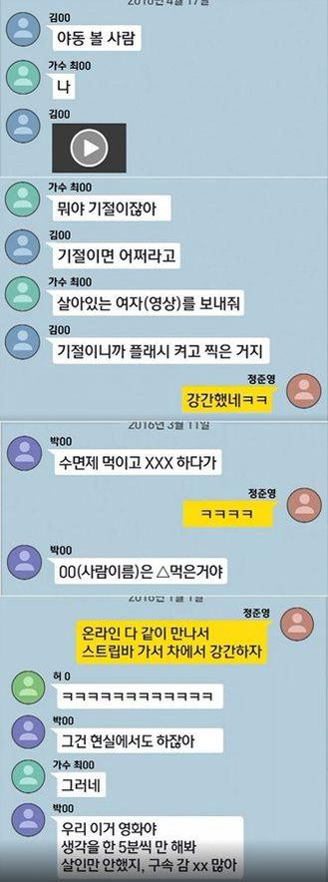

**Korean**

김00 :야동 볼 사람

가수 최00 :나

김00 : (video)

가수 최00 :뭐야 기절이잖아

김00 :기절이면 어쩌라고

가수 최00 :살아있는 여자(영상)를 보내줘

김00 :기절이니까 플래시 켜고 찍은 거지

정준영 :강간했네ㅋㅋ

**English**

Kim 00 : Who wants to watch porn

Singer Choi00 : Me

Kim 00 : (video)

Singer Choi00 : what is that? She faints

Kim 00 : So what if she faints

Singer Choi00 : Sent (video) alive woman, please

Kim 00 : Because She’s fainted, so I can take the video with flash

Jung Junyoung : You rape her keke

**Table 5.1**

|  |  |  |
| --- | --- | --- |
| 야동  (yadong) | 볼  (bol) | 사람  (saram) |
| Porn | Look | Person |
| Who wants to watch porn | | |

**Table 5.2**

|  |  |
| --- | --- |
| 뭐야 | **기절**이잖아 |
| What is that | She **fainted** |

**Table 5.3**

|  |  |
| --- | --- |
| 기절이**면** | 어쩌라고 |
| If faint | So what |
| So what if she fainted | |

**Table 5.4**

|  |  |  |
| --- | --- | --- |
| 살아있는  (sara-itneun) | 여자를  (yeoja-reul) | 보내**줘**  (bonaejwo) |
| Alive | Woman | Send **please** |
| Sent (video) alive woman, please | | |

**Table 5.5**

|  |  |  |  |
| --- | --- | --- | --- |
| 기절이**니까**  (kijeori**nikka**) | 플래시  (peullaeshi) | 겨고  (kyeogo) | 찍은거지  (jjigeun geoji) |
| **Because** fainted | flash | against | Take video |
| Because she fainted, so I can take the video using flash | | | |

**Table 5.6**

|  |  |
| --- | --- |
| 강간  (kang-gan) | 했네  (haenne) |
| rape | Do |
| You rape her | |

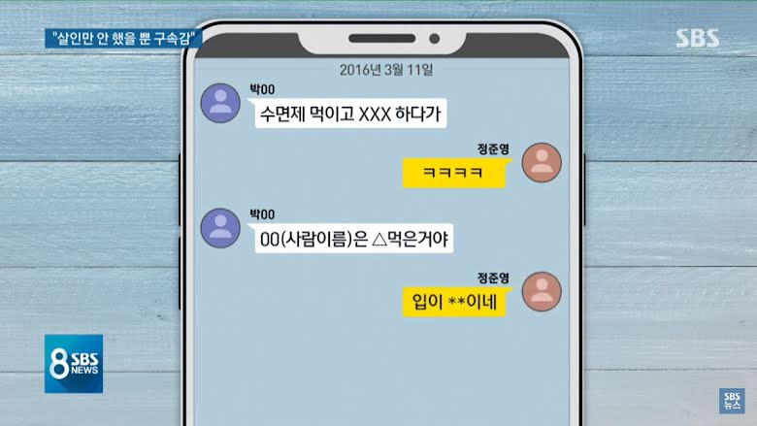**Chat 6**

**Korean**

박00 :수면제 먹이고 XXX 하다가

정준영 : ㅋㅋㅋ

박00 :00(사람이름)은 △먹은거야

정준영 :입이 **이네

**English**

Park 00 : I gave her a sleeping pill before sleeping with her

Jung Junyoung : kekeke

Park00 : 00 (the person’s name) is eating △(the name of the drug)

**Table 6.1**

|  |  |  |  |
| --- | --- | --- | --- |
| 수면제  (sumyeonje) | 먹이고  (mogigo) | XXX | **하**다가  (hadaga) |
| Sleeping pill | eat | (censored word for raping or sex) | While/before **do** |
| I gave her a sleeping pill before sleeping with her | | | |

**Table 6.2**

|  |  |  |
| --- | --- | --- |
| 00(사람이름)은  00(saram ireum)eun | △ | 먹은거야  (mogeungeoya) |
| 00(the victim’s name) | (name of the drug) | eat |
| 00 (the person’s name) is eating △(the name of the drug) | | |

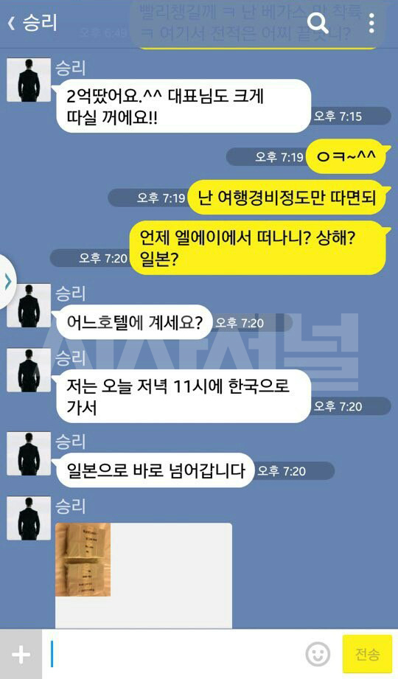**Chat 7**

Table 7.1

|  |  |  |  |  |  |
| --- | --- | --- | --- | --- | --- |
| 2**억**  (I eok) | 땄어요  (ddasseoyo) | 대표님  (daepyonim) | 도  (do) | 크게  (keuge) | 따실 꺼에요  (ddashil kkeo-eyo) |
| 2 (hundred million) | win | President | too | big | Will win |
| I won 2oo million.^^ You will win big too, president!! | | | | | |

Table 7.2

|  |  |  |  |  |  |
| --- | --- | --- | --- | --- | --- |
| 난  (nan) | 여행  (yeohaeng) | 경비  (kyeongbi) | 정도  (jeongdo) | 만  (man) | 따면되  (ddamyeondwae) |
| I | travell | expenses | enough | just | Win |
| Okay~^^ I just need to win enough to cover my travell expenses | | | | | |

Table 7.3

|  |  |  |  |  |
| --- | --- | --- | --- | --- |
| 언제  (eonje) | 엘에이에서  (el-e-i- eseo) | 떠나니?  (ddeonani?) | 상해?  (shanghae?) | 일본?  (ilbon?) |
| When | LA | Leave | Shanghai? | Japan? |
| When are you leaving L.A.? Shanghai? Japan? | | | | |

Table 7.4

|  |  |  |
| --- | --- | --- |
| 어느 | 호텔에 | 계세요? |
| Which | Hotel | Stay? |
| Which hotel are you staying? | | |

Table 7.5

|  |  |  |  |  |  |
| --- | --- | --- | --- | --- | --- |
| 저는  (jeoneun) | 오늘  (oneul) | 저녁  (jeonyeok) | 11시에  (ship-il shi-e) | 한국**으로**  (han-guk-**euro**) | 가서  (kaseo) |
| I | today | evening | 11 o’clock | **To** Korea | Go |
| Which hotel are you staying at? I’m going back to Korea tonight at 11 P.M. | | | | | |

Table 7.6

|  |  |  |  |
| --- | --- | --- | --- |
| 일본**으로**  (ilbon-**euro**) | 바로  (baro) | 넘어  (neom-eo) | 갑니다  (kamnida) |
| **To** Japan | straight | over | Go |
| I’m going to straight to Japan | | | |

**Chat 8**

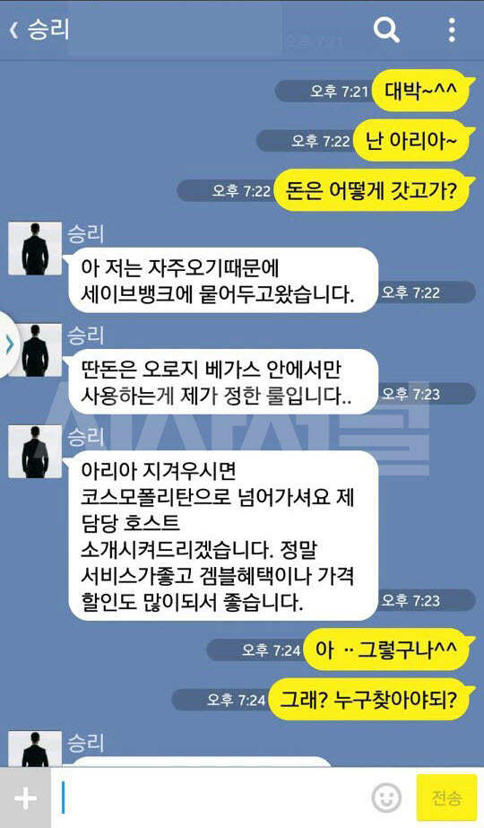

Table 8.1

|  |  |  |  |  |  |
| --- | --- | --- | --- | --- | --- |
| 대박  (daebak) | 난  (nan) | 아리아  (aria) | 돈은  (don-eun) | 어떻게  (eotteohke) | 갓고가  (katgoga) |
| Amazing | I am | Aria | Money | How | Bring |
| Amazing~^^ I am at Aria~ How to bring the money? | | | | | |

Table 8.2

|  |  |  |  |  |  |  |
| --- | --- | --- | --- | --- | --- | --- |
| 저는  (jeoneun) | 자주  (jaju) | 오기  (ogi) | 때문에  (ddaemun-e) | 세이브뱅크에  (se-ibeu baengkeu-e) | 묻어  (mud-eo) | 두고왔습니다  (dugowaseumnida) |
| I | Often | come | because | Save Bank | keep | Leave behind |
| Because I often come here, so I left it at the Save bank | | | | | | |

Table 8.3

|  |  |  |  |  |
| --- | --- | --- | --- | --- |
| 딴  (ddan) | 돈은  (don-eun) | 오로지  (oroji) | 베가스  (begaseu) | 안에서  (aneseo) |
| Different | Money | Only | Vegas | Inside |
| 만  (man) | 사용하는게  (sayonghaneun-ge) | 제가  (jega) | 정한  (jeonghan) | 룰입니다  (rul imnida) |
| Just | Using | I | set | Rule |
| I set a rule only to use the money I win in Vegas | | | | |

Table 8.4

|  |  |  |  |  |
| --- | --- | --- | --- | --- |
| 아리아  (aria) | 지겨우시면  (jikyeo-ushimyeon) | 코스모폴리탄**으로**  (koseumopollitan-**euro**) | 넘어가셔요  (neom-eo gasyeo-yo) | |
| Aria | If bored | **To** Cosmopolitan | Jump Over | |
| 제  (je) | 담당  (damdang) | 호스트  (hoseuteu) | 소개  (sogae) | 시켜드리겠습니다  (shikyeodeurikesseumnida) |
| I | In charge | Host | Introduce | Will |
| If you are bored in Aria, Jump over to Cosmopolitan, I will introduce you to my host | | | | |

Table 8.5

|  |  |  |  |  |
| --- | --- | --- | --- | --- |
| 정말  (jeongmal) | 서비스가  (seobiseuga) | 좋고  (johgo) | 겜블  (gembeul) | 혜택이나  (hyetaek-ina |
| Really | Service | Good | Gamble | Benefit |
| 가격  (kagyeok) | 할인도  (hal-indo) | 많이되서  (manhidwaeseo) | 좋습니다  (johseumnida) |  |
| Price | discount | Many | Good |  |
| They have great service, and the gambling benefits and discounts are good there | | | | |

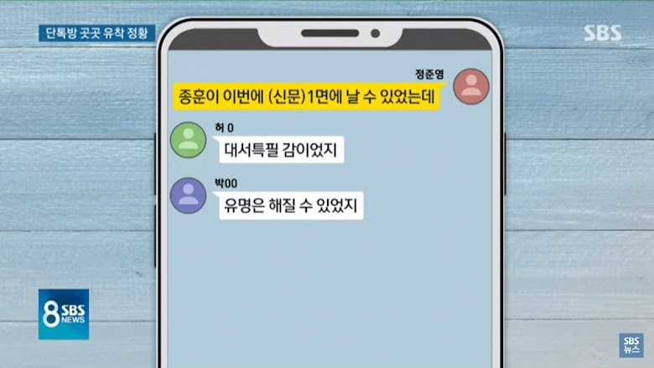**Chat 9**

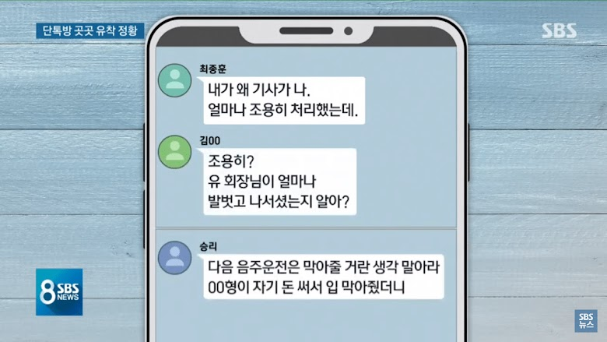

**Korean**

정준영 :종훈이 이번에 (신문) 1면에 날 수 있었는데

허0 : 대서특필 감이었지

박00 : 유명은 해질 수 있었지

최종훈 :내가 왜 기사가 나.

얼마나 조용히 처리했는데.

김00 :조용히?

유 회장님이 얼마나 발벗고 나서셨는지 알아?

승리 :다음 음주운전은 막아줄 거란 생각 말아라 00형이 자기 돈 써서

입 막아줬더니

**English**

Jung Joon-young : "Jonghoon could have made it to the front page of the newspaper this time."

Heo 0 : "I can feel it will be a headline."

Park 00 : "He could have become famous."

Choi Jonghoon : "Why should I appear in the article? I handled it quietly."

Kim 00 : "Quietly? Do you know how Chairman Yoo stepped forward?"

Seungri : "Stop thinking you can prevent the next drunk driving incident. Brother 00 used his own money to bribe the police

**Table 9.1**

|  |  |  |  |  |  |
| --- | --- | --- | --- | --- | --- |
| 종훈이  (Jonghoon-i) | **이**번에  (ibeon-e) | (신문)  (shinmun) | **1**면에  (**il** myeon-e) | 날  (nal) | 수있었는데  (su isseoneunde) |
| Jonghoon | **This** time | newspaper | **First** page | day | Could be |
| Jonghoon could be in the front page of newspaper this time | | | | | |

**Table 9.2**

|  |  |  |
| --- | --- | --- |
| 대서특필  (daeseoteukpil) | 감이  (gam-i) | 었지  (eotji) |
| Headline | feel | have |
| I have feeling it will be a headline | | |

**Table 9.3**

|  |  |  |
| --- | --- | --- |
| 유명은  (yumyeongeun) | 해질  (haejil) | 수 있었지  (su isseotji) |
| Famous | do | Can |
| He can be famous | | |

**Table 9.4**

|  |  |  |  |
| --- | --- | --- | --- |
| 내가  (naega) | 왜  (wae) | 기사가  (gisaga) | 나  (na) |
| I | why | article | appear |
| Why should I appear in the article? | | | |

**Table 9.5**

|  |  |  |  |
| --- | --- | --- | --- |
| 얼마나  (eolmana) | 조용히  (joyonghi) | 처리  (cheori) | 했는데  (haenneunde) |
| How | quiet | handle | Did |
| I handled it quietly | | | |

**Table 9.6**

|  |  |  |  |  |  |
| --- | --- | --- | --- | --- | --- |
| 조용히?  (joyonghi?) | 유 회장님이  (yoo hwejangnim-i) | 얼마나  (eolmana) | 발벗고  (balbeotgo) | 나서셨는지  (naseosyeonneunji) | 알아?  (ar-a) |
| Quietly? | President Yoo | How | Bare feet | step | Know? |
| Quietly? Do you know how much President Yoo stepped forward? | | | | | |

**Table 9.7**

|  |  |  |  |  |  |
| --- | --- | --- | --- | --- | --- |
| 다음  (da-eum) | 음주  (eumju) | 운전은  (unjeon-eun) | 막아  (mag-a) | 줄  (jul) | 거란  (georan) |
| Next | Drunk | driving | stop | can | give |
| 생각  (saeng-gak) | 말아라  (mar-ara |  |  |  |  |
| think | Don’t |  |  |  |  |
| Stop thinking you can stop your drunk driving incident. | | | | | |

**Table 9.8**

|  |  |  |  |  |  |  |
| --- | --- | --- | --- | --- | --- | --- |
| 00형이  (00 hyeong-i) | 자기  (jagi) | 돈  (don) | 써서  (sseoseo) | 입  (ib) | 막아  (mag-a) | 줬더니  (jwotteoni) |
| Brother 00 | own | money | spend | lip | stop | gave |
| Brother 00 used his own money to bribe the police. | | | | | | |