|  |
| --- |
| **DEVELOPMENT OF PHYSICS E-MODULES BASED ON A SCIENTIFIC APPROACH USING SIGIL *SOFTWARE* FOR STUDENTS OF CLASS X SMA/MA** |
| Nurul Hikmah Hidayah1, Yurnetti1*, Desnita1 , Murtiani1 |

*1Department Of Physics, Universitas Negeri Padang, JL. Prof. Dr. Hamka Air Tawar Padang 25131, Indonesia*

*Corresponding author. Email:* [*yurnetti@fmipa.unp.ac.id*](mailto:yurnetti@fmipa.unp.ac.id)

**ABSTRACT**

|  |  |  |  |  |  |  |  |  |  |  |  |  |
| --- | --- | --- | --- | --- | --- | --- | --- | --- | --- | --- | --- | --- |
| |  |  | | --- | --- | | *According to Circular No. 4 of 2020 on the Implementation of Educational Policies in the Emergency Period Due to the Spread of the Covid-19, in-person learning must be done through distance learning (online). We need educational tools that can assist pupils to learn autonomously to alter the circumstances. The goal of this study is to create a physics e-module based on a scientific method that uses Sigil software to assist students to grasp momentum and momentum material, as well as harmonic vibration material. The purpose of this study was to determine the validity and practical utility of the produced e-module.*  *The sort of study conducted is R&D employing the Plomp model, which is confined to the one-to-one evaluation stage. A questionnaire in the form of content and construct validity cards was employed as the study instrument. Five verifies verified the constructed electrical module, comprising three physics lectures and two physics teachers from SMA Negeri 5 Solok Selatan, as well as six students from SMA Negeri 5 Solok Selatan.*  *For validity and practicality, the data was analyzed using Cohen's Kappa moment value. The validity test results were 0.89 with a very valid category based on the data analysis. Students' practicality test scores are 0.90 in the highly practical category, while educators' scores are 0.86 in the very practical category. It is possible to conclude that the physics e-module based on the scientific approach and utilizing the Sigil software is legitimate and useful for students at the X SMA/MA level.* | | |  | | | **Keywords:** *E-module, Scientific Approach, Sigil Software, Momentum and Impulse, Harmonic Vibration, Validity, Practicality* | | |  | **This is an open access article distributed under the Creative Commons 4.0 Attribution License, which permits unrestricted use, distribution, and reproduction in any medium, provided the original work is properly cited. ©2019 by author and Universitas Negeri Padang.** | |  | | |  | | |

# INTRODUCTION

During the industrial revolution, the application of information and communication technology in many aspects of life, including education, marked the progress of the twenty-first century. 4.0. This is shown by the rise of technology-based learning. The progress gained poses a challenge for teachers and students, particularly in terms of the implementation of innovative learning [1]. To achieve quality education, quality Human Resources (HR) in elements of spirituality, understanding, and skills are very important to adapt to the evolution of the twenty-first century.

In this century, the national educational system tries to encourage students to acquire a skill that is significant and valuable for them to be more open to changes and advancements. The most essential aspect of education is encouraging students to develop a foundation of profound knowledge and comprehension so that they may become lifelong learners. As a result, the educational system must take into account several characteristics that are unique to 21st-century schooling. Government measures, such as the adoption of the 2013 curriculum, play an essential role in this situation.

The 2013 curriculum mandates that students have the flexibility to think about and analyze issues, develop problem-solving techniques, and come up with ideas freely and openly throughout the implementation of learning, requiring students to be more active, creative, inventive, and independent[2]. The instructor, on his part, is a facilitator and motivator who is in charge of promoting learning and assisting pupils in the learning process[3]. The 2013 curriculum, according to Permendikbud No. 21 of 2016, pertains to several competency levels in Indonesia, including early childhood education, basic education, and secondary education[4]. Physics is one of the disciplines offered in the secondary education curriculum in 2013. Most students still regard physics lectures as having a passive approach toward grasping the content and are more inclined to memorize. The majority of physics textbooks cover numerous topics that students must grasp.

Understanding the notion of physics refers to students' capacity to acquire physics content that is not only recalled and understood but can also be re-expressed in a more straightforward manner[5]. Momentum Impulse and Harmonic Vibration is the physics textbook assigned to class X. Both resources provide thoughts on how pupils comprehend topics. Learning physics necessitates several successful methods for picking students' interest in learning and comprehending topics, including the use of relevant media and learning methodologies. To achieve the objectives of the curriculum, one of the roles of the government is to improve the quality of learning by using various approaches in the learning process [6]. The scientific approach is one of the learning approaches that may assist students to identify their concepts in learning.

The scientific approach is a basic concept that inspires or underlies the creation of a teaching strategy by adding scientific characteristics into the processes of observing (observing), enquiring (questioning), testing (experimenting), reasoning (associating), and communicating (communicate) The scientific approach teaches students to recognize and grasp a wide range of resources by demonstrating that knowledge may be obtained from everywhere and at any time without depending on information supplied by the instructor as an educator[7]. Through the enhancement of attitude, talents, and integrated knowledge, learning outcomes are supposed to lead to active, imaginative students and innovation[8]. Learning based on a scientific approach to learning students is expected to have a balanced competition between attitudes, skills, and knowledge that is much better than before. The scientific approach needs didactic resources for its implementation, and the module is one of the most extensive and valid printed didactic materials available. The teaching materials used in the learning process are systematically ordered by the teacher, taken from various learning sources [9]. The module is one of the didactic tools used by educators to help them reach learning objectives by including information, attitudes, and skills[10].

On the other hand, teachers face significant challenges while creating new physics lectures. Physics learning and learning processes were challenged during the Covid-19 outbreak because what was previously a face-to-face learning technique became a remote learning method. Circular No. 4 of 2020 on the Implementation of Educational Policies in the Emergency Period issued by the Minister of Education and Culture Because of the Virus's spread, all educational institutions must be able to transition from face-to-face to distance learning (online)[11]. Naturally, this demands extensive planning both before and throughout the apprenticeship. Of course, this necessitates many preparations, both before and during the apprenticeship. Online learning also needs educators to be more innovative in terms of delivering content and selecting relevant teaching resources so that students can grasp the subject when studying alone.

In today's world of education, the e-module[12] is an example of how information and communication technologies are being employed. The e-module is a technology-based module that is interactive, easy to navigate, and includes training exams and quizzes that provide feedback to students[13]. It also allows for the display/loading of graphics, audio, video, and animation, as well as the display/loading of graphics, audio, video, and animation. E-module are self-contained learning materials that are presented systematically into learning units to achieve specific learning objectives [14]. One piece of software that may be used to develop e-modules is Sigil Software.

Depending on observations made at SMA Negeri 5 Solok Selatan, the learning process is conducted in a hybrid manner, both online and offline, with a distribution based on the absence of students using an odd-even approach. This school employs Zoom/Google Meet media as well as school-provided print books and worksheets as learning partners in the online learning process. The researchers also looked at some of the available training resources, including electronic ones. Several items were discovered after analyzing different accessible teaching materials, both print and electronic teaching materials, including one teaching material that used a scientific approach to learning, but only the learning stages were not documented, and the six didactic materials were evaluated. There was no evidence of learning based on a scientific method. Some training materials did not include the terms KI, KD, or Indicators at the start of the presentation. Electronic learning resources resemble books in appearance.

Given this circumstance, one of the innovations that might be used to help with the learning process, stimulate students’ interest, or encourage them to take a more active role in learning is the use of didactic materials generated by students using scientific methods. Teaching Tools in the form of self-designed electronic modules based on scientific approaches are thought to help students grasp topics both during the learning process and during independent study. E-module made using Sigil Software may be accessed easily and rapidly. It may be utilized by a large number of students regularly. The E-Module is designed for materials that have a lot of velocity and impulse as well as a lot of harmonic vibration. The authors are interested in conducting research named "Development Of Physics E-Modules Based On A Scientific Approach Using Sigil Software For Students Of Class X SMA/MA" using teaching materials in the form of e-module to give learning renewal.

# METHOD

This type of investigation is carried out using a research and development (R&D) strategy. [15] "The R&D process is a research method for developing products and evaluating their efficacy." This type of study was chosen to generate a product that aims to design and validate a product due to existing approaches. The research's ultimate product is an e-module physics for X-class SMA/MA students that includes limitations in momentum and momentum materials, as well as harmonic vibration, and was created with the use of Sigil software. In this study, the Plomp model was used as the research model. This paradigm was developed by Tjerd Plomp and consists of three stages: preliminary inquiry (early research), prototype stage (prototyping), and evaluation stage (evaluation stage)[16].

In the academic year 2021/2022, SMAN 5 Solok Selatan conducted research on the creation of a physical-module for X-class SMA/MA students based on a scientific method utilizing Sigil Software. The goal of this study is to learn about the physics of e-module utilizing Sigil software for X-class SMA/MA students. Lectures from the FMIPA UNP's physics department, physics teachers, and students from the X SMA/MA class were the subjects of this study.

The content validity, design, and practicality examination methodologies are based on Boslaugh's modified categorical judgments[17]. The validator receives inquiries and then assesses each statement in categorical judgments. The provided sheet is in the form of a questionnaire, and the validator has the authority to decide on the evaluation's outcomes. The Kappa Cohen formula was used to study the validator's judgment of each assertion, and the kappa moment was calculated at the end of the procedure.

*Moment kappa (k) = $\frac{Po - Pe}{1- Pe}$*  (1)

**Table 1.** Category Validity Based on Moment Kappa *(k)*

|  |  |  |
| --- | --- | --- |
| **No** | **Interval** | **Category** |
| 1 | 0,81- 1,00 | Very Valid |
| 2 | 0,61- 0,80 | Valid |
| 3 | 0,41- 0,60 | Valid Enough |
| 4 | 0,21- 0,40 | Less Valid |
| 5 | 0,01- 0,20 | Not Valid |
| 6 | < 0,00 | Very Not Valid |

(Boslaugh,2008:12)[18]

The same principles apply to data analysis as they do to content and construction validity sheet analysis. The practicality sheet was calculated using the distribution of teacher and student response surveys, which were also assessed using the Kappa Cohen technique, with the proviso that intervals less than 0.00 were considered impractical.

**Table 2**. Practicality Category Based on Kappa Moment *(k)*

|  |  |  |
| --- | --- | --- |
| **No** | **Interval** | **Category** |
| 1 | 0,81- 1,00 | Very Practical |
| 2 | 0,61- 0,80 | Practical |
| 3 | 0,41- 0,60 | Practical Enough |
| 4 | 0,21- 0,40 | Less Practical |
| 5 | 0,01- 0,20 | Not Practical |
| 6 | < 0,00 | Very Not Practical |

# RESULTS AND DISCUSSION

Using Sigil software, the researchers want to develop an e-module physics based on a scientific approach to momentum and momentum materials, as well as harmonic vibrations. The Plomp development model is used in this work, and it consists of three stages: fundamental research, prototype stage (prototyping stage), and assessment stage (evaluation stage). However, prototype III was legitimate and practicable in this study since it was limited to the level of prototyping, that is one-to-one testing.

1. **Preliminary Research**

The first stage of research is to identify the fundamental issues that exist in the sector and to develop answers to these issues. Needs analysis, literature study, and conceptual framework building was among the tasks completed. According to the 2013 Curriculum Needs Analysis, instructors and students are expected to be adept in the use of media and technology in the 2013 curriculum. SMAN 5 Solok Selatan had integrated the 2013 curriculum in the learning process, according to data acquired during the first research stage.

Due to the present state of the Covid-19 epidemic, the learning procedure in SMAN 5 Solok Selatan is conducted entirely online. A study of the availability of instructional materials is also conducted as part of the requirements analysis. Based on an examination of several printed and electronic teaching materials, it was discovered that while the majority of the teaching materials in the presentation of the content were full, other components such as KI, KD, and indications were still missing. Of course, they are interconnected based on this scientific method, thus it is required to design an electronic module in Physics based on this scientific approach.

A literature evaluation was also conducted at this stage of the research to hunt for references connected to the study. References are found in books, publications, and on the internet. To discover and compile material concepts, a conceptual framework is created, which is subsequently turned into a concept map.

1. **Prototyping Stage**

Three prototypes were created at the prototype stage: prototype I, prototype II, and prototype III, with a formative review for each prototype. The goal of formative evaluation is to increase a product's quality. The developed product, in the form of an e-module, adheres to the Ministry of Education and Culture's (2017)[19] guidelines for the e-module component, which includes a cover, prologue, index, glossary, preliminary activities (KI, KD, IPK, descry, option, and instructions for the use of e-module), learning activities, evaluation sheets, answer keys, and bibliography. The prototype is organized with a scientific approach to assist students to identify concepts in the form of a physics e-module based on a scientific approach. Visualization can be offered in the constructed e-module in the form of visuals and animated learning films, which can pique students' interest in learning the content.

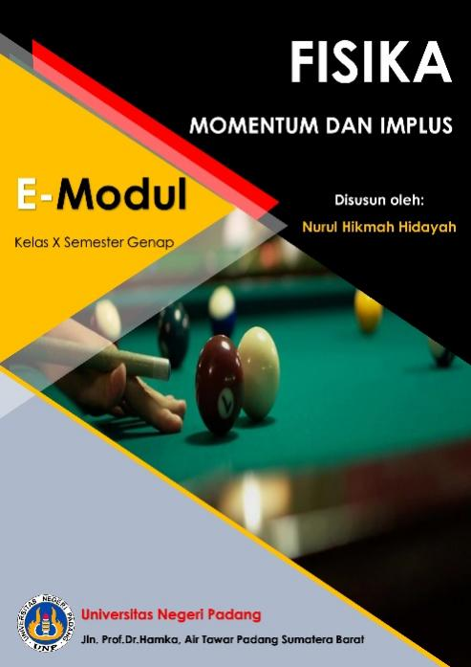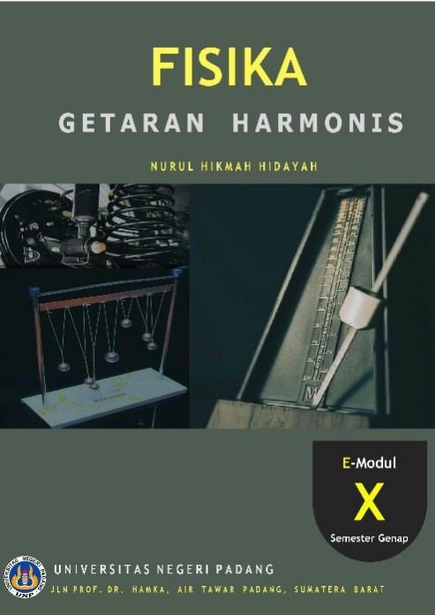

Fig 1. Cover E-Module momentum and impulse and harmonic vibration

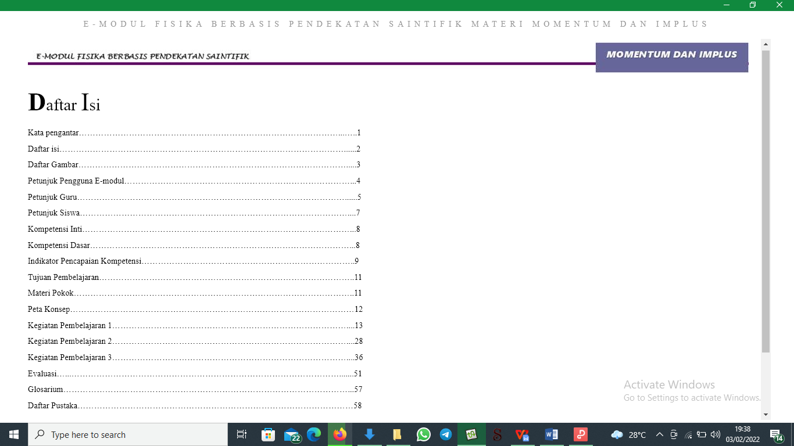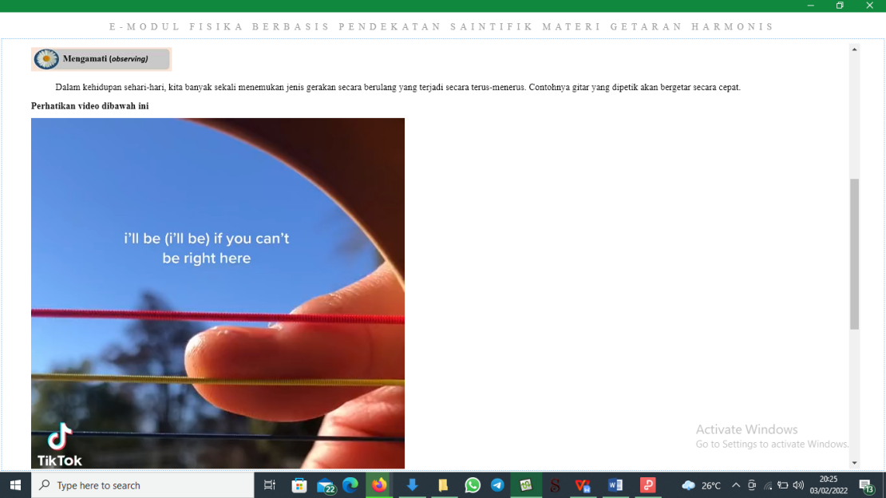

Fig 2.Table of contents Fig 3.Material on the e-module

The assessment strategy utilized determines the quality of research for development findings. Tessmer's formative assessment approach was applied in this study, and it comprised self-evaluation, expert review, and one-on-one assessment. The evaluation assesses the quality of the result generated in this case in the form of a physic e-module for X class SMA/MA students based on a scientific approach utilizing the Sigil software. Validity, practicality, and efficacy are three characteristics that define a product's quality. Validity and practicality are the only criteria used in this study.

1. **Validity of E-module**

The validity of the electronic module was evaluated using an assessment questionnaire that was validated by five validators, including three FMIPA UNP physics professors and two SMAN 5 Solok Selatan physics professors. The validator gives the electrical physics module an assessment based on a scientific method in the material of momentum and momentum, as well as in the material of harmonic vibrations, utilizing the sigil software. There are four categories of components in the validity instrument: content components, language components, presentation components, and visual components. The Kappa Cohen formula was used to process the data collected. The validator assessed the e-physics module's validity utilizing sigil software and a scientific methodology for the four components with a very valid validity category.

**Table 3**. E-module Validation Analysis

|  |  |  |  |
| --- | --- | --- | --- |
| **No** | **Rated Components** | **Average *k*** | **Category** |
| 1 | Content Component | 0,85 | Very Valid |
| 2 | Linguistic Component | 0,90 | Very Valid |
| 3 | Serving Component | 0,89 | Very Valid |
| 4 | Graphic Component | 0,93 | Very Valid |
| **Mean *k* validity** | | **0,89** | **Very Valid** |

Table 3 shows that the Kappa Moment of the four components is in a very valid range, based on the validity of three FMIPA UNP physics lectures and two SMAN 5 Solok Selatan physics teachers. This demonstrates that the physics of the e-module, which is founded on a scientific method and implemented using the designed sigil program, is correct and extremely valid. Based on the validity of the five validators, recommendations are made for improving the physics e-module for X-class SMA/MA students utilizing a scientific approach and the sigil software.

1. **Practicality**

The usefulness of the e-module is assessed by a product assessment administered to instructors and students in the form of a questionnaire. The three essential components of assessed practicality are simplicity of use, learning time efficiency, and advantages. To calculate the value of the Kappa Moment, the data on the practicality of the electronic learning modules was assessed using the Kappa Cohen formula. Students and educators were done as respondents using an assessment instrument in the form of a questionnaire based on the practicality test of the product in the form of a physics e-module based on a scientific approach employing sigil software. Educators' practicality is assessed on a one-to-one basis, with two physics instructors from SMAN 5 Solok Selatan and six students from the X SMAN 5 Solok Selatan class.

Tables 4 and 5 show the results of a practicality test conducted by two Physics teachers and six students from the X SMAN 5 Solok Selatan class, which yielded an average value of the Kappa Moment of practicality for both teachers and students. The practicality of e-learning modules by educators and students from the components of the simplicity of use, the science of learning, time, and advantages is in extremely practical ranges, according to the average Kappa Moment test findings.

**Table 3**. Student Questionnaire Analysis

|  |  |  |  |
| --- | --- | --- | --- |
| **No** | **Rated Components** | **Average *k*** | **Category** |
| 1 | Ease Of Use | 0,90 | Very Practical |
| 2 | Learning Time Efficiency | 0,85 | Very Practical |
| 3 | Benefit | 0,95 | Very Practical |
| **Average *K*** | | **0,90** | **Very Practical** |

**Table 3**. Teacher Questionnaire Analysis

|  |  |  |  |
| --- | --- | --- | --- |
| **No** | **Rated Components** | **Average *k*** | **Category** |
| 1 | Ease Of Use | 0,87 | Very Practical |
| 2 | Learning Time Efficiency | 0,85 | Very Practical |
| 3 | Benefit | 0,88 | Very Practical |
| **Average *K*** | | **0,86** | **Very Practical** |

In general, the results of the practicality test analysis of physics e-modules based on a scientific approach using Sigil software are practical and can be easily used by teachers and students because the e-module was designed with stages of a scientific approach in mind to meet the demands of the 2013 curriculum. As a supplement to traditional classroom teaching materials for instructors and students in the learning process both inside and outside of the classroom.

# CONCLUSION

Based on the findings, it can be determined that the validity and practicality values of the e-physics module for X class SMA/MA students based on a scientific approach utilizing Sigil Software are in the highly valid and very practical categories.

1. REFERENCES
2. Kuncahyono, & Aini, D. F. N. (2020). Student Active Learning Sebagai Pendukung Development of E-Module Guidelines Oriented Towards Active Student Learning As. *Jurnal Pendidikan Dasar Nusantara*, *5*(2), 292–304.
3. Sinambela, P. nauli josip mario. (2013). Kurikulum 2013, Guru, Siswa, Afektif, Psikomotorik, Kognitif. *E-Journal Universitas Negeri Medan*, *6*, 17–29.
4. Mulyasa, E. (2013). *Pengembangan Implementasi Kurikulum 2013.* Bandung: PT.Remaja Rosdakarya.
5. Permendikbud No.21(2016). Standar Isi Pendidikan Dasar dan Menengah. Jakarta: Depertemen Pendidikan Nasional dan Kebudayaan.
6. Hau, rambu Ririnsia Harra, and Nuri Nuri, *Pemahaman Siswa Terhadap Konsep Hukum I Newton*. *Variable* 2.2 (2019): 56-61
7. Murtiani, Ahmad Fauzan, & Ratnawulan. 2012. Penerapan Pendekatan Contextual Teaching And Learning (CTL) Berbasis Lesson Study Dalam Meningkatkan Kualitas Pembelajaran Fisika Di SMP Negeri Kota Padang. Jurnal Penelitian Pembelajaran Fisika, Vol 1. (1), 1-21. doi: <https://doi.org/10.24036/jppf.v1i1.597>
8. Okyranida, I. Y. (2020). *Schrӧdinger Pengembangan Modul Pembelajaran Fisika Berbasis Saintifik pada Materi Momentum dan Impuls Kelas X SMA*. *1*(1).
9. M.Hosnan. (2014). *Pendekatan Saintifik Dan Konstestual Dala/on m Pembelajaran Abad 21.* Bogor: Ghalia Indonesia.
10. Desnita, D., Putra, A., Hamida, S., Marsa, P., & Novisya, D. (2021). Quality Test of Student Worksheets Based on Contextual Teaching And Learning for Class XI High School Physics. Jurnal Penelitian Pendidikan IPA, 7(1), 92-101. doi: <https://doi.org/10.29303/jppipa.v7i1.600>
11. Syafitri, Yunita. 2019. Pembuatan E-Modul Berorientasi Higher Order Thinking Skills (Hots) Untuk Pembelajaran Fisika Pada Materi Kalor Dan Teori Kinetik Gas Di Kelas Xi Sma/Ma: *Pillar Of Physics Education*, Vol 12. (4), 777-784.
12. Pusdiklat Pegawai Kementerian Pendidikan dan Kebudayaan. “Surat Edaran Mendikbud No 4 Tahun 2020 Tentang Pelaksanaan Kebijakan Pendidikan Dalam Masa Darurat Penyebaran Corona Virus Disease (Covid- 1 9),” 24 Maret 2020.<https://pusdiklat.kemdikbud.go.id/suratedaran-mendikbud-no-%204-tahun-2020-tentang-pelaksanaan-kebijakan-pendidikandalam-masadarurat-penyebaran-corona-virus-disease-covid-1-9/>
13. Fauzi, H., Farida, I., Sukmawardani, Y., & Irwansyah, F. S. 2019. *The making of e-module is based on an inquiry on chemical bonding concept with representation ability oriented. In Journal of Physics*: Conference Series, 1402 (5), p. 055059
14. Suarsana, I. M., & Mahayukti, G. A. (2013). Pengembangan E-Modul Berorientasi Pemecahan Masalah Untuk Meningkatkan Keterampilan Berpikir Kritis Mahasiswa. *Jurnal Nasional Pendidikan Teknik Informatika (JANAPATI)*, *2*(3), 193. https://doi.org/10.23887/janapati.v2i3.9800
15. Ramadhanty,Nadia. 2020. Perbandingan Hasil Belajar Siswa Menggunakan E-Modul Berbasis Ctl Dengan Buku Teks Fisika Pada Materi Hukum Newton Gravitasi Dan Usaha Energi Kelas x SMAN 2 PADANG: *Pillar Of Physics Education*, Vol 13. (3), 419-426.
16. Sugiyono. (2013). *Metode Penelitian Pendidikan Kuantitatif Kualitatif dan R&D.* Bandung: Alfabeta.
17. Plomp, T., & Nienke N. (2013). *Education Design Research.* Enschede Netherland: National Institute for Curriculum Development (SLO).
18. Boslaugh, S., & Adrew PW. (2008). *Statistics, in a Nutshell, a desktop quick reference.* Beijing: Cambridge, Farnham, Koln, Sebastopol, Taipei, Tokyo; O’Reilly.
19. Boslaugh, S., & Adrew PW. (2008). *Statistics, in a Nutshell, a desktop quick reference.* Beijing: Cambridge, Farnham, Koln, Sebastopol, Taipei, Tokyo; O'Reilly.
20. Kemendikbud. (2017). *Panduan Praktis Penyusunan E-Modul tahun 2017* .Jakarta: Direktorat Pembinaan Sekolah Menengah Atas Direktorat Jenderal Pendidikan Dasar Dan Menengah Kementerian Pendidikan Dan Kebudayaan.