THE RESULTS OF NEED ANALYSIS MODEL OF CONTENT COMPLEXITY AND COGNITIVE PROCESS LEVEL ON DYNAMIC FLUID CONCEPTS FOR HIGH SCHOOL PHYSICS LESSON
Fauziah Alkhoriza Syafni¹, Amali Putra¹*, Akmam¹,WahyuniSatria Dewi¹
¹Department of Physics , UniversitasNegeri Padang, Jl. Dr. Hamka Air Tawar, Padang, 25131, Indonesia
Corresponding author. Email:amali.unp@gmail.com
ABSTRACT
In physics learning tools, it is necessary to develop complex knowledge dimensions and high-level thinking skills for students according to the revised Bloom's Taxonomy. The situation in the field, the availability of content according to the dimensions of knowledge and cognitive processes in teacher learning tools that have not been developed properly. The solution is to design the results of the Dynamic Fluid requirements analysis model obtained in the lesson plans, teaching concepts, and instrument evaluations to be used as references to develop content and cognitive processes in other materials. This type of research is Research and Development (R&D) using the Plomp development model. The research instrument is an interview instrument, an assessment instrument and instrument validation. The data were processed using the percentage technique and presented in graphs and tables to be analyzed, interpreted and described. The results of the analysis of the availability of content in teacher learning tools: 48% conceptual, 33% factual, 19% procedural, and 0% metacognitive. cognitive processing availability: remember 20%, understand 37%, apply 22%, analyze 12%, realize 8%, and create 1%. availability of scientific approach: 28% observing, 22% asking, 12% trying, 19% reasoning and 8% communicating. The correct assessment of aspects of content, language, graphics and presentation: RPP 90.5%, Teaching Concept 88.49%, and evaluation instruments 89.9%. Thus, due to the analysis of concept requirements for Dynamic Fluids, the keyword physics learning model meets the very valid criteria and is suitable for use in high school physics learning.
Keywords :Need Analysis; Content Complexity; Cognitive Process; Dynamic Fluid; Learning Tools.
 | This is an open access article distributed under the Creative Commons 4.0 Attribution License, which permits unrestricted use, distribution, and reproduction in any medium, provided the original work is properly cited. ©2019 by author and Universitas Negeri Padang.

INTRODUCTION
The development of Science and Technology in the 21st century is rapidly known as the industrial revolution era 4.0. Revolution can be interpreted as changes that occur quickly regarding the joints of life. This is marked by the shortening of the lifespan of a technology product, which then quickly switches to more sophisticated and modern technology based on automation, digital systems and uses a lot of machine power and intelligent robots. Thus, jobs that are dominated by the ability to work muscles are getting eliminated. As a result, the unemployment rate will increase if the competence of each individual is not updated by the demands of the job market and the times. Meanwhile, the industry is defined as an activity to produce something with added value or a finished product useful for life. This means that the estuary of competence from every educational activity is what each individual can make creations after attending an education.
The more complicated jobs are based on muscle work. The orientation of education must be oriented to the work of the brain. This can be done through optimizing the training of thinking (cognitive) and reasoning skills, which must be increased in intensity so that cognitive abilities are increasing from level 1 (remembering and understanding) to level 2 (applying), and level 3 (analyzing, evaluating, and creating). One of the advantages of the 2013 revised 2017 curriculum is that it has facilitated students to develop these six abilities from elementary school to university, according to their age level and development of thinking skills.
Physics is one of the compulsory subjects in the revised 2017 edition of the 2013 Curriculum, taught in Senior High Schools. Physics lesson focuses more on problems related to material aspects, the nature of nature and examines various physical symptoms that can be found in the human environment [1]. The author's experience during the implementation of the Educational Field Practice found problems in learning fluid physics, namely the mastery of student concepts, especially about the basic concepts and principles that build laws on Dynamic Fluid content. The indication is that when the teacher throws questions or problems that ask for arguments, explanations, and descriptions from students after learning is done, students rarely can answer them, especially to questions that begin with the question words why, why, and how. This condition indicates that teachers only develop factual and conceptual knowledge in learning through an emphasis on memory skills training. In contrast, problem-solving exercises that can develop procedural knowledge and metacognitive knowledge are not applied by teachers.
Content in English means content, while online KBBI content means information or concepts available through speech, writing, media, or electronic products. Content in learning can be interpreted as subject matter. Thus, the complexity of the content can be analyzed as the completeness of the subject matter contained in a subject to be taught to students. As for integrating content in learning, they plan competency-based education by mapping Core Competencies, Basic Competency, indicators, and learning objectives. Then compose the learning content that will be presented referring to the competencies to be achieved by providing media or learning resources equipped with evaluation instruments to achieve the competencies students must possess [2]. In the selection, development, and determination of learning content, it is necessary to develop increasingly complex dimensions of knowledge and higher-level thinking skills for each student as a provision for his life. The knowledge dimension in Revised Bloom's Taxonomy consists of factual, conceptual, procedural, and metacognitive knowledge [3].
The four pieces of knowledge are complementary. Factual knowledge is the basis for building conceptual knowledge and procedural knowledge. These three pieces of knowledge are a source of inspiration for each student to construct metacognitive knowledge based on self-knowledge about the advantages and disadvantages of each in dealing with and solving the problems they face. At the same time, the ability to think includes six levels of cognitive processes in the revised Bloom's Taxonomy consisting of remembering, understanding, applying, analyzing, evaluating, and creating [3]. This taxonomy is used as the basis for the 2013 curriculum by the Ministry of Education and Culture. By applying this Revised Bloom's taxonomy, it is hoped that the quality of learning will be better, and the learning outcomes achieved by students will increase so that educational goals can be reached as they should. In addition, in strengthening the learning process, the 2013 Curriculum demands that physics learning in high school be carried out using a scientific approach which consists of five steps, namely observing, asking, trying/gathering information, reasoning/associating, and communicating [4].
Need analysis consists of two words, namely need and analysis. Need is defined as the gap between what is expected and the actual conditions [5]. At the same time, analysis is an activity to look for patterns or ways of thinking related to systematic testing to determine parts, relationships between components, and their relationship to the whole [6]. It can be concluded that a need analysis (need assessment) is a process carried out to find information about the gaps that arise between the goals we expect and the conditions that are happening. The actual situation in the field regarding physics learning is based on the initial investigation phase, or area needs analysis through interview sheets and observations of physics subject teachers regarding dynamic fluid concepts at high schools in the Mentawai Islands Regency.
The results obtained are: 1) the results of the analysis of the lesson plans and teacher teaching concepts regarding the physics learning approach from the three schools that were sampled, the availability of the aspect of the scientific approach has not been correctly accommodated; 2) the results of the analysis of the teacher's lesson plans show that the lesson plans have not been appropriately developed. It tends to copy and paste from existing lesson plans. It cannot be used as a guide for teacher learning activities and is only needed as a teacher administration requirement. Other indications of lesson plans are a) Operational Verbs used to measure low-level thinking skills regarding the ability to remember, understand and apply. In contrast, higher-order thinking skills related to analyzing, evaluating, and creating are very few and tend to be very small or invisible. b) The knowledge aspect that follows the Operational Verbs in the lesson plans is still general in nature and tends to the dimensions of factual and conceptual knowledge, while procedural knowledge and metacognitive knowledge have not been developed much; 3) the results of the analysis of the availability of the four dimensions of knowledge as teacher learning content in teaching concepts, show that the proportions are not evenly distributed for each dimension of knowledge; 4) the results of the analysis of cognitive ability exercises contained in the learning tools of teaching concepts and evaluation instruments based on the results of the analysis of the availability of cognitive processes in the learning tools of Physics teachers from the three schools showed that the average number was dominated by the ability to remember, the ability to understand and the ability to apply, while the ability to analyze , the ability to evaluate, and the ability to create is also not seen; 5) the results of discussions and interviews with physics teachers who were used as respondents, information was obtained that teachers needed a need analysis model that was outlined in the design of learning tools such as lesson plans, teaching concepts and evaluation instruments on Dynamic Fluids concept to be used as a reference for teachers in developing content and levels of cognitive processing in other concepts. Based on the background described, a research was carried out with the title " The Results Of Need Analysis Model Of Content Complexity And Cognitive Process Level On Dynamic Fluid Concepts For High School Physics Lesson."

METHOD
The research conducted is Research and Development (R&D). R&D is one of the research methods that can be used to research, design, produce, and test the validity of the products that have been made [7]. The development procedure in this study based on the Plomp development model consists of five phases, namely the preliminary investigation phase, the design phase, the realization/construction phase, the test phase, evaluation, and revision and Implementation Phase [8]; however, the Plomp model development is applied only to the test, evaluation, and revision phase.
The data from this study is processed using the percentage technique and presented in the form of graphs and tables that will be used for analysis, interpretation, and description to determine the availability of teacher learning tools in terms of the scientific approach, content complexity, and cognitive process levels based on Bloom's Taxonomy Revised by Anderson and Krathwohl 2001 Meanwhile, to determine the validity criteria using the Likert scale in table 1.
Tabel 1.Likert Scale Validity Criteria
Percentage | Criteria
0-20 | Invalid
21-40 | Not Valid
41-60 | Quite Valid
61-80 | Valid
81-100 | Very Valid
(Source: Ref [9])
The validation instruments and learning tools developed are valid if the scores obtained are valid or very valid based on the interpretation criteria.

RESULTS AND DISCUSSION
Based on the research objectives and needs analysis in the initial investigation phase, it was shown that the learning tools for high school physics teachers in the Mentawai Islands Regency did not contain the complexity of content and levels of cognitive processes optimally and proportionally. The complexity of the content on teacher learning tools is dominated by conceptual knowledge and factual knowledge, while procedural knowledge and metacognitive knowledge tend to be invisible. The results of the analysis of the availability of content complexity on teacher learning tools can be seen in Figure 1.
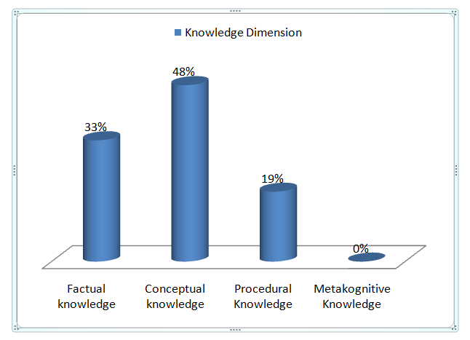
Fig. 1. Availability of content complexity
The analysis of the availability of content complexity in teacher learning tools obtained the highest average percentage of 48%, namely on conceptual knowledge, 33% on factual knowledge, 19% on procedural knowledge, and 0% on metacognitive knowledge. The level of cognitive processes in teacher learning tools is also dominated by the ability to remember, understand and apply only. In contrast, the ability to analyze, evaluate and create tends to be invisible. The results of the analysis of the availability of Cognitive processes on teacher learning devices can be seen in Figure 2.
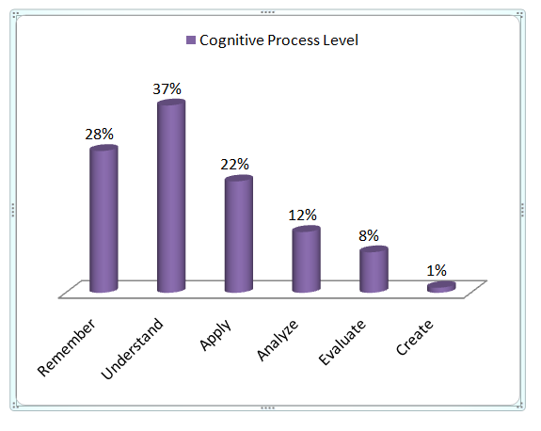
Fig. 2. Cognitive process availability

The results of the analysis of the availability of cognitive processes in Physics teacher learning tools are still dominated by the ability to remember 20%, the ability to understand 37%, the ability to apply 22%, the ability to analyze 12%, the ability to evaluate 8%, and the ability to create 1%. The results of this study are almost in line with Amali Putra's 2015 research at Padang City Public High Schools, which concluded that the quality of student competency achievement in physics learning at Padang City High Schools was still low, in terms of the complexity of the content and the level of cognitive processes in Physics learning content because some Most of them are still at levels C1, C2, C3, while for levels C4, C5, C6 are still very few and tend not to appear [2]. In addition, the scientific approach in the lesson plans used by teachers has not been appropriately accommodated. In practice, students are not used to actively asking or answering questions, especially questions that use the words why, why, and how. The results of the analysis of the availability of the scientific approach on teacher learning tools can be seen in Figure 3.
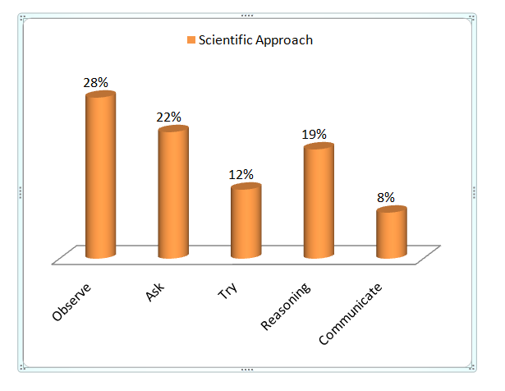
Fig. 3. Availability of scientific approach
Based on the results of the analysis of the availability of the scientific approach in teacher learning tools, the highest average percentage was 28%, namely in observing activities, 22% in questioning activities, 12% in trying activities, 19% in reasoning activities, and 8% in reasoning activities communicate. The complexity of the content and the level of cognitive processes presented by the teacher is not optimal and proportional to the analysis results. It shows that the teacher is not too familiar with integrating the dimensions of knowledge and cognitive processes in the content of Physics lessons, especially Dynamic Fluids. To create quality learning, of course, it takes a good design from the teacher so that students' thinking skills develop well and the knowledge of students increases.
One form of design in the Design Phase is to design the steps of need analysis, content complexity and cognitive process levels in Dynamic Fluids material to produce a need analysis model as a solution to the problems found in the field starting from: First, Basic Competency (BC) analysis in Core Competencies (CC) which produce learning topics and sub-topics; Second, the Basic Competence (BC) analysis produces Competency Achievement Indicators (CAI). The indicator consists of two indicators, namely the Competency Achievement Indicator which is known as the learning indicator and the Assessment Indicator which is used in compiling the grid and writing questions known as the question indicator [10] which is formulated using Operational Verbs (VO). VO is a verb whose achievement can be measured, changes in behavior or actions can be observed, can be tested and used to formulate indicators and learning objectives [11]. Examples of the application of Operational Verbs in designing evaluation questions based on the knowledge dimension are:

- Factual Knowledge: Sequence the activity steps to determine the relationship between the diameter of the leak hole and the velocity of the fluid (analyze).
- Conceptual Knowledge: Examine why airplanes and helicopters are designed differently, even though they are both used as air transportation (evaluate).
- Procedural Knowledge: Calculate the furthest horizontal distance from the perforated tank using tools and materials available in the Laboratory (apply)
- Metacognitive Knowledge: Realize a simple tool by applying Bernoulli's principle (creating).

Third, analysis of Competency Achievement Indicators (CAI) to produce Learning Objectives (LO). Learning objectives are formulated using the principles of A(Audience), B(Behavior), C(Condition), and D(Degree) + K (Knowledge). Audience is a learning target, namely students, Behavior is a cognitive process or student activity in learning, Condition is a condition created by educators for students in the learning process, Degree is a comparison of conditions before and after learning and Knowledge is knowledge about the competencies to be achieved . These five components must be in the formulation of learning objectives for each Basic Competency in order to create a quality learning process and make learning more meaningful [12]. Examples of the application of the ABCD+K principle in formulating learning objectives are:

- Given the concept of SI and the cgs system, students are able to recognize quantities related to dynamic fluids (symbols, units and dimensions) correctly.
- Given the relevant phenomena, students are able to identify the general characteristics of dynamic fluids and ideal fluids correctly.

Fourth, the analysis of Learning Objectives (LO) to generate content complexity includes the dimensions of factual, conceptual, procedural and metacognitive knowledge. Examples in dynamic fluid content are:

Factual Knowledge | : | The flow of river water when passing through a wide river gap its speed is slow but after passing through a narrow river gap its speed becomes fast.
Conceptual knowledge | : | Compressible fluid is a fluid whose volume or density changes when it is compressed (compressed)
Procedural knowledge | : | The experimental work step determines the relationship between the height of the tank leak hole and the distance the fluid falls from the leak hole
Metacognitive Knowledge | : | Strategies to solve problems using the Bernoulli’s equation

Fifth, the analysis of Learning Objectives (LO) to produce evaluation instruments includes the cognitive process level. Examples of dynamic fluid evaluation questions are:

The following experiment is one way to strengthen the understanding of Bernoulli's principle on tank leakage. The tool used is a tank design made of hollowed out paralon, equipped with a meter scale on the paralon wall and on the floor as shown in Figure 1. The experiment was carried out by filling it with water. When allowed to leak, students take pictures of the scale of the water drop (a) and other students take pictures of the horizontal direction of water jets (s) simultaneously, with the same signal seven times. The data is processed and graphed with (a) as the X axis and (s) as the Y axis as shown in Figure 2. The conclusion of the experiment is....
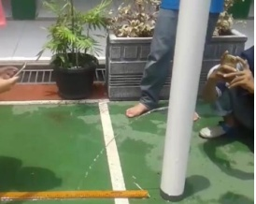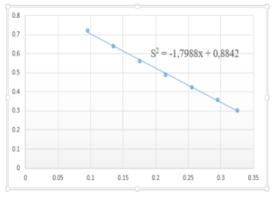
Fig. 1 Fig. 2

Further need analysis steps can be seen in Figure 4.
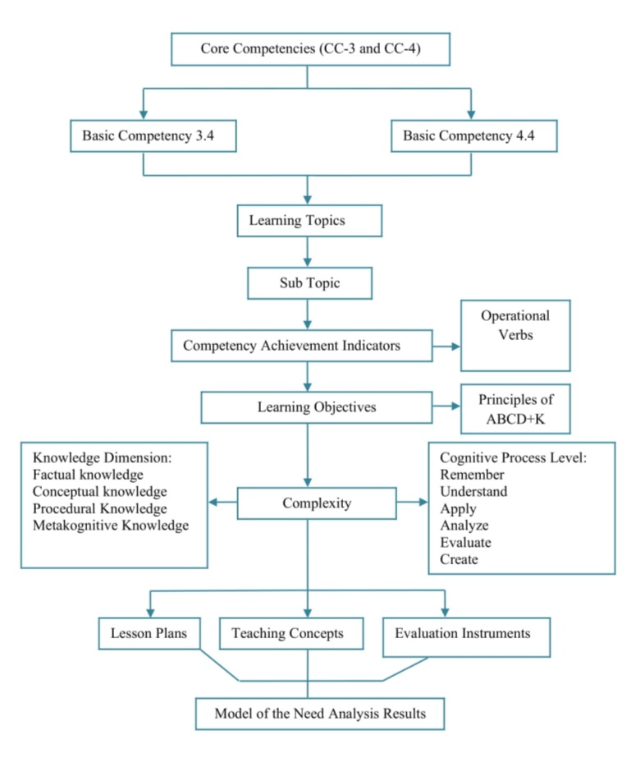
Fig. 4. Need analysis steps
In the realization/construction phase, the model resulting from the need analysis is outlined in the design of the learning device. Learning devices are tools and materials used by educators in learning activities[13]. The model resulting from the need analysis as outlined in the design of learning tools consists of several components, namely: 1) Competency Achievement Indicators; 2) Learning Objectives; 3) Learning Implementation Plan; 4) Teaching Concepts; 5) Evaluation Instrument. The learning tools were developed based on the analysis of Permendikbud No. 22 of 2016, the Ministry of Education and Culture in 2017, and the Ministry of National Education in 2008. Then proceed with the test, evaluation, and revision phase (trial, evaluation, and revision), where the learning tools are validated by Lecturers and Teachers using validation instruments prepared previously. The results of the assessment of the validation of the RPP instrument are 87.78%, the Teaching Materials instrument is 87.78%, and the evaluation instrument is 87.78%, with the overall decision of the validation instrument components of each device meeting the very valid criteria. According to the validator's assessment, it is declared feasible to be used for trial after revision. Then, it was continued with the validation of learning tools which included several aspects, namely aspects of content feasibility, linguistic aspects, graphic aspects and presentation aspects. Based on the validation results from the Lecturer, the final results of RPP validation are 88.03%, Teaching Materials are 88.74%, and evaluation instruments are 84.2% with the decision that the overall components of the learning device validation instrument meet the very valid criteria and are declared eligible to be used for testing. try. While the validation results from the Physics teacher, the final results of RPP validation are 93%, teaching materials are 88.24%, and evaluation instruments are 95.6% with the overall decision that the components of the learning device validation instrument meet the very valid criteria and are declared suitable for testing.

CONCLUSION

Based on the data analysis that has been carried out, this study concludes that the availability of content complexity in the learning tools of Physics teachers in the Mentawai Islands Regency is still dominated by conceptual knowledge and factual knowledge. In contrast, procedural knowledge and metacognitive knowledge tend to be invisible. Likewise, the availability of cognitive processes in Physics teacher learning tools is still dominated by the ability to remember, understand, and apply. In contrast, the ability to analyze, evaluate, and create skills also tends to be invisible. In addition, the availability of a scientific approach in physics teacher learning tools is also not optimal.

This study recommends that it is necessary to design a model of the need analysis results in high school physics learning tools in the Mentawai Islands Regency. The results of the need analysis model are outlined in the design of learning devices in the form of lesson plans, teaching concepts, and evaluation instruments on Dynamic Fluids concept. The results of the validity of learning tools include content feasibility, linguistic aspects, graphic aspects, and presentation aspects, so the final results of RPP validation are 90,5%, teaching concepts are 88,49%, and evaluation instruments are 89,9%. Thus, it can be concluded that the model-oriented Physics learning device resulting from the need analysis of Dynamic Fluids concept for class XI high school meets the very valid criteria and is suitable for use in physics lesson for class XI high school.

REFERENCES
- Irawati, I. 2012. Metode analogi dan analogi penghubung (bridging analogy) dalampembelajaran fisika. Jurnal pendidikan.
- Putra, Amali, 2015. Pencapaian Kompetensi Siswa Dalam Pelajaran Fisika Ditinjau Dari Kompleksitas Konten Dan Tingkatan Proses Kognitif Pada SMA Negeri Di Kota Padang :Eksakta Vol. 1 Tahun XVI Februari 2015. Padang : FMIPA UNP.
- Anderson, L.W., dan Krathwohl, D.R. 2001. A Taxonomy For Learning, Teaching, And Assesing; A Revision Of Bloom's Taxonomy Of Education Objectives. New York: Addison Wesley.
- Kemendikbud. 2017. Model Pengembangan RPP. Jakarta: Direktorat Pembinaan Sekolah Menegah Atas Direktorat Jenderal Pendidikan Dasar dan Menengah.
- Gary.R,Morrison,StevenM,Ross,JerroldEKemp. 2001. DesigningEffectiveInstruction,Seventh EditionJohnWileyandSons. USA: w i l e y.
- Sugiyono. 2015. Metode Penelitian & Pengembangan (Research and Development/ R&D). Bandung: Alfabeta.
- Sugiyono. 2017. Metode Penelitian & Pengembangan (Research and Development/ R&D). Bandung: Alfabeta.
- Plomp, Tj. 1997. Educational Design: Introduction. From Tjeerd Plomp (eds). Educational & Training System Design: Introduction. Design of Education and Training (in Dutch).Utrecht (the Netherlands): Lemma. Netherland.Faculty of Educational Science and Technology, University of Twente.
- Riduwan. 2015. Skala Pengukuran Variabel-Variabel Penelitian. Bandung: Alfabeta.
- Hartini, Sri. 2015. Pengembangan Indikator Dalam Upaya Mencapai Kompetensi Dasar Bahasa Indonesia di Sekolah Menengah Atas Kabupaten Karanganyar Jawa Tengah. Karanganyar : Disdikpora Kabupaten karanganyar.
- Depdiknas. 2003. UU No. 20 Tahun 2003 Tentang Sistem Pendidikan Nasional. Jakarta: Depdiknas.
- Putra, Amali. 2017. Buku Ajar Perencanaan Pembelajaran Fisika. Padang: Sukabina Press.
- Trianto. 2010. Model Pembelajaran Terpadu. Jakarta: Bumi Aksara.

