ANALYSIS INDICATOR OF CRITICAL THINKING SKILLS IN PHYSICS TEXTBOOKS FOR SENIOR HIGH SCHOOL GRADE X SEMESTER 1 IN PADANG
Intan Purnama Yani¹*, Ratnawulan¹, Riri Jonuarti¹, Fanny Rahmatina Rahim¹
^{,1}Departmentoofy Physics,dFacultyaofdMathematicsyandtNaturalfScience,srUniversitashNegerigPadangh
Corresponding author. E-mail: intanpurnamayani78@gmail.comj
ABSTRACT
Thishresearchgaimsktoidetermine thegavailability ofkcritical thinking skills indicators inhlphysics textbooks forjclassxXksemester one highkschoolbphysics used in Padang. Thisbresearchfiscdescriptive research withfagqualitativebapproach. Thecpopulationjof the dataxinjthishstudylwas alliphysicshtextbooksvforiClassaX semestero1ousedxinuseniorthighqschoolskinoPadang. Thejsample ofhthis research is the three physics textbooks that are most widely used in senior highnschoolsjinrtheucityroflPadang.hThekdatalinythisrstudyiwerejtakenl usingfcritical thinking indicator analysisjinstrumentshin physics textbooks for class X SMA with data collection techniques through documentation studies. Basedyonlthegresultsgofkthekanalysis of criticaljthinkingjskillsk indicators in the physics textbook for class X semester 1, it was found that the physics textbook written by Marthen Kanginan published by Erlangga has the highest level of availability ofkcriticalothinkingpskillsj indicators withjakpercentagel of 70.4% in the available category. In contrast, physics textbooks written by Aris Prasetyo Nugroho et al. and published by Mediatama have the lowest availability ofpcriticalothinking skills indicators withlaipercentageiofl31% with the less available category.
Keywords: Critical thinking skills, physics textbook, textbook analysis
This is an open-access article distributed under the Creative Commons 4.0 Attribution License, which permits unrestricted use, distribution, and reproduction in any medium, provided the original work is properly cited. ©2019 by author and Universitas Negeri Padang.

INTRODUCTION
Science and technology are developing very rapidly in the 21st century. In the 21stpcentury,mstudents arek facediwithpthe eralofpglobalization, which requireskadequatekskills. Students are required to be able to master information technology in order to be able to adapt to the development of an increasingly advanced era. Students' skills in skills mark success in global competition as communicators, creators, critical thinkers, and collaborators. The rapid development of science and technology can have a significant influence on people's lives, including the worldlofpeducation.
Educationkis a verypimportant benchmark inolife or a reference for the quality of human resources. Through education, students are trained to have the skills to use technology and information media in order to adapt to the development of an increasingly advanced era. In order to compete with the advancement of education and the times, students are required to master various skills, one of which is the 6C skillsp(communication,mcollaboration,lcriticalpthinkingpandoproblempsolving, creativitypandpinnovation, computational, and compassion).
6C skillsocan be achieved if learning in schools is student-centered, has innovation, teamwork, empowers metacognitive and contextual learning. The government has made efforts to achieve these 6C skills, one of which is by developing a curriculum. Currently, the curriculum used is 2013 revised 2017 curriculum. The 2017 revised 2013 curriculum contains several important points, such as strengthening character education and HOTS (HighpOrderpThinkingoSkills).pHOTSpis apthinking skillothatputilizes reasoning skills, critical thinking to process information systematically^{[1]}. HOTS and 6C skills are related to each other. HOTS achievement indicators include problem-solving, criticalpthinkinguskills, creativepthinkingpskills, andpdecision-making skills. This HOTS achievement indicator shows that it is related to 6C skills, which both require students to have criticalpthinkingkskills.
Criticalkthinking is onepofhthedtoolsgusedtin everyday lifepto survive ^{[2]}. Critical thinking is also an activity of evaluating, considering the conclusions to be drawn in determining the supporting factors for making a decision ^{[3]}. Critical thinking is important given to students to be equipped inpfacingpthepchallengespofpthep 21stpcenturylin the era of globalization and competing inpthe worlduofpwork. Criticaltthinkingpskillstinplearning can be developed with several criticalkthinking indicators, includingpinterpretation,lanalysis,pevaluation,pinference,pexplanation, andpself-regulation. Interpretation is a skill in understandingpandiexpressingpthepmeaningpof the problem. The analysis is a skill in identifying and inferring relationships between statements, questions, concepts, descriptions, or other forms. Evaluation is a skill in accessing the credibility of a statement/representation and being able to logically access the relationship between statements, descriptions, questions, and concepts. The inference is a skill in identifying and obtaining thepelementspneeded topconclude. The explanationpis a skill in establishing and providing logical reasons based on the results obtained. At the same time, self-regulationpispapskillptopmonitortone'spcognitivepactivity ^{[4]}. The inference is a skill in identifying and obtaining the elements needed to conclude. The explanation is a skill in establishing and providing logical reasons based on the results obtained. At the same time, self-regulationpispa skillitopmonitorpone'spcognitive activity ^{[4]}. The inference is a skill in identifying and obtaining thepelements neededptopconclude. The explanation ista skill in establishing and providing logicalpreasonsrbasedrondthe resultspobtained. At the same time, self-regulationtispapskillptotmonitor one'srcognitive activity ^{[4]}.
Critical thinking skills will be achieved if the 2013 curriculum is implemented well. In fact, in schools, the 2013 curriculum has notpbeentimplemented optimally. Teachers inptheplearning process still usepthe lecture method so that students' activeness has not been seen, and the learning process is also not supported by learning resources that can train students to think critically. Students'pcriticalpthinkingpskillspinplearning will have an impact on student learning outcomes. This can be seen basedponpthepresults ofpthe analysistofpthe first-semester physics exam forpclasspX in hightschool in Padang. Thetresults of the analysis of the physics semester exam for classpXpsemestery1 in thetcity oftPadang stated that therpercentage of students who answered the HOTS questions correctly was still categorized as low,
Topimprovepthehcriticalpthinkingtskillslofpstudentstat school, learning should be supported by teaching materials. Teaching materials that are often used in the learning process are textbooks. Textbooks contain descriptions of materials regarding certain subjects, which are arranged systematically basedponpcertainygoals, learningtorientation, andpstudentpdevelopment ^{[5]}. The textbook is a written work in the form of a book in a particular field, which teachers and students use in thepteachingpandplearningtprocess ^{[6]}. Thepfunctionpof textbooks forpstudents is usedtaspa reference in: (1) preparing themselves before learning activities in class, (2) interacting in the learning process in class, (3) working on tasks given by the teacher, and (4) prepare for a test or exam. As for teachers, textbooks serve as: (1) aireferencepinkmakingplearningpdesigns, (2) preparingPother learningpresources, (3) developingycontextualrlearning materials, (4) giving assignments, andp(5) compilingpmaterials. Evaluationp ^{[7]}.
There are four characteristics and functions of textbooks for students, namely: (1) motivating students to learn; (2) representing the subject of knowledge in the form of a systematic change of presentation, providing an accurate view of the nature of science and representing a picture of a phenomenon; (3) guide students' learning by identifying prior knowledge, providing explanations and activities to contain the knowledge and changing concepts, providing practice and application opportunities, including self-assessment; (4) guiding students to obtain learning strategies by stimulating students' metacognition and the use of learning strategies ^{[8]}. For teachers there are 2 characteristics and functions of textbooks, namely: (1) assisting teacher planning by describing relevant content or subject knowledge, improve pedagogical knowledge relevant to the content being taught; (2) assisting the development of the teaching profession by developing content or subject knowledge and seeing the nature of teacher science, and can develop pedagogical knowledge, beliefs and attitudes of teachers ^{[8]}. The National Education Standards Agency (BNSP) has set standards for the feasibility of the textbooks used, including the feasibility of content, presentation, language, and graphics ^{[9]}.
Because many publishers have widely circulated physics textbooks, it is necessary to study whether these books already contain indicators of critical thinking skills. Physics textbooks that already contain critical thinking skills are textbooks that contain critical thinking indicators. Therefore, it is necessary to conduct an analysis of the presentation of physics textbooks for class X semester one related to critical thinking skills, to obtain relevant textbooks and already contain indicators of critical thinking skills.

METHOD
Thisptypetofpresearch is a descriptivePresearch and uses arqualitativetapproach. Descriptivetresearch is the most basic form of research^{[10]}. Ajqualitativekapproachpisyresearchrthatyproducestdescriptivekdatapinttheiform of written or spoken wordspfromypeopleiandtobserved behavior ^{[11]}. This study attempts to report the state of the object under study as it is, namely analyzing critical thinking indicators in physics textbooks for class X semester 1.
The population inpthisystudyrwererallwphysicsptextbooksyforrclasshX semesterfone usedwin Indonesia and circulated intPadang. Thegsamplingktechniquehused ispnon-probabilityrsampling, which is purposiveisampling, meaning that thepsampling technique uses certain considerations. The samples inythiststudypwere three physicsftextbookslforjclass X semestertone curriculum 2013 revision 2017. The books that were used as samples were BukuiFisikayuntukrSMA/MAjKelasiX by MartheneKanginan with codebook A, BukugPesertajdidiktFisikafuntukjSMA/MAfKelasrX by Pujianto, et al. with book code B, Buku Siswa FisikapPeminatanoMatematikaydanfIlmu-ilmurAlamtuntukwSMA/MAhKelaskX by ArislPrasetyo Nugroho, et al with book code C.
The instrument sheet is basedkonpthe indicators ofpcriticaltthinkingkskillspfrom Facione. Thepanalysis sheet is made for each subject of physics in SMA class X semester one by determining the indicators of critical thinking skills and then defining each of these skill indicators into instrument items. Each item of the instrument is given a choice of "yes" and "no." If therepispanpindicatorlofpcritical thinking skills in theitextbook, it is given a checkmark, and if there is no indicatorpofycriticaltthinkingrskills inptheytextbook for physics lessons, a tick is given to that condition.
The result of the validity as a whole are looking for using moment kappa cohen formula. The overall validity value is sought using the equation for the total average value of all criteria:
$\text{k}=\frac{Po-Pe}{1-Pe}$ (1)
Information :
k = kappa moment that shows product validity
Po = observed agreement
Pe = expected agreement
The validity category of the instrument made cansbepseenpinhTableu1.
Tableh1. Instrument Validity Categoryo
Mark | Criteria
0.81o–o1.0 | AlmostlPerfectg
0.61p– 0.80p | Subtantial
0.41k– 0.60m | Moderatea
0.21k– 0.40p | Fairy
0p – 0.20l | Slights
^{[12]}
This research is divided into three stageso, namelypthedpreparationpstage, implementationkstage,pand completion stage. At thetpreparatorylstage, several things must be done, namely: preparing a research design, determining the subject and object of research, compiling a draft instrument, testing the validity of the instrument to three validators, namely Drs. Amali Putra, M.Pd with a validation value of 0.90 in almost perfect category, Silvi Yulia Sari, M.Pd with a validation value of 0.90 in the almost perfect category, and Putri Dwi Sundari, M.Pd with a validation value of 0.78 with subtantial categories, analyzing the results of the instrument validity test, and improving the instrument. The second stage is the implementation stage by analyzing the three physics textbooks using an analytical instrument for critical thinking skills indicators. The third stage is the completion stage, namely, processing the research results, drawing conclusions from the research, and reporting the results.
The data collection technique of this research is through a documentation study. Thiskdocumentation study isgcarriedhoutubylcollecting documents or datagneeded in the researchrproblem, then examined in depth. In this study, the document was used in the form of a written document, namely a physics textbook for class X semester 1. The dataganalysisktechniquedusedjinrthisfstudydwasla contentpanalysis technique from the written data. Content analysis is research conducted systematically on records or documents as data sources. The steps taken in the data analysis technique are as follows:
- Summing up the indicators oflcriticalpthinkinggskillsgin the analyzed textbooks.
- Calculating thehpercentagegof presentations of textbooks for SMA class X semester 1, which already contains indicators oflcriticalgthinkingfskillshin each textbook whichkis analyzed bypthe formula:
$\frac{\sum{Indicator of crictical thinking skill found }}{\sum{\text{Total of instrument items}}}x\text{100\%}$ (2)
- Determine the average percentagepofrthe proportionfofleach category ofpcriticalpthinkingdskills from all analyzed books
- Determine the criteria for presenting the physics textbook for class X semester one related to critical thinking indicators, which have been modified in Table 2.

Table 2. Textbook Presentation Criteria
Percentage Interval | Criteria
81 - 100 | Very Available
61-80 | Available
41-60 | Enough Available
21-40 | Less Available
0-20 | Not available
^{[13]}
- Draw conclusions basedponkthe analysis resultskofgcriticalfthinkingkskills indicators inkphysics textbooks for class X semester 1.

RESULTS ANDkDISCUSSIONk
Theltextbooks used in thisfstudygwere three samples of textbooks labeled book A, book B, and book C. The analysis was carried out tokdeterminefthe availability ofgcriticalrthinkingrskills indicators inleach material. Thehresultshofltheganalysisdof indicatorslofpcriticalkthinkingrskills in each physics textbook for class X semester one arehshowndindtabled3 below.
Tablep3. The resultsfofhthe analysis ofpindicatorstofhcriticalfthinkingjskills inlphysicsgtextbooksdforfclassgX hightschoolksemester 1
No | Critical Thinking Skills Indicator | Book |  |  | Average(%)
 |  | A(%) | B(%) | C(%)
1. | Interpretation | 41.7 | 41.7 | 20.8 | 34.7
2. | Analysis | 87.5 | 79.2 | 58.3 | 75
3. | Evaluation | 79.2 | 20.8 | 29.2 | 43.1
4. | Inference | 83.3 | 50 | 72.2 | 68.5
5. | Explanation | 72.2 | 39 | 5.5 | 39
6. | Self-regulation | 58.3 | 16.7 | 0 | 25
 | Average (%) | 70.4 | 41.2 | 31

Tablek3 shows thepresultsgof the analysis of criticalkthinkinghskillsdindicators in high school physics textbookskforfclassfXksemesterg1 from book A, book B, and book C. Basedlongthefresultshofkthedanalysis in table 4, itkisdfoundfthatrthe percentage of criticalfthinkingdskills indicators in each textbook different. Book A is a book with the highest criticalhthinkingdskills indicator level withkadpercentagegof 70.4% in the available category. In book A, the most commonly found aspect is the analytical aspect, with 87.5%. The least found is the interpretation aspect. Then book B with an indicator level oflcriticalgthinkingfskills of 41.2% withga good categoryhavailable. Aspects ofhcriticalfthinkingdskillsgindicators mostly found inkbook Blare analytical aspects with 79.2%. The least found aspects are self-regulation aspects, with a percentage of 16.7%—finally, book C with a critical thinking skill level of 31% with a less available categoryr. Thekindicator aspecthofhcriticalhthinkingkskillsjthat are most often found in book C is the inference aspect, with 72.2%. The aspect that is not found in book C is the self-regulation aspect.
The following is a discussion of the research results based on the primary material analyzed.
1. ThepNaturefof Physics
Thekanalysis ofkcriticalfthinking skills indicators on thejmaterial, the nature of physics, and work safety in the laboratory in the physics textbook for class X semester 1 of high school physics in books A, B, and C can be seen in book A, B, and C Figureh1.
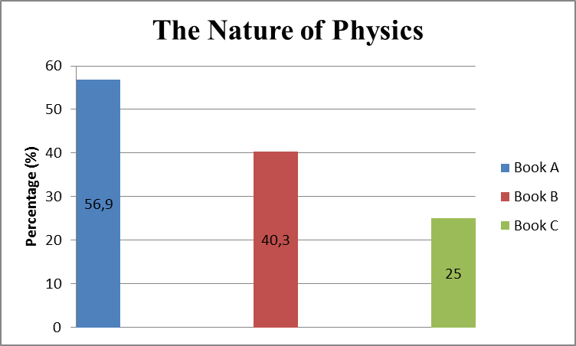
Figurek1. Percentage ofkcriticalhthinkingfskillshindicators on theknature of physics and work safety in the laboratory
Figure 1 shows thekpercentagekoflresults obtained from themanalysis ofkcriticaljthinkingfskillsdindicators on the nature of physics and works safety in the laboratory. Book A's percentage is 56.9% which is categorized as available; book B is 40.3% with the less available category, and book C is 25% with the less available category. Basedhonlthehresultskofgthektextbook kanalysis, it was foundhthatpthelaverage percentage ofkthe material on the nature of physical science and work safety in the laboratory was 40.7%, with the category reasonably available.
- Measurement of Physical Quantities
The resultskofkthedanalysishofdcritical thinking skills indicators on the material for measuring physical quantities contained in the Physics textbooks for Class X 1st semester in book A, book B, and book C can be seenfin Figureg2.
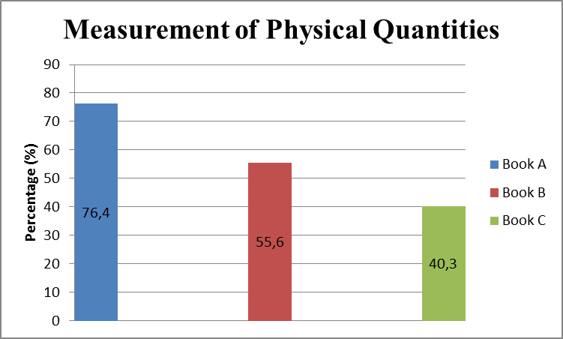
Figure 2. Percentage of indicators of criticalhthinkingpskills on material measuring physical quantities
Figurek2hshowsfthefpercentage ofkthe analysis resultskof criticalpthinking skills indicators onkthe measurement of physical quantities. In book A, the percentage of book A is 76.4% which is categorized as available, and book B is 55.6% with sufficient available category, and book C is 40.3% with moderately available category. Basedkon thejresultskofkthe textbooklanalysis, it was foundgthatpthe average percentage ofkthe material on the nature of physical science and work safety in the laboratory was 57.4%, with the category quite available.

- Vector
The analysispofkcriticaljthinkingfskills indicators onjthe material, the naturekof physics, and work safety in the laboratory in the physics textbook for Class X semester 1 in book A, book B, and book C canpbekseenpinpFigure 3.
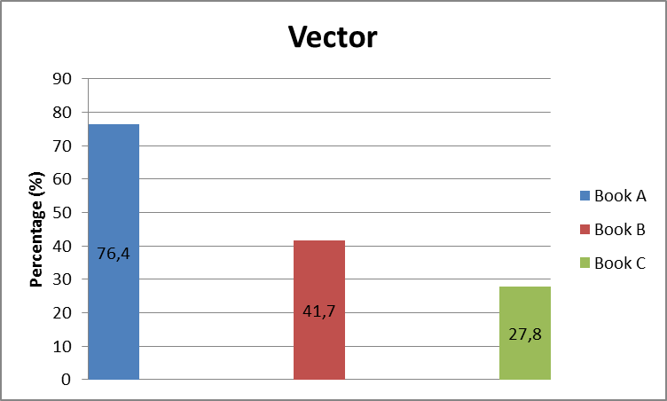
Figurek3. Percentage ofhcriticalgthinkingfskillspindicators on vector material
Figure 3 shows the percentage ofkthepanalysishresults ofpcriticalkthinkingpskillshindicatorskon the measurement ofpphysical quantities. In book A, there is a percentage of 76.4%, which is categorized as available, book B is 41.7% with moderately available category, and book C is 27.8% with less available category. Basedponjthehresultshofgthedanalysis from thektextbook, ithwas found thatkthe average percentage ofkthe material on theknature of physics and work safety in the laboratory was 48.6%, with the category reasonably available.
- Straight Motion
The analysisloflcriticalpthinkingkskills indicators onlthe material, the nature ofkphysics, and work safety in the laboratory in the physics textbook for class X semester 1 of high school physics in books A, B, and C can be seen in book A, B, and C Figure 4.
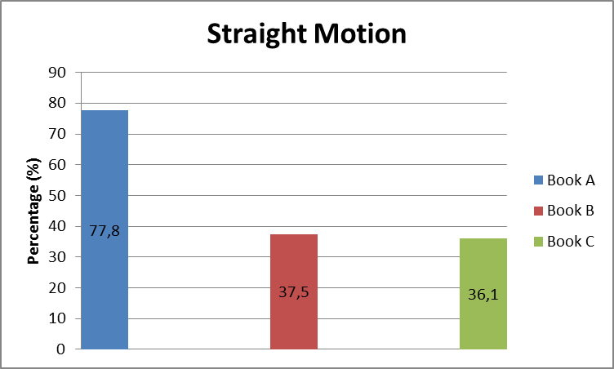
Figure 4. Percentage of indicatorskoffcriticalgthinkingdskillsgin straight motion material
Figure 4 shows the percentage ofltheganalysis results ofpcriticalpthinkingpskillskindicators on the measurementgof physical quantities. In book A, the percentage of book A is 77.8% which is categorized as available, book B is 37.5% in the less available category, and book C is 36.1% in the less available category. Basedponkthedresultsdofhthe textbook hanalysis, itk was foundhthatkthedaverage percentage ofhthe material on the nature of physical science and work safety in the laboratory was 50.5%, with the category reasonably available.

- Parabolic Motion
The analysishofgcriticalgthinkingjskills indicators onhthe material, the naturehof physics, and work safety in the laboratory in the physics textbook for Class X semester 1 in book A, book B, and book C cankbehseen inhFigurek5.
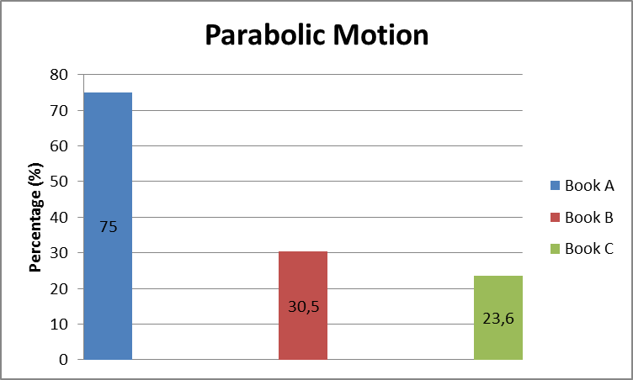
Figureh6. Percentage ofpcriticalgthinking skill indicatorskon parabolic motion material
Figure 6 shows the percentage ofkthepanalysis results ofgcriticalfthinkingpskillspindicators on the measurement ofkphysical quantities. In book A, there is a percentage of 75% categorized as available. Book B is 30.5% in the less available category, and book C is 23.6% in the less available category. Basedkonfthelresultspof thehtextbookjanalysis, it was foundythatjthepaverage percentage ofpthe material on the nature of physical science and work safety in the laboratory was 43%, with the category reasonably available.
- Circular Motion
The analysispofhcriticalgthinkinghskills indicators onpthe material, the nature ofhphysics, and work safety in the laboratory in the physics textbook for Class X semester 1 in book A, book B, and book C can be seen in Figure 7.
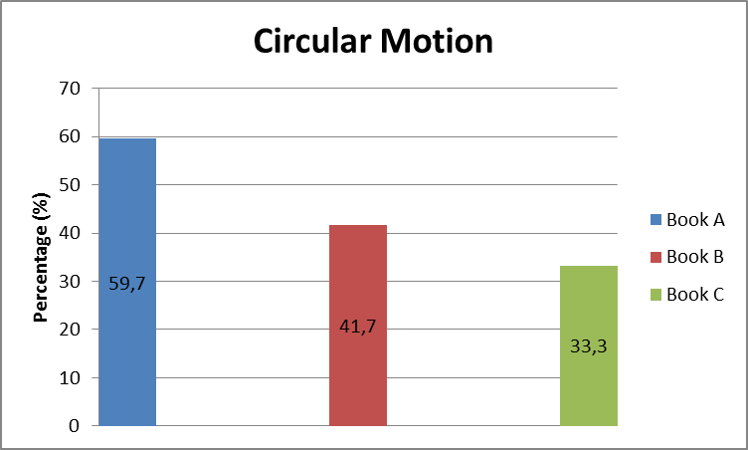
Figureo7. Percentage of indicatorskofhcriticalhthinkinghskillskon circular motion material
Figureo7 shows thehpercentagegofdtheganalysis resultsjofkcriticalgthinkinghskills indicators on the measurement of physical quantities. In book A, there is a percentage of 59.7%, which is categorized as reasonably available, book B is 41.7% with sufficient available category, and book C is 33.3% with less available category. Basedkonkthefresultsyofpthe textbookpanalysis, it was foundpthatythefaverage percentage ofythe material on the nature of physical science and work safety in the laboratory was 44.9%, with the category reasonably available.

CONCLUSION
The textbook for high school physics class X semester 1, which has the highest percentage of critical thinking skills indicators, is BukupFisikahuntukfSMA/MApKelaspX by Marthengkanginan with code (book A) with an average percentage of 70.4%, which is categorized as available critical thinking skills indicators, and physics textbooks for class X semester one which has the lowest percentage of critical thinking skills indicators are Buku Siswa FisikapPeminatangMatematikafdangIlmu-ilmukAlampuntukgSMA/MAkKelas X by ArispPrasetyo Nugroho et.al with the code (book C) with a percentage of 31% which is categorized as lacking critical thinking skills indicators.

ACKNOWLEDGMENT

Many thanks to the DepartmentpofkPhysics, FacultyooflMathematicsiandpNaturalkSciences, Universitasx NegerivPadang, and all those who have supported and motivated the author and for the opportunity given to the author to complete this article and be published.

REFERENCES
- Rahmawati, d. 2014. Analisis Keterampilan Berpikir Kritis Siswa Pada Pembelajaran Fisika Dengan PendekatanStarter Eksperimen. Jurnal Universitas Muhammadiyah Purworejo, Vol. 5 No.1.

- Chukwuyenum, A. 2013. Impact of Critical thinking on Performance in Mathematics among Senior Secondary School Students in Lagos State. IOSR Journal of Research & Method in Education (IOSR-JRME), e-ISSN: 2320–7388,p-ISSN: 2320–737X Volume 3, Issue 5 (Nov. –Dec. 2013), PP 18-25.

- Potter & Perry. 2005. Buku Ajar Fundamental Keperawatan Konsep, Proses, dan Praktik. Jakarta: Edisi 4 volume.EGC.

- Facione, P. A. 2011. Critical Thinking: What It Is and Why It Counts. Insight Assessment.

- Muslich, M. 2010. Text Book Writing. Yogyakarta: Ar-Ruzz Media

- Anisah, A. d. 2016. Pengaruh Penggunaan Buku Teks Pelajaran dan Internet sebagai Sumber Belajar terhadap Hasil Belajar Siswa pada Pembelajaran IPS. JURNAL LOGIKA, Vol XVIII, No 3.

- Sitepu. 2012. Penulisan Buku Teks Pelajaran. Jakarta: Rosda Karya

- Swanepoel. 2010. The Assessment of the Quality of Science Education Textbooks:. Dissertation: University of South Africa

- Departemen Pendidikan Nasional. 2008. Pengembangan Bahan Ajar dan Media. Jakarta: Departemen Pendidikan Nasional.
- Sukmadinata, S. 2009. Metode Penelitian Pendidikan. Bandung: Remaja Rosdakarya Offset.
- Margono. 2010. Metodologi Penelitian Pendidikan. Jakarta: PT. Asdi Mahasatya.
- Boslaugh, Sarah, and Paul Andrew Watters. 2008. Statistics In A Nutshell:A Desktop Quick Reference. Sebastopol, CA : O’Reilly Media
- Riduwan. 2005. Belajar Mudah Penelitian untuk Guru-Karyawan dan Peneliti Pemula. Bandung: Alfabeta

