THE EFFECT OF HOTS-ORIENTED WORKSHEETS ON HEAT AND KINETIC THEORY OF GASES ON STUDENTS' CRITICAL AND CREATIVE THINKING ABILITY WITH GUIDED INQUIRY MODEL IN GRADE XI SMA AL-ISTIQAMAH PASAMAN BARAT
Hilmi Rizki Anjani¹⁾, Silvi Yulia Sari²⁾, Yenni Darvina²⁾, Letmi Dwiridal²⁾
¹ Physics Education Student, FMIPA Universitas Negeri Padang
² Lecturer at the Department of Physics, Universitas Negeri Padang
Corresponding author. Email: hilmirizkianjani01@gmail.com
ABSTRACT
This research aims to see how effect of HOTS-oriented worksheets on heat and kinetic theory of gases on students' critical and creative thinking ability with guided inquiry model in grade XI SMA Al-Istiqamah Pasaman Barat. The type of research used is quasi-experimental. In this research, two classes were used as the sample class, where class XI IPA 1 was the experimental class and class XI IPA 2 was the control class. The difference in treatment between the two classes is that in the experimental class the product given is HOTS-oriented worksheets while in the control class the product given is conventional student worksheets in schools. For the treatment equation in the two classes, the learning model used is the guided inquiry learning model. The technique for collecting data was a written test with HOTS oriented questions. Critical and creative thinking skills are the basis for assessment in this research. The results of the study after being given treatment in both classes found that the highest skill score between the two classes was the value obtained by the experimental class. Based on the research that has been done, it is concluded that after being given treatment to the sample class, there is an increase in students' critical and creative thinking skills for each indicator. The improvement of students' critical and creative thinking skills on each indicator got higher results in the experimental class than the control class.

Keywords : Critical and Thinking Skills, Guided Inquiry, HOTS
This is an open access article distributed under the Creative Commons 4.0 Attribution License, which permits unrestricted use, distribution, and reproduction in any medium, provided the original work is properly cited. ©2019 by author and Universitas Negeri Padang.

INTRODUCTION
21st century craftsmanship is the hottest thing in recent years. The responses given by each person differ from one another or can be said to vary. There are some of them who take this problem seriously, and some of them take this problem just plainly, and some of them don't even want to know about the problem. The absence of a response from the latter group that the authors are referring to is not necessarily a sign of ignorance of them, but it is most likely due to the lack of understanding they have of the skills intended for the 21st century.
Talking about education, we can actually interpret education as a process of learning that includes knowledge, skills, and habits of a group of people who have been passed down from generation to generation continuously through teaching, training, or research. To carry out an education, all process activities often occur under the guidance of others, but there is also the possibility that education is obtained independently. General education is divided into stages such as preschool, elementary school, junior high school, high school, and then university.
The teacher is the key actor in the learning. In this case the teacher has a very important and fundamental role in guiding, educating, directing students in every learning process. The teacher has a very important role because no matter how good the curriculum has been and the education system is, without the support of the competencies of a teacher, everything that has been designed will only be in vain. Conversely, with teachers who have competence, the curriculum and education system that are not good will be covered due to the competence of the teacher.
One of the factors for the success of learning is the existence of learning resources. Learning resources are everything that is around the learning activity environment that can functionally be used to help optimize learning outcomes. One of the learning resources is teaching materials. One of the teaching materials is the Student Worksheet. Worksheet are sheets containing material, summaries and instructions for implementing learning tasks that should be done by students. Worksheet can help teachers in the learning process according to the demands of the 2013 curriculum. The worksheets used are expected to build student understanding and can improve students' critical thinking and creative thinking skills in supporting physics learning..
The structure in the worksheets that is made must be in accordance with predetermined rules. It is intended that these worksheets can support the learning process in accordance with the demands of the 2013 curriculum. The general structure of the worksheets is as follows: Title, learning instructions, competence to be achieved, supporting information, tasks and work steps, assessment ^{[1]}. With the worksheet , it is expected to improve the existing abilities of students. However, the fact in the field is that the student worksheets that are still in school still lack an explanation of the material oriented to High Order Thinking Skills (HOTS). Meanwhile, HOTS skill is one of the skills that students must master in the 21st century.
Higher Order Thinking Skill (HOTS) is a high-level cognitive ability (thinking) which in the taxonomy of cognitive education objectives consists of the ability to analyze, evaluate, and create. High-order thinking skills can occur when a person associates newly received information with information that is already stored in his / her memory, then connects and / or rearranges and develops the information so that a goal or a solution to a situation that is difficult to solve is achieved ^{[2]}. Higher Order Thinking Skill (HOTS) has 4 indicators, namely problem solving, decision-making skills, critical thinking skills, and creative thinking skills ^{[3]}.
Based on the facts in the field, after conducting an interview with one of the physics teachers at SMA Al-Istiqamah Pasaman Barat that the lowest HOTS skill score was in class XI on heat material and kinetic gas theory. This is due to the fact that the heat material and the kinetic theory of gases are still abstract to be explained in plain view. In addition, the facts that reinforce the teacher's argument can be seen from the pretest results obtained by the students of SMA Al-Istiqamah Pasaman Barat on the heat material and the kinetic theory of gases, can be seen in Table 1 below:
Table 1. The Average Pretest Score of Sample Class in SMA Al-Istiqamah Pasaman Barat
No | Class | Heat Material | Gas Kinetic Theory Material
1 | XI IPA 1 | 28.811 | 39.216
2 | XI IPA 2 | 30.081 | 38.27

Based on Table 1, which has been described above, it can be seen that the student's ability to solve HOTS-oriented questions is still very low, because the value obtained is below 50% of the value that the student should get. This also strengthens researchers to conduct research this time, because researchers want to try to improve the HOTS skills of class XI students of SMA Al-Istiqamah Pasaman Barat.
To improve HOTS skills possessed by students, researchers try to provide solutions so that there is a significant increase in students' HOTS skills scores. In this research, HOTS skills are focused on only two skills, namely critical thinking skills and creative thinking skills. Each skill will also be focused into two sub-indicators for each skill. The sub-indicators used in critical thinking skills are elementary clrification and advanced clarification. Meanwhile, the sub-indicators used in creative thinking skills are fluency thinking and flexibilty thinking.
To get the expected skill value, the researcher provided a solution in the form of HOTS-oriented worksheets on heat material and the kinetic theory of gases that had previously been made by previous researchers, but these researchers had not examined the effect of the worksheets giving. In addition, researchers also provide solutions in the form of using the most effective learning model in this study, namely the guided inquiry model, due to the fact that the learning model used by the teacher is still monotonous.
Guided inquiry model is a series of learning activities that thoroughly involve students' ability to seek and investigate systematically, critically, and logically so that they can find their own knowledge, attitudes and skills as a form of behavior change. This is also in line with what was stated ^{[4]}. The general purpose of guided inquiry learning is to help students develop intellectual skills and other skills, such as asking questions and finding (looking for) answers that originate from their curiosity ^{[5]}. Therefore, the guided inquiry model is suitable to be a solution to the problems in this study. The steps of guided inquiry learning model are 1) orientation, 2) formulating problems, 3) formulating hypotheses, 4) collecting data, 5) testing hypotheses, 6) formulating conclusions ^{[6]}.
In this research, the method used is an experimental method which is closely related to the guided inquiry model used. The experimental method is an experiment to prove a certain question or hypothesis. Experiments can be carried out in a laboratory and can also be carried out outside the laboratory. Experimental work contains the meaning of learning to do, because it can be included in teaching and learning methods^{[7]}. The purpose of using the experimental method is 1) so that students are able to conclude the facts, information or data obtained, 2) train students to design, prepare, carry out and conduct experiments, 3) train students to use inductive thinking logic to draw conclusions from facts, information or data collected from experiments^{[8]}.
In this research, the class used as the sample class in this study was two classes, namely the experimental class and the control class. The difference in treatment between the two classes is that in the experimental class the product given is in the form of HOTS-oriented worksheets on heat material and gas kinetic theory, while in the control class the products given are conventional worksheets at school on heat material and gas kinetic theory. And the same treatment was given to both classes in the form of using the same model and method, namely the guided inquiry model and the experimental method.
This research was conducted with the aim of knowing whether there was any influence after being given treatment in the form of HOTS-oriented worksheets on heat material and kinetic gas theory on the value of critical and creative thinking skills of students of class XI SMA Al-Istiqamah.

METHOD
This type of research is quasi-experimental. The research design used was Quasi Experimental Design. The main characteristic of Quasi Experimental Design is the development of True Experimental Design, which has a control group but cannot fully function to control external variables that affect the implementation of the experiment^{[9]}.
Based on the explanation above, it can be concluded that Quasi Experimental Design is a type of research that has a control group and an experimental group, not randomly selected. Researchers used Quasi Experimental Design because in this study there were external variables that could not be controlled by the researcher. The population is all members of the research subject. The population of this study were all class XI SMA Al-Istiqamah odd semester 2020/2021 school year.
Table 2. Population List of all class XI SMA Al-Istiqamah Pasaman Barat
The entire population of Class XI SMA Al-Istiqamah
XI IPA | XI IPS
XI IPA 1  XI IPA 2 | XI IPS 1  XI IPS 2  XI IPS 3  XI IPS 4

Samples are objects or subjects that are in a population area and meet certain requirements related to research problems. The sample of this study were two XI classes of SMA Al-Istiqamah from the entire class as the research population in the odd semester of the 2020/2021 school year. Sampling in this research using purposive sampling technique.
Purposive sampling is one of the non-random sampling techniques where the researcher determines the sampling by determining special characteristics that are in accordance with the research objectives so that it is expected to answer the research problem. From the population data of all class XI SMA Al-Istiqamah which has been described in the table, it is found that the samples are class XI IPA 1 and class XI IPA 2. This is because there are only two science classes in Al-Istiqamah High School so that researchers can simultaneously directly determine the sample in this research. The sample that became the experimental class was class XI IPA 1 and the sample that was the control class was class XI IPA 2.
Research variables are anything that will be the object of research observations. Research variables can also be said to be the factors that play a role in the symptoms to be studied^{[11]}. The kinds of research variables were independent variables, dependent variables, moderator variables, intervening variables and control variables. In this study only used three kinds of variables, namely independent, dependent, and control variables.
The first variable is the independent variable. The independent variable is the variable that causes the dependent variable to arise^{[12]}. The independent variable in this study is HOTS-oriented worksheets in Guided Inquiry Model. The second variable is the dependent variable. The dependent variable is the variable that is influenced by the presence of the independent variable. The dependent variable in this study is the learning outcomes of class XI SMA Al-Istiqamah Pasaman Barat. The third variable is the control variable. Control variables are controlled variables so that the influence of independent variables with the dependent variable is not influenced by external factors that are not examined. The control variables in this study are learning materials, teachers, number and types of questions tested, assessment on aspects of knowledge, attitudes and skills.
Research data are all facts and figures that can be used as material to compile information^{[13]}. The data taken for this study are the assignment values ​​contained in HOTS-oriented worksheets in the guided inquiry model and student learning outcomes include three aspects, namely attitudes, knowledge, and student skills. The data collection technique on the attitude aspect is the attitude observation technique, the data collection technique on the knowledge aspect is written tests, and the data collection technique on the skills aspect is performance appraisal.
The research instrument used in this study was the Learning Implementation Plan (RPP), HOTS-oriented worksheets, conventional student worksheets which are commonly used by schools, and question-test sheets to determine student learning outcomes. This test is used pretest and posttest.

RESULTS AND DISCUSSION

Research data
The data obtained from this researcher is the value of critical thinking indicators and indicators of creative thinking from students of Class XI SMA Al-Istiqamah. The indicators studied by researchers, especially indicators of critical thinking, are indicators that elementary clarification and advanced clarification, while on indicators of creative thinking the indicators are fluency and flexibility thinking. The research data were obtained from the results of the pretest and posttest obtained by students, where the pretest and posttest questions were in the form of essay questions.
The first assessment is done by giving a final test in the form of a posttest to the two sample classes, where the posttest is given in the form of a graded essay of 5 questions. In this test, students were previously given a grid of questions to make it easier for students to understand the material that had been taught previously. After calculating and analyzing each indicator, data on critical and creative thinking skills for the two sample classes can be obtained in Figure1.Following:
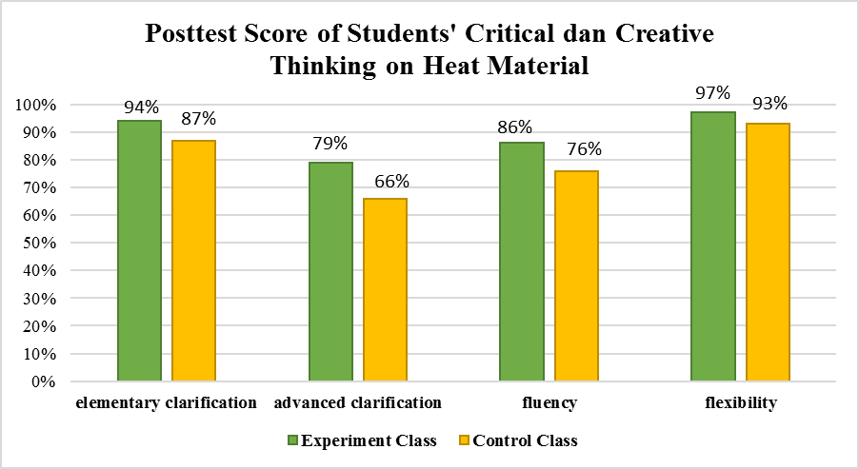
Figure 1. The Posttest Value of Critical and Creative ThinkingStudents on Heat Material

Based on Figure 1, it can be seen that the posttest value on the observed heat material is an indicator of critical thinking, namely the indicator elementary clarification and advanced clarification, while in the indicator of creative thinking the indicator is fluency and flexibilty thinking. First, in the Experiment class, the elementary clarification indicator is 94%, advanced clarification is 79%, fluency is 86%, and flexibility is 97%. Students' initial critical and creative thinking skills are categorized as critical and creative. While the control class for the elementary clarification indicator is 87%, the indicator advanced clarification is 66%, fluency is 76%, and flexibility is 93%. Students' initial critical and creative thinking skills are categorized as critical and creative.
The second data is obtained from the final test results in the form of posttest to the two sample critical thinking, namely the indicator elementary clarification and advanced clarification, while in the classes, where the posttest is given in the form of a graded essay of 5 questions. In this test, students were previously given a grid of questions to make it easier for students to understand the material that had been taught previously. What the researchers did after getting the results of the posttest scores of the two sample classes was calculating and analyzing all the components of the related indicators in the posttest of the two classes. The ability to think critically and creatively for the two sample classes can be seen in Figure 2.The following:
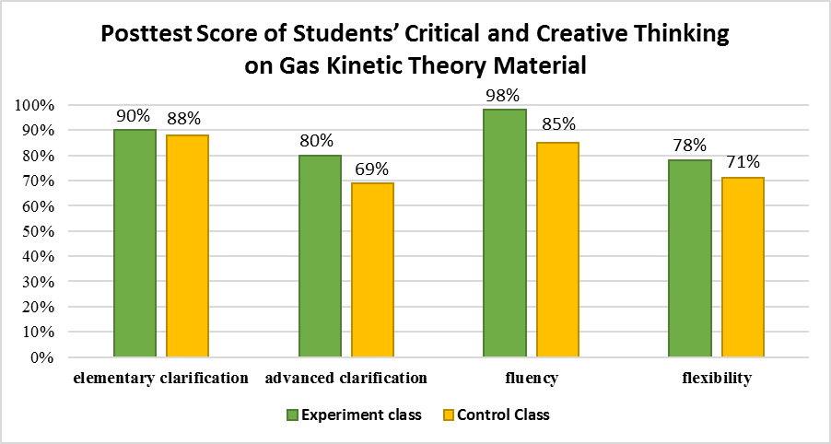
Figure 2. Posttest Value of Critical and Creative ThinkingStudents on Gas Kinetic Theory
Based on Figure 2, it can be seen that the posttest value on the material of gas kinetic theory observed is an indicator of critical thinking, namely the indicator elementary clarification and provides further explanation advanced clarification, while in the creative thinking indicator the indicator is fluency and flexibilty thinking. First in class XI IPA 1 for the elementary clarification indicator is 94%, the indicator advanced clarification is 79%, fluency thinking is 86%, and flexibilty thinking is 97%. Students' initial critical and creative thinking skills are categorized as critical and creative. While class XI IPA 2 for elementary clarification indicator is 87%, indicator advanced clarification is 66%, fluency is 76%, and flexibility is 93%. Students' initial critical and creative thinking skills are categorized as critical and creative.

Data Analysis
- N-Gain
In this N-gain test, researchers can analyze the cognitive aspects of learning outcomes that researchers get from the results of the scores of each sample class both the experimental class and the control class. These results were obtained from the pretest and posttest conducted by students before and after the learning material was carried out. The research success criteria based on the N-Gain test are divided into 3 N-gain interpretation criteria, namely, firstly N-gain> 0.7 means that the interpretation criteria are high, secondly 0.3≤N-gain ≤ 0.7 means that the interpretation criteria are moderate, and the third N-gain <0.3 means that the interpretation criteria are low. In this research, the N-gain test was carried out 4 times, namely the heat material in the experimental class, the kinetic theory material of gas in the experimental class, the heat material in the control class, and the gas kinetic theory material in the control class. The following are the results of the N-gain test obtained from the four assessments in Heat (Experiment Class) N-Gain Score is 0.804, Heat (Control Class) is 0.657, Gas Kinetic Theory (Experiment Class) is 0.774, and Gas Kinetic Theory (Experiment Class) is 0.635. The results of the N-gain test in the experimental class on the two materials are included in the high interpretation criteria, while the control class in both materials is included in the criteria for moderate interpretation. With these results, this study achieves the goal of the N-gain test, which is to provide meaning or results from the treatment given to the sample class studied.
- Normality Test
The researcher did this normality test because the researcher wanted to see whether the two sample classes were normally distributed. The results of the normality test that have been carried out have been obtained L_{o} and L_{t} at the significant level (α) 0.05 with 37 students in each sample class. The results are said to be normally distributed if L_{o} of all samples is smaller than the price of L_{t}, and vice versa. L_{t} in this research is 0.145. In this research, the normality test was carried out 8 times, namely 4 times the pretest value and 4 times the posttest value. The following are the results of the normality test in Pretest Heat (Experiment) is 0.21057, Pretest Heat (Control) is 0.1545, Pretest Gas Kinetic Theory (Experiment) is 0.21685, Pretest Gas Kinetic Theory (Control) is 0.18835, Posttest Heat (Experiment) is 0.07062, Posttest Heat (Control) is 0.10277, Posttest Gas Kinetic Theory (Experiment) is 0.1001, Posttest Gas Kinetic Theory (Control) is 0.13388 . The normality test above shows that the data before being given treatment or the pretest value data are not normally distributed because L_{o} for each sample is larger than L_{t}, the normality test on the pretest value is carried out before being given treatment to all sample classes. An explanation of the normality test for all pretest. While the data after being given treatment or posttest value data are all normally distributed because L_{o} each sample is smaller than L_{t}. The normality test on the posttest value is carried out after the treatment is given to all samples.

- Homogeneity Test
The test carried out after the normality test is the homogeneity test, the aim of the researcher is to carry out the homogeneity test to see whether the data from the two sample classes has homogeneous or non-homogeneous variances. The results of the homogeneity test performed showed the F_{c} and F_{t}. Samples that have a homogeneous variance if the price of F_{c} <F_{t}, and vice versa, the sample that has a variance is not homogeneous if the price of F_{c}> F_{t}, F_{t} in this study is 2.89. The following are the results of the homogeneity test in Pretest Heat is 2.5626, Pretest Gas Kinetic Theory is 1.182, Posttest Heat is 1.403, Posttest Gas Kinetic Theory is 1.387. All samples in this research are homogeneous because the F_{c} in each sample is smaller than the F_{t} value in this study. In this study, the researcher conducted 4 homogeneity tests where 2 times the test before being given the treatment where the homogeneity test was carried out on each pretest sample value per material being studied. After being given the treatment the researcher also conducted a homogeneity test by testing the homogeneity of the results of each posttest value of the sample per material.

- T Test
Researcher's T test was conducted to determine whether the hypotheses that the researcher had previously described in Chapter 3 were accepted or rejected. The T test is done by testing the comparison. The data obtained are normally distributed with homogeneous variance. T-test can be directly performed on these data. The receiving area H_{o} is obtained if t_{coun}t is between the value of ttable or t_{count} <t_{table}. If t_{count} is outside the receiving area H_{o} or t_{coun}t <t_{table} then H_{o} in the study is rejected. T test results on the posttest value of each material in Posttest Heat is t_{count} 2.33596 anda t_{table} 2.11571. Posttets Gas Kinetic Theory is t_{count} 2.03452anda t_{table} 2.03452. The two data are outside the H_{o} area, or it can be said that the data continues to experience H_{o} rejection. This is because the t_{count} in each material, both heat material and kinetic theory of gas, is greater than the t_{table} in this research, where the t_{table} is 2.30452. Due to H_{o}'s rejection, H_{a} is accepted in this study, that if H_{a} is accepted, in this research there is a significant effect on the use of HOTS oriented worksheets on heat material and kinetic gas theory on the critical and creative thinking skills of class XI students of SMA Al-Istiqamah Pasaman Barat.

CONCLUSION
Based on the results of the research that has been done, it can be concluded that after being given treatment to the sample class in the form of giving HOTS-oriented worksheets to the experimental class and conventional student worksheets at school to the control class so that there is an increase in students' critical and creative thinking skills for each indicator. The improvement of students' critical and creative thinking skills on each indicator got higher results in the experimental class than the control class. The t test results indicate that there is a significant effect on the use of HOTS-oriented worksheets on heat material and kinetic gas theory on the critical and creative thinking skills of class XI students of SMA Al-Istiqamah Pasaman Barat

ACKNOWLEDGMENT
The research that has been done has limitations in its implementation. It is hoped that the limitations that occur during the research will make experience and can be improved in the future. The limitation is that there are no practicum tools used in the heat material and the kinetic theory of gas at SMA Al-Istiqamah Pasaman Barat, which causes practicum to be carried out virtually

REFERENCES
- Direktorat Pembinaan Sekolah Menengah Atas. (2017). Panduan Penilaian Oleh Pendidik dan Satuan Pendidikan SMA. Jakarta : Kementrian Pendidikan dan Kebudayaan.
- Rosnawati, R. (2013). Kemampuan Penalaran Matematika SMP Indonesia Pada TIMSS 2011. Yogyakarta : Universitas Negeri Yogyakarta.
- Desi Eka Wahyuni dan Alimufi Arief. (2015). Jurnal Inovasi Pendidikan Fisika. Yogyakarta : Universitas Yogyakarta
- Hanafiah, Nanang. (2009). Konsep Strategi Pembelajaran. Bandung: PT Refrika Aditama
- Ertikanto,Prabowo. (2015). Panduan Kreatif Membuat Bahan Ajar Inovatif. Yogyakarta: Diva Press
- Sanjaya, W. (2008). Pembelajaran Dalam Implementasi Kurikulum Berbasis Kompetensi. Jakarta: Kencana Prenada Media Group
- Wijaya, Cece & Tabrani Rsyan. (2016). Kemampuan Guru Dalam Proses Belajar Mengajar. Bandung: Remaha Rosdakarya.
- Triyono. (2013). Metodologi Penelitian Pendidikan. Yogyakarta: Ombak.
- Sugiyono. (2012). Metode Penelitian Kuantitatif Kualitatif dan R& D. Bandung: Alfabet
- Sugiyono. (2014). Metode Penelitian Pendidikan. Bandung: Alfabeta
- Djamas, Djusmaini. (2015). Metodologi Penelitian Pendidikan Fisika. Padang : Universitas Negeri Padang
- Sugiyono. (2012). Metode Penelitian Kuantitatif Kualitatif dan R& D. Bandung: Alfabet
- Arikunto, S. (2002). Metodologi Penelitian Suatu Pendekatan Proposal. Jakarta: PT. Rineka Cipta.
.

