|  |
| --- |
| THE EFFECT OF HOTS ORIENTED WORKSHEETS WITH BARCODE ASISTANT IN ONLINE LEARNING TO THE STUDENTS’ CRITICAL AND CREATIVE THINKING ON HEAT AND THE KINETIC THEORY OF GASES LEARNING TOPIC IN GRADE XI 1st HARAU DISTRICT SENIOR HIGH SCHOOL |
| Trio Junira Fernando1) Yenni Darvina2) Silvi Yulia Sari2)Letmi Dwiridal2) Fanny Rahmatina Rahim2) |
| |  |  | | --- | --- | | 1 *Physics Education Student, FMIPA Universitas Negeri Padang*  *2 Physics Department Lecturer’s, FMIPA Universitas Negeri Padang*  *Corresponding author. Email:* triofernando98@gmail.com ydarvina@fmipa.unp.ac.id silviyuliasari@fmipa.unp.ac.id letmidwiridal@gmail.com fannyrahmatina@fmipa.unp.ac.id | | | **ABSTRACT** | | | This study aims to see the effect of hots oriented job sheets with barcode assistance in online learning to the students' critical and creative thinking on heat and the kinetic theory of gases learning topic in grade xi of 1st harau district senior high school. This type of research is a quasi-experiment with a randomized only control group design. This study involved two classes, the first class as the experimental class using hots-oriented job sheets with barcode assistance and the second class as the control class. Data collection techniques in the form of a written test with a graded essay question model. The assessment is based on observable indicators of critical and creative thinking skills. data analysis using qualitative descriptive analysis techniques. The results showed that there was an increase in the ability to think critically and creatively. the experimental class was 57% and the control class was 12%. Based on the research results it can be concluded that: First, after implementing HOTS-oriented worksheets assisted by barcodes in online learning, there was an increase in students' critical thinking skills and creative skills in the experimental class. Second, there is a significant difference in the improvement of students' critical and creative thinking skills in the experimental class after implementing HOTS-oriented job sheets assisted with barcodes in online learning compared to the control class that did not apply the job sheets. Third, HOTS-oriented worksheets assisted with barcodes are very suitable to be applied in schools with an online learning system because they can improve students' critical thinking skills and creative thinking skills on heat material and the kinetic theory of gases | | |  | | | **Keywords : Critical and creative skills, online learning, barcode** | | |  | **This is an open access article distributed under the Creative Commons 4.0 Attribution License, which permits unrestricted use, distribution, and reproduction in any medium, provided the original work is properly cited. ©2019 by author and Universitas Negeri Padang.** | |  | | |  | | |

# INTRODUCTION

Education is one of the most important components in facing the times. Education will continue to develop by the demands of the 21st century. This is marked by the use of science and technology in all aspects of life. The demand one must have in life in the 21st century is to master a variety of skills. Therefore, education is expected to be able to prepare human resources who master various skills to become successful and qualified individuals. In Law Number 20 of 2003 concerning the National Education System states that education is a conscious and planned effort to realize an active student learning process so that they can develop their potential. As a forum for developing capabilities and shaping a dignified national character and civilization, it is also a function of national education.

To achieve the goals of 21st century education, currently the Indonesian government is implementing the 2013 revised 2017 curriculum. 2013 curriculum learning is student-centered, so students are required to be active in the learning process. The 2013 curriculum has goals including for students to have 4C skills (communication, collaboration, critical thinking, creativity), HOTS (Higher Order Thingking Skill). Higher Order Thinking Skill (HOTS) is a high level cognitive ability (thinking) which in the taxonomy of cognitive realm consists of the ability to analyze, evaluate and create[1]. HOTS can also be defined as the ability to use information to solve problems, analyze arguments, and make predictions. Based on the 2017 revised Bloom's taxonomy, HOTS category is the ability to analyze (C4), evaluate (C5), and create (C6). HOTS of students can be measured through the HOTS achievement indicator. HOTS indicators are students able to think critically, make decisions and think creatively, the ability to solve problems.

Critical thinking is thinking reasonedly and reflectively by emphasizing making decisions about what to believe or do [2]. The critical thinking abilities of students can be strengthened by incorporating student-centered learning[3]. Meanwhile, Beyer stated that critical thinking is making a reasonable judgment [4]. So it can be concluded that critical thinking skills are the ability to analyze ideas in detail so that they can draw the right conclusions.

Creative thinking skills are the ability to come up with new ideas by combining existing ideas. Creative thinking skills are self-potentials that lead to creativity to create something new[5]. So it can be concluded that critical thinking skills are the ability to produce something new that emerges from self-potential that gives rise to creativity.

The critical and creative thinking abilities of students can be examined by markers of creative and critical thinking abilities. Critical thinking indicators include analysis, evaluation, inference, deductive thinking and inductive thinking[6]. Of the five indicators of critical thinking skills above, this study only observes three indicators, namely analysis, evaluation and inference.

Indicators of creative thinking skills include smoothness, flexibility, authenticity, and elaboration. Of the four indicators of creative thinking, in this study ha¬nya observed one indicator that is the indicator of elaboration. Elaboration is the ability of students to detail the answers they make.

From the answers to student test questions, especially essay questions, creative and critical thinking abilities are measured by correlates of critical and creative thinking skills.

Students' thinking of critical and thinking of creative skills will be achieved if the 2013 curriculum is implemented properly. In fact, in school, the 2013 curriculum has not been optimally implemented. Teachers in the learning process are still using lecture methods so that students have not seen the activists in finding their own problems and solutions to the problems in accordance with the demands of the 2013 curriculum. The use of learning models is only done occasionally but in the process is not optimal.

The first reality, looking at the current situation and conditions, the earth is facing an extraordinary crisis in the field of health that propagates to the world of education, namely the coronavirus disease 2019 (Covid-19) attacks. During this pandemic, all schools were closed and the learning system was also changed from face-to-face to online learning. From the results of an interview conducted to one of the physics teachers of 1st Harau District Senior High School obtained information. First, students have difficulty following online learning. Second, students have difficulty accessing teaching materials online.

The second reality relates to the use of student worksheets and the 2013 curriculum learning model. First, the use of physics worksheets is only for practicum activities and cannot train students' HOTS and only focuses on paper forms and there is no variation in learning media in it. Second, the learning

model that is applied in the learning process is not carried out well, because teachers tend to use the lecture method. The cause of this problem is the difficulty of teachers in delivering physics material, because the sub-material to be taught is very much and there is a lack of time in teaching activities.

Table 1. Mapping of HOTS Questions



The third reality is the students' HOTS ability. Judging from the results of data analysis based on Table 1, it can be described the number of UAS questions based on cognitive levels such as HOTS as many as 3 questions or 7.5%, MOTS as many as 29 questions or 72.5%, and LOTS as many as 8 questions or 20%. This final exam problem can be concluded that the questions are dominant at the MOTS level and very few questions are at the HOTS level. Thus, the ability of Higher Order Thinking Skills (HOTS) of state high school students in West Sumatra is still low. So, it can be concluded that there are still many students who cannot answer HOTS-based questions [7].

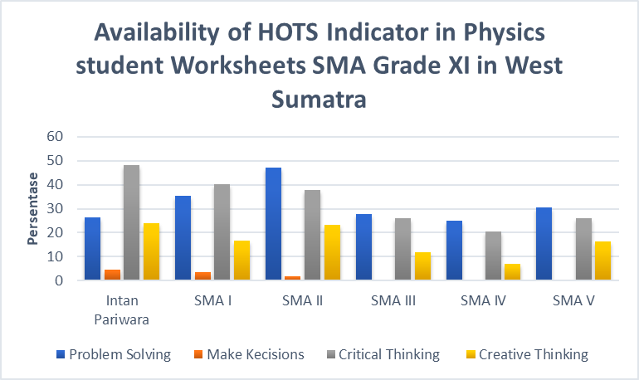

Figure 1. Availability of HOTS Indicators on the worksheets on for grade XI XI high school physics students in West Sumatra

The last fact is the availability of HOTS indicator in Physics Student’ worksheet SMA class XI in West Sumatra. From the data obtained, it can be concluded that the availability of indicators HOTS LKS Physics SMA class XI in West Sumatra is classified as less available [7].

Then the learning process is less supported by learning resources that can train students to think critically and creatively. Learning resources such as Student Worksheets (LKS) are only used for practicum activities, so it is not optimal in training students' thinking of critical and thinking of creative skills.

Based on the existing reality we can know that the 2013 curriculum has been implemented in schools, but in the process of implementation is not optimal, because the learning process uses lecture methods, implementation of learning models that are not optimal and the use of Student Worksheets is only for practicum activities only. This causes students' critical and creative thinking skills to remain relatively low.

Mapping of HOTS questions to improve the critical and creative thinking skills of students in school, action needs to be taken, namely meeting the demands in accordance with the 2013 curriculum, one of which is the use of Student Worksheets based on learning models. As has been made by previous researchers namely HOTS oriented Student Worksheets and modified by researchers now with additional barcode technology.

Student Worksheets contains a set of basic activities that must be done by students to maximize understanding in an effort to form basic abilities according to indicators of achievement of learning outcomes that must be taken [8]. Student Worksheets in learning functions as a medium and tool to enrich learning outcomes, because it contains activities that can expand and enrich the learning material being studied. Student Worksheets requires students to learn actively because Student Worksheets is an active learning medium. Student Worksheets when used appropriately and in accordance with the curriculum will add to the learning experience and students' insight. Student Worksheets have various functions 1) Minimizing the role of the teacher, but maximizing the role of students. 2) Make it easy for students to understand the material given. 3) Concise and rich tasks to practice. 4) Facilitate the implementation of teaching to students [9]. So learning using student worksheets will be more effective because using learning worksheets will be more effective as described above.

The inquiry learning model is one of the learning innovations that can lead students to make discoveries so that students can gain deeper knowledge [10]. The inquiry model is a model that trains students' ability to search for information systematically, logically and critically so that they are able to find solutions to the problems at hand. The inquiry model places students as learning subjects, meaning that students' learning activities are maximized to search and find. So students not only receive explanations from the teacher, but students also play a role in discovering the subject matter themselves. Thus students are expected to have a confident attitude.

The learning steps for the guided inquiry model are 1) orientation, 2) formulating problems, 3) formulating hypotheses, 4) collecting data, 5) testing hypotheses, and 6) formulating conclusions [11]. In the problem orientation stage, the teacher stimulates students to think about solving problems. The stage of formulating the teacher's problem leads students to be able to find answers to the puzzle problems presented. In the stage of formulating a hypothesis, the teacher guides students to be able to formulate temporary answers to existing problems. In the data collection stage, the teacher asked students to gather as much information as needed to test the hypothesis. The stage of testing the hypothesis, the teacher guides students to prove the provisional answers proposed. In the stage of formulating conclusions, the teacher straightens the concepts and guides students to draw conclusions from solving the problems at hand.

QR code stands for Quick Respone code or better known as barcode, barcode is a garus code where each line thickness is different according to the contents of the code, the code represents certain data or information usually the type of price of goods such as food and books. Nowadays, the use of barcodes is very wide, but generally used to encode website addresses, contact numbers, email addresses, phone numbers or just plain text[12].

Online learning is indeed a relatively new learning technology in Indonesia. Online learning is learning that uses internet networks with accessibility, connectivity, flexibility, and the ability to generate various types of learning interactions [13]. E-learning is learning that is structured with the aim of using an electronic system or computer so that it is able to support a learning process [14]. So in its implementation, e-learning uses audio, video or computer services or a combination of the three. The formal definition of the term e-learning is given by several experts, including the widely adopted opinion of Harley, which states that online learning is a type of teaching and learning that allows teaching materials to be delivered to students using the Internet, Intranet or other computer network media.

Barcode-assisted HOTS-oriented worksheets are student worksheets which use in the learning process to load HOTS indicators and use barcode technology to help access digital learning media such as learning videos, virtual labs, and learning animations, and barcode-assisted HOTS-oriented worksheets are equipped with a guided inquiry model where aims to trigger students to think critically and creatively in order to actively discover concepts independently [15].

By implementing HOTS-oriented worksheets assisted with barcodes, it is hoped that an increase in students 'Critical and innovative skills in thought can be measured from the answers to students' graded essay questions. Critical and creative thinking skills are only observed in the aspect of knowledge. With the guided inquiry model, students are expected to be more independent in learning and with barcode technology students become more active in learning.

# METHOD

The type of research that researchers do is quasi-experimental research. Quasi-experimental research is research that is intended to determine whether there is a result of something imposed on the research subject [16]. This means that this research sees the effect of giving treatment to the sample to be studied.

The design that will be used in this research is Posttest Only Control Group Design. Posttest Only Control Group Design is a randomly selected group design [17]. which in this study uses two classes. The first class is an experimental class using HOTS-oriented student worksheets assisted by barcode and the second class is a control class that does not use HOTS-oriented student worksheets assisted by barcodes, but the treatment of these two classes is the same on heat material and kinetic gas theory and with the same teacher. researchers use is as in Table 2.

Table 2. Research Design Randomize Posttest Only Control Group Design



Information :

X = The use of student worksheets with high ordet thinking skills assisted by Barcodes

O1 = The final test after being given treatment

O1 = The final untreated test

The population of this study was class XI science 1 and XI science 4 in 1st Harau District Senior High School which were registered in the 2020/2021 school year. Population selection is based on the similarity of teachers who teach population classes. The sample is a part of the population that is representative (has). The sample class in this study consisted of two classes, namely the experimental class and the control class. The sampling technique used was the purposive sampling technique. Purposive sampling is a sampling technique with certain considerations. This sampling technique is based on specific objectives not based on strata, random, or regional. Sampling in this study is based on classes that are taught the same by the same teacher, schedule learning hours that are close to each other, and have the same average daily replay [19]. The classes used as samples are class XI science 1 and class XI science 4. Both classes have 33 students each.

After obtaining two classes that will be used as sample classes, the researcher conducted a normality test, a homogeneity test, and a two class similarity test according to Sudjana. The normality test, homogeneity test, and class average similarity test can be seen in Table 3, Table 4 and Table 5 below.

Table 3. Result of Normality Test for Both Class Samples



Based on Table 3. after a normality test, it can be seen that L0< Lt for both classes of samples This means that each class comes from a normally distributed population at a significant level of 0.05

Table 4. Initial Data Homogeneity Test Results of Both Sample Classes



From Table 4, it can be seen that the Fh value is in the Ho acceptance area for the two sample classes. This means that the two sample classes have homogeneous variances.

Table 5. Similarity Test Results Two Initial Data Mean of Both Sample Classes



From Table 5, it can be seen that the test results of the similarity of two average sample classes at the signification level of 0.05 obtained th value are in the area of Ho acceptance. This means both sample classes have the same initial ability.

Determine the experimental class and control class. The determination of the two sample classes using cluster random sampling. The trick is to use currency techniques. In this study, class XI science 1 is an experimental class using HOTS-oriented student worksheets assisted with barcodes, and class XI science 4 as a control class that does not use HOTS-oriented student worksheets assisted by barcode.

This study has 3 main variables, namely the independent variable (the treatment given to the experimental group, namely the application of the HOTS-oriented Student Worksheet assisted with barcodes, the dependent variable (improvement in students' critical and creative thinking skills after the action is given to the sample class), and the control variable (material given to the two sample classes the same, the teacher who teaches the same).

The data needed in this study consists of primary data and secondary data. The data used in this study were collected directly by the researcher directly from the sample in the form of increasing students 'critical and creative thinking skills obtained after being treated, namely using HOTS-oriented student worksheets assisted by barcodes in terms of analysis of students' abilities to answer critical and creative thinking questions. This data is primary data taken in the posttest from the two classes. Meanwhile, the secondary data were obtained from the analysis of the daily test documents of the static fluid topic for grade XI students of the odd semester before the research which were obtained from the teacher.

A research instrument is a tool used to measure the observed phenomenon (variable). The instrument used in this study was a test of students' critical and creative thinking skills. The instrument used in this study was a student competency achievement test in the realm of knowledge. The test is in the form of a graded essay written test. The questions used previously had been tested for validity, reliability test, difference power, and problem difficulty level. So that the questions used are categorized as suitable for use in this study.

# RESULTS AND DISCUSSION

1. **Deskription of data**

The data obtained from this research is the value of students' critical and creative thinking skills. The data to be described from the research are: first, the value of the students' initial critical and creative thinking skills of the second class of the sample obtained from the results of the analysis of the answers to the daily test questions of static fluids topic. Second, the value of students' final critical and creative thinking skills obtained from the results of the analysis of the answers to the quizzes and final tests given to students after applying HOTS-oriented student worksheets assisted by barcodes. The assessment is carried out based on the observed indicators of critical and creative thinking. The indicators of critical thinking that are observed are analysis, evaluation, and inference. Meanwhile, the indicator of creative thinking that is observed is an elaboration

After calculating the initial critical and creative thinking skills of the sample class students, it can be seen in Figure 2 below:

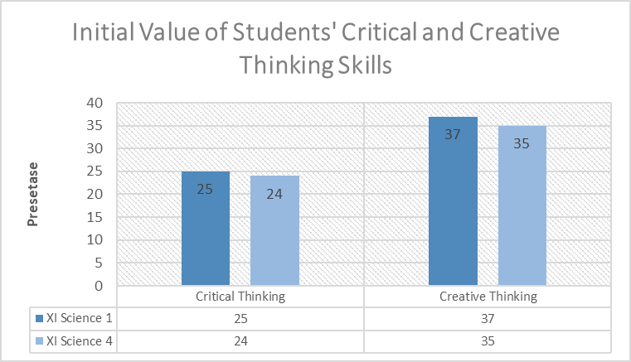

Figure 2. Initial Value of Students' Thinking of Critical and thinking of Creative Skills

Based on Figure 2, it can be described the value of critical thinking skills observed from indicators of analysis, evaluation, and inference. The value of students' critical thinking skills in the Experiment class was 25%, and for the control class was 24%. The value of creative thinking skills is observed from the elaboration indicator. The value of creative thinking skills in the experimental class was 37% and the control class was 35%. From this data, it can be concluded that students' critical thinking skills for the two sample classes are categorized as non-critical. Students' creative thinking skills for the experimental class were included and the control class was included in the less creative category.The second assessment was carried out by giving quizzes and a final test to the two sample classes in the form of a written test with 7 graded essay questions at the end of the study which was equipped with a question grid. After calculating, the data for critical and creative thinking skills for the two sample classes can be seen in Figure 3 below:

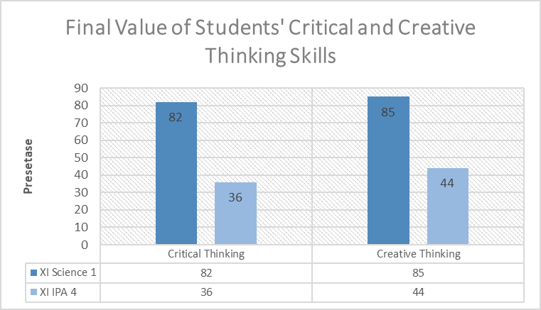

Figure 3. Final Value of Students' Thinking of Critical and thinking of Creative Skills

The importance of critical thinking abilities observed from measures of analysis, assessment, and inference can be defined on the basis of Figure 3. The importance in the experimental class of the critical thinking abilities of students was 82% and 36% for control. The value of creative thinking skills is observed from the elaboration indicator. The value of creative thinking skills in the experimental class was 85% and the control class was 44%.

From Figure 3, we can see that students' Skill in Critical Thought for the experimental class are categorized as critical, while critical thinking skills in control class students are categorized as non-critical [17]. Students' Skill in Creative Thought In the research class were very creative and for the control class, they were included in the less creative category [18]. This indicates an increase in critical and creative thinking skills before and after the implementation of HOTS-oriented student worksheets assisted with barcodes.

1. **Data Analyze**

From the data obtained, data analysis was carried out regarding : First, an increase in the value of students' critical Thought and skills in creative thinking before and accordingly applied HOTS-oriented student worksheets assisted by barcodes. Second, the average final score of students' creative and creative thinking skills.

The improvement of students' critical and creative thinking skills for the two sample classes can be seen in Figure 4 below.

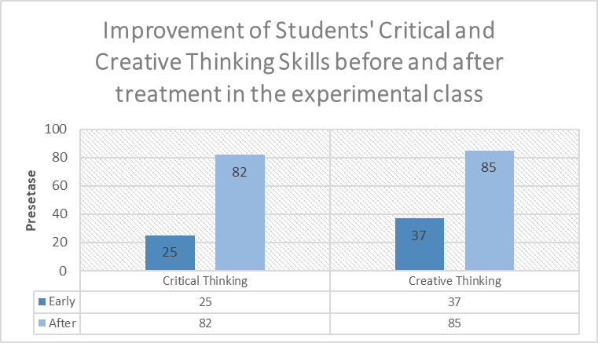

Figure 4. Improvement of Students' Skill in Critical and Creative thought

Based on Figure 4, it can be described that there is an increase in students' critical and creative thinking skills before and after implementing HOTS-oriented worksheets assisted with barcodes. The experimental class's critical thinking ability improved by 57%. The creative thinking skills of the experimental class students increased by 48%.

The final average score of students can be seen in Figure 5 below:

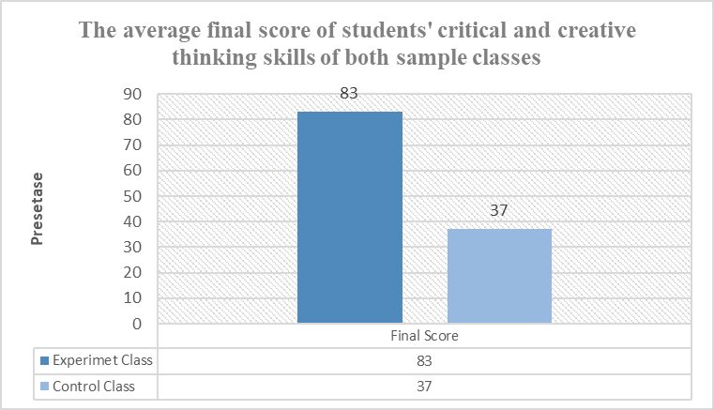

Figure 5. The final average value of students' Skills for critical and creative thinking of both sample classes

From Figure 5, it can be described that the average value of students' critical and creative thinking skills for the experimental class is higher than the control class.

To test the research hypothesis, the t-test was used through the average value of students' critical and creative thinking skills after applying HOTS-oriented student worksheets assisted by barcodes in the experimental class. From the final average value of students' critical and creative thinking skills, after calculating the statistical results obtained from the two sample classes. The results of statistical calculations are seen in Table 6 below:

Table 6. Results of Data Analysis of the Average Final Score of skill in Critical and thinking of Creative skill of the Two-Sample Classes



Based on Table 6, it can be described from the statistical results of the parameters of the knowledge aspect. The parameter statistics used are descriptive statistical analysis, normality test, homogeneity test, and comparison test.

The normality test is used to see whether the two sample classes are normally distributed. The results of the normality test that have been carried out obtained Lo and Lt prices at the real level (α) 0.05 with 33 students per class. So if the two sample classes have Lo prices smaller than Lt prices, the sample data is normally distributed, and vice versa.

The two sample classes are equally normally distributed, this is based on the Lo value is smaller than the Lt. The experimental class obtained a Lo value of 0.084, the control class obtained a Lo value of 0.124, while the Lt value was 0.154 at the 0.05 level for N = 3.

The following step is the homogeneity test, which aims to see that both sample classes have variants that are not homogeneous or homogeneous. The results of the homogeneity test performed showed the Fh and Ft. So, if the value of Fh is smaller than Ft, then the two sample classes meet the requirements to have homogenate variance, and vice versa

In table 6, we can see the results of the homogeneity test. From the calculation, the value of Fh is small from the value of Ft. So that the sample has a homegene variance. The value of Fh = 1.83 and Ft = 1.84. So that the two classes used as samples have homogeneous variances.

The next step is to test the hypothesis. The test is conducted to prove the hypothesis is rejected or accepted. The comparison test is used as a hypothesis test. The test used is the t-test because the sample class data is normally distributed and has a homogeneous variance.

From Table 6, it can be explained that the th value of the two sample classes. Th value of 220.48. The tt value with the dk = n1 + n2 -2 value is tt = 1.669013. The receiving area of ​​Ho, if the value of t count is between the value of t table while the area of ​​rejection of Ho, if the value of t count is outside the area of ​​acceptance of Ho This means that there is an effect of HOTS-oriented student worksheets assisted with barcodes on online learning on students' skill for critical and creative thinking on heat and the kinetic theory of gases topic for grade XI 1st Harau District senior high school.

1. **Discussion**

Based on the data analysis of the research results obtained by document analysis, the implementation of quizzes and final test carried out at the end of the study. The aspect that is observed is only the aspect of knowledge. The results obtained from the study were to see the effect of using HOTS-oriented student worksheets with barcode assistance in online learning on students' critical and creative thinking skills on heat and the kinetic theory of gases topic for grade XI 1st Harau District senior high school..

The results of this study are: first, there is an increase in students' skill for critical and creative thought after applying hots-oriented student worksheets assisted by barcodes. in accordance with theoretical studies, student worksheets are used as guides to guide students in learning and practicing students' critical and creative thinking skills. this is a student worksheet used in both sample classes is a hots-loaded student worksheet that can train students to think critically and creatively and can improve aspects of their knowledge. the improvement of students' critical and creative thinking skills occurs because the student worksheets implemented by the hots-oriented student worksheets are barcode-assisted with guided inquiry learning models. where this learning model is a model of learning used in the implementation of the curriculum 2013 that has one of the objectives so that students have skill for critical and creative thougth.

Second, the guided inkuiri model is very suitable for online learning by applying HOTS-assisted student worksheets with barcode-assisted, as it can trigger an increase in students' critical and creative thinking characterized by increased student grades on both indicators. Through the inquisic model, students become more active because of student-centered learning that requires students to find concepts independently.

Third, see whether this barcode technology is an alternative online learning media on heat material and kinetic gas theory.

This barcode-assisted hots-oriented student worksheets is very worth using, because this student worksheets contains hots indicators and is equipped with a guided inquiry learning model where this learning model triggers students to find their own concepts so that students will be more active in exploring the problems that arise. with scientific solutions that can show an increase in students' critical and creative thinking [20]. With this student worksheet, the barcode feature is more effective, because students become easier to access learning devices and make students more active and worthy to use in learning in the midst of the current pandemic where learning is done online*.*

# CONCLUSION

Based on the results of data analysis can be drawn 3 conclusions. First, after the implementation of HOTS-oriented student worksheets assisted by barcodes on online learning, there was an increase in critical thinking skills and creative skills of students in the experimental class which previously the critical thinking value of students was 25% and the students' creative thinking skills by 37%, after being treated there was a significant increase, where the value of students' critical thinking skills became 82% and the student's creative thinking skills score was 85%. Second, the use of the guided inquiry model is very suitable to be applied to heat material and kinetic gas theory because it triggers students to be more active in learning. These three barcode technologies are very suitable to be applied in schools with online learning systems because they can improve students' critical thinking skills and creative thinking skills and make students more active in learning on heat materials and gas kinetic theory.

ACKNOWLEDGMENT

Thank you so much the Department of Physics, Faculty of Mathematics and Natural Sciences, state university of Padang, and all parties who have guided and motivated the author and for the opportunity given to the author to complete this journal and can be published Pillar of Physics Education.

REFERENCES

|  |  |  |
| --- | --- | --- |
| [1] | Direktur Pembinaan SMA.2018. *Modul Pelatihan Implementasi Kurikulum 2013 SMA Tahun 2018*. Jakarta: Direktorat Pembinaan Sekolah Menengah Atas. | |
| [2] | [Ennis, Robert Hugh](http://lib.ui.ac.id/hasilcari?query=pengarang:%20%22Ennis,%20Robert%20Hugh%22), 2011. *Critical Thinking.* New Jersey: [Prentice Hall](http://lib.ui.ac.id/hasilcari?query=penerbit:%20%22Prentice%20Hall%22).Uper Saddle River | |
| [3] | Aryana, I. B. P. (2009). *Meningkatkan Keterampilan Berpikir Tingkat Tinggi Melalui Pembelajaran*. Singaraja: UNDIKSHA. | |
| [4] | Filsaisme, Dennis K. (2008). *Menguak Rahasia Berpikir Kritis Dan Kreatif*. Jakarta: prestasi Pustaka. | |
| [5] | Arini, Wahyu & Asmila. 2017. *Analisis Kemampuan Berpikir Kreatif Pada Materi Cahaya Siswa Kelas VIII SMP Xavarius Kota Lubuklinggau.* Jurnal *Science and Physics Education Journal (SPEJ).* Vol 1. No 1 | |
| [6] | Sari,Revi febrina., Sari, Silvi Yulia., Darvina, Yenni & Asrizal. 2020. *Meta-Analisis Pengaruh Penerapan Model Pembelajaran Inkuiri Terbimbing Terhadap Hasil Belajar Siwa Dalam Pembelajaran Fisika Di SMA. Pillar of Physics Education, Vol 13. No 3, 2020, Hal 451-458* | |
| [7] | Syafrinaldi., Sari, Silvi Yulia,. Darvina,Yenni & Dewi, Wahyuni Satria. 2020. *Analisis Ketersediaan HOTS Pada Lembar Kerja Siswa Fisika SMA Kelas XI Semester 1 di Sumatera Barat*. *Pillar of Physics Education, Vol 13. No 3, 2020, Hal 387-394* | |
| [8] | Trianto.2012. *Model Pembelajaran Terpadu : Konsep, Strategi dan Implementasinya dalam Kurikulum Tingkat Satuan Pendidikan (KTSP)*. Jakarta : Bumi Aksara. | |
| [9] | Andi Prastowo. (2011). Panduan Kreatif Membuat Bahan Ajar Inovatif. Yogyakarta: Diva Press | |
| [10] | | Dewi,Pramita Sylvia. *Perspektif Guru Sebagai Implementasi Pembelajaran Inkuiri Terbuka Dan Inkuiri Terbimbing Terhadap Sikap Ilmiah Dalam Pembelajaran sains.* Tadris: Jurnal Keguruan dan Ilmu Tarbiyah 01 (2) (2016) 179-186 |
| [11] | | Sanjaya, W., 2016. *Strategi Pembelajaran Berorentasi Standar Proses Pendidikan*. In: Jakarta: Prenamedia Group. |
| [12] | | Goval, Saroj., Yadav, Surendra & Mathuria, Manish. 2016. *Exploring concept of QR code and its benefits in digital education system.* [International Conference on Advances in Computing, Communications and Informatics (ICACCI)](https://ieeexplore.ieee.org/xpl/conhome/7592392/proceeding) : Jaipur : India |
| [13] | | Kuntarto, E. (2017). *Keefektifan Model Pembelajaran Daring dalam Perkuliahan Bahasa Indonesia di Perguruan Tinggi. Indonesian Language Education and Literatur*e, 3(1), 99-110. 10.24235/ileal.v3i1.1820 |
| [14] | | Ardiansyah, I. (2013). *Eksplorasi Pola Komunikasi dalam Diskusi Menggunakan Moddle pada Perkuliahan Simulasi* *Pembelajaran Kimia*. Bandung: Universitas Pendidikan Indonesia. |
| [15] | | Imelda, Elsa., Darvina, Yenni & Sari, Silvi Yulia., 2019. *Validitas Lks Beroerientasi Hots Dalam Model Inkuiri Terbimbing Pada Materi Kalor Dan Teori Kinetik Gas*. *Pillar of Physics Education, Vol 12. No 4, 2019, 729-736* 729 |
| [16] | | Arikunto, S., 2005. *Manajemen Peneltian*. Jakarta: PT Rineka Cipta. |
| [17] | | Arini, & junaidi. (2018). *Analisis Kemampuan Berpikir Kritis Pada Mata Pelajaran Fisika Untuk Pokok Pembahasan Vektor Siswa Kelas X SMAN 4 Lubuklinggau, Sumatera Selatan*. Jurnal Berkala Fisika Indonesia. Vol (10). NO.1 |
| [18] | | Arini, Wahyu & Asmila. 2017. *Analisis Kemampuan Berpikir Kreatif Pada Materi Cahaya Siswa Kelas VIII SMP Xavarius Kota Lubuklinggau.* Jurnal *Science and Physics Education Journal (SPEJ).* Vol 1. No 1 |
| [19] | | Zikri, Afdatul & Darvina, Yenni., 2020**.** *Perbandingan keterampilan berpikir kritis dan kreatif siswa dengan menerapkan lks berbasis problem solving dan inkuiri terbimbing pada materi kalor dan teori kinetik gas kelas XI SMAN di Sumatera Barat. Pillar of Physics Education, Vol 13. No 1, 2020, 41-48* |
| [20] | | Yarsina, desra., Sari, Silvi Yulia., Darvina, Yenni & Asrizal. 2020. *Kajian Literatur Pengaruh LKS Inkuiri Terbimbing Terhadap Hasil Belajar Fisika Siswa Untuk Berbagai Jenjang Pendidikan*. *Pillar of Physics Education, Vol 13. No 3, 2020, Hal 467-474* |