ANALYSIS OF B-VALUE AND PEAK GROUND ACCELERATION (PGA) IN WEST SUMATRA PROVINCE USING MAXIMUM LIKELIHOOD METHOD AND EMPIRICAL FORMULA
(EARTHQUAKE DATA PERIOD 2007-2020)
Fandu Alfadilah¹, Syafriani^{1*}, Fajri Syukur Rahmatullah²
¹ Department of Physics, Universitas Negeri Padang, Jalan Prof. Dr. Hamka Air Tawar, Padang, 25171, Indonesia
²Badan Meteorologi Klimatologi dan Geofisika, Jalan Angkasa 1 No. 2 Kemayoran Jakarta Pusat, 10610, Indonesia
Corresponding author. Email:syafri@fmipa.unp.ac.id
ABSTRACT
West Sumatra is a province located on the west coast of the central part of Sumatra island which has four active fault segments. This segment is part of the Sumatran fault zone. This geological condition causes frequent earthquakes in the province of West Sumatra. Therefore, it is necessary to research b-value analysis and peak ground acceleration (PGA) in the province of West Sumatra by using the maximum likelihood method and empirical formula for earthquake disaster mitigation efforts. This study aims to determine the b-value as the level of rock fragility and peak ground acceleration (PGA) as the level of earthquake activity and determine the distribution map. The data used is earthquake data for the period 2007-2020 with a magnitude ≥ 5 SR and a depth of ≤ 100 km. The results of data processing produce a map of the distribution of b-value and peak ground acceleration in the province of West Sumatra. B-value in each region ranged from 0.8421-1.4477. Based on the b-value distribution map, the area that has the smallest b-value is in region 6, while the largest value is in region 2. A low B-value correlates with high rock stress conditions. This value illustrates that area 6 has a high chance of a major earthquake occurring. Furthermore, the calculation of the peak ground acceleration value refers to the general form of Lin and Wu's empirical equation to obtain a new empirical formula model. The value of the coefficient a = 1.20543, b = 0.839093, and c = 6.88858. The peak ground acceleration value of West Sumatra province ranges from 1.23-49.43 gal. Based on the map of the distribution of peak ground acceleration, the Mentawai Islands Regency has the highest α value, which is 9-29 gal, while the lowest α value is in Dharmasraya Regency, which is 1-3 gal.
Keywords : Earthquake; Seismicity; B-value; PGA.
This is an open access article distributed under the Creative Commons 4.0 Attribution License, which permits unrestricted use, distribution, and reproduction in any medium, provided the original work is properly cited. ©2022 by author and Universitas Negeri Padang.

INTRODUCTION
Indonesia is an archipelagic country that is traversed by the path of three active tectonic plate encounters in the world, namely the Indo-Australian Plate, the Pacific Plate, and the Eurasian Plate. The movement of these three tectonic plates results in the release of energy that radiates in all directions to the earth's surface, causing earthquakes. This situation makes Indonesia often hit by earthquakes.
Sumatra Island is one of the islands located in the western part of Indonesia which is the epicenter of the earthquake. The island of Sumatra has three tectonic systems that can affect the level of seismic activity. First, is the subduction zone which is the boundary between the Indo-Australian Plate and the subducting Eurasian Plate with the rock mass above it [1]. The Indo-Australian Plate and the Eurasian Plate are moving at a speed of 60-70 mm per year [2]. Second, the Sumatran fault, which was formed when the Indo-Australian Plate slipped under the Eurasian Plate, tilted about 40-45 degrees. The sloping subduction resulted in the formation of the Sumatran fault zone [3]. Third, the Mentawai fault which stretches for 600 km and is located to the east of the Mentawai Islands between the forearc ridge and forearc basin. This fault is a fault parallel to the Sumatran fault or the Semangko fault [4].
West Sumatra is one of the provinces located on the west coast of the island of central Sumatra which has four active fault segments. This segment is part of the Sumatran fault zone. Among them, the Sumpu Segment, Sianok Segment, Sumani Segment, and Difficult Segment [5]. This geological condition causes frequent earthquakes in the province of West Sumatra. An earthquake is a sudden release of seismic wave energy. This release of energy is caused by the deformation of tectonic plates that occur in the earth's crust [6]. Earthquakes can cause damage, loss of property and claim many lives. The processes that cause large and destructive earthquakes in an area need to be understood with local tectonic stress conditions and the level of seismic activity [7].
Local tectonic stress conditions and the level of seismic activity can be determined by performing b-value analysis and peak ground acceleration (PGA). B-value is one of the parameters of tectonic conditions in an area that is being observed and depends on the nature of local rocks and the level of rock fragility [8][9]. B-value also reflects tectonic conditions related to rock stress in an area. High B-value correlates with low rock stress conditions and has a high heterogeneity medium, but a low b-value correlates with high rock stress conditions and has low heterogeneity medium [7][10]. B-value can be estimated using statistical analysis methods, one of which is proposed by Utsu (1965) known as the Maximum Likelihood method as defined as follows [11]:

$b=\frac{\log{e}}{\overline{M}-M_{0}}$ or $b=\frac{0.4343}{\overline{M}-M_{0}}$ (1)

where:
$\overline{M}$ = Average Magnitude
$M_{0}$ = Minimum Magnitude

Peak ground acceleration (PGA) is one of the parameters that determines the value of the largest ground acceleration that has ever occurred in an area caused by waves from an earthquake [12]. The size of the ground acceleration indicates the level of seismic activity or the risk of an earthquake that needs to be taken into account as one of the measuring points in the design of earthquake-resistant buildings [13]. This parameter can be calculated based on the magnitude and distance of the earthquake source that occurred at the measurement point [14]. The PGA value is obtained from the measurement results either directly using the accelerograph or through calculations using an empirical formula using earthquake data [15].
Several empirical formulas that can be used in calculating the peak ground acceleration value in an area include the formula from Donovan (1973), Esteva (1970), and Lin and Wu (2010). The form of the equation formula from Donovan (1973) is:

$α=\frac{1080×exp⁡(0.5Ms)}{{(R+25)}^{1.32}}$ (2)

where:
α = Peak Ground Acceleration Value (gal)
M_{S} = Surface Magnitude
R = Hypocenter Distance (km) [16].

The form of the formula equation from Esteva (1970) is:

$α=\frac{1230×exp⁡(0.8Ms)}{{(R+25)}^{2}}$ (3)

where:
α = Peak Ground Acceleration Value (gal)
M_{S} = Surface Magnitude
R = Hypocenter Distance (km) [17].

The form of the formula equation from Lin and Wu (2010) is:

$\log{α}=-0.395×\log{R+0.125×M+1.979}$ (4)

where:
α = Peak Ground Acceleration Value (gal)
M = Magnitude
R = Hypocenter Distance (km) [18].

Based on the above formulas, in this study, in determining the empirical formula for the PGA model, it will refer to the Lin and Wu empirical equation. The general form of Lin and Wu's empirical formulation is:

$\log{α=a\log{R+bM+c}}$ (5)

where:
α = Peak Ground Acceleration Value (gal)
M = Magnitude
R = Hypocenter Distance (km)
a = Geometrical Spreading Coefficient
b = Magnitude Empirical Coefficient
c = Constant

Mapping and analysis of local tectonic stress conditions and the level of seismic activity based on rock physical parameters are one of the efforts to mitigate earthquake disasters. The local tectonic stress conditions and the level of seismic activity can be determined by performing b-value analysis and peak ground acceleration (PGA). The magnitude of the value of ground acceleration indicates the risk of an earthquake that needs to be taken into account as a part of the planning of earthquake-resistant buildings [13]. Therefore, these two values can be used as information on earthquake disaster mitigation, especially for the province of West Sumatra in the process of building earthquake-resistant structures and infrastructure facilities.

METHOD
This type of research is a descriptive study using secondary data in the form of earthquake data sourced from the catalog of the National Earthquakes Information Center U.S. Geological Survey (NEIC/USGS) in the 2007-2020 period. This study examines local tectonic stress conditions and the level of seismic activity by analyzing b-value and peak ground acceleration (PGA) using the maximum likelihood method and empirical formulas to obtain new information. The parameters used in this study were latitude, longitude, magnitude, epicenter, hypocenter, earthquake depth, and peak ground acceleration value. The earthquake data used has a magnitude ≥ 5 SR and a depth of ≤ 100 km which is located in the province of West Sumatra with coordinates 3º 50' S - 1º 20' N and 98º 10' - 102º 10' E. The steps of data processing carried out to produce the b-value and peak ground acceleration in this study are as follows.
The first is to calculate the distance between the coordinates of the earthquake epicenter to each of the coordinates of the calculation area so that the epicenter distance (D) is obtained using Equation (6).

$D^{2}={\left(x_{2}-x_{1}\right)}^{2}+{\left(y_{2}-y_{1}\right)}^{2}$ (6)

where D is the distance from the epicenter to the earthquake recording station, x₁ is the latitude of the epicenter, x₂ is the latitude of the earthquake recording station, y₁ is the longitude of the epicenter, and y₂ is the longitude of the earthquake recording station. The units for D, x₁, x₂, y₁ and y₂ are in degrees (˚). The epicenter distance obtained must be in km, so it must be converted first, where 1˚ = 111.322 km.
The second is to calculate the distance of the earthquake hypocenter (R) to each coordinate of the calculation area. The hypocenter distance (R) can be determined using Equation (7).

$R^{2}=D^{2}+H^{2}$ (7)

where R is the hypocenter distance (km), D is the epicenter distance (km), and H is the earthquake depth (km).
After these parameters are obtained, then these values are substituted into the general form of the Lin and Wu empirical equation (5) to obtain a model of the empirical formula. The coefficients a, b, and c in Equation (5) can be found using the Gaussian elimination application on the Inversion Problem and processed using the MATLAB R2007b software. The peak ground acceleration data is taken from the occurrence of 15 earthquake points recorded on the accelerograph, with the same earthquake station, namely the Padang earthquake station (PDSI) with latitude 0.9118 and longitude 100.4617.
The third is calculating the b-value in the province of West Sumatra using the maximum likelihood method. The b-value calculation is done by dividing the research area into 8 regions and calculated using Equation (1). Next, calculate the peak ground acceleration value in the province of West Sumatra using Equation (8) based on historical data from earthquakes that occurred in the province of West Sumatra. The research area is on a grid with a distance of 0˚ 10' or 0.167˚ as shown in Figure 1 below.

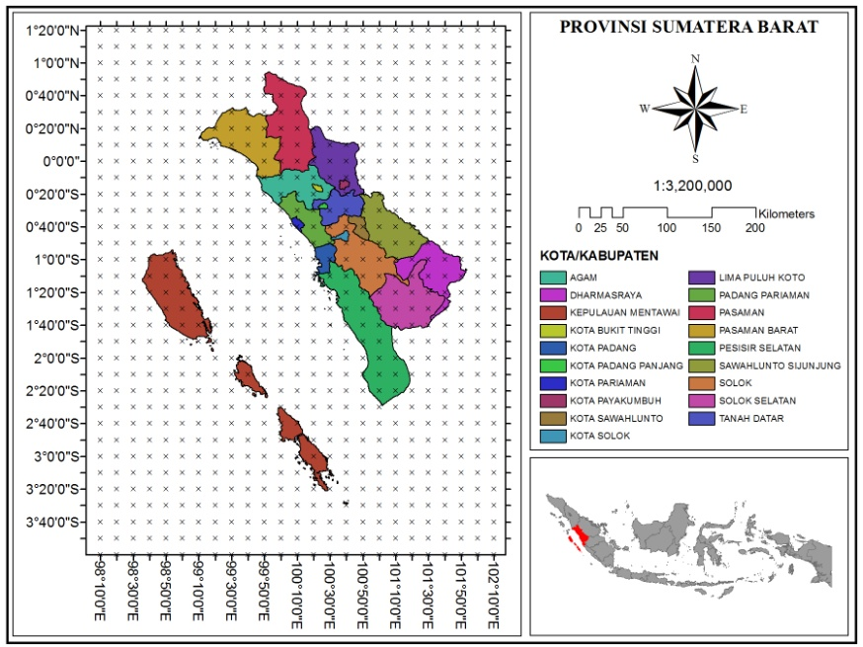
Fig. 1. Grid Map of West Sumatra Province.

Based on Figure 1 there are 800 calculation points, where each point is calculated the peak ground acceleration value from earthquake data for the 2007-2020 period with a magnitude ≥ 5 SR and a depth of ≤ 100 km.
The fourth is analyzing and making a map of the distribution of b-value and the peak ground acceleration value in the province of West Sumatra based on the results of calculations using ArcGIS 10.8 software. These two values can be used as information on earthquake disaster mitigation, especially for the province of West Sumatra in the process of building earthquake-resistant structures and infrastructure facilities.

RESULTS AND DISCUSSION
The results obtained from this study are the b-value and the peak ground acceleration (PGA) value which is the processing of secondary earthquake data sourced from the National Earthquakes Information Center U.S. Geological Survey (NEIC/USGS) site. The earthquake data in this study amounted to 275 events in the period from January 1, 2007, to December 31, 2020. The map of the distribution of earthquake data can be seen in Figure 2.
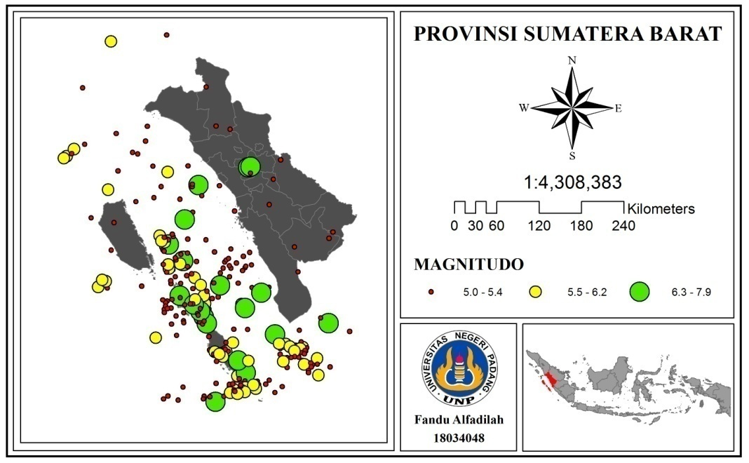
Fig. 2. Map of West Sumatra Province Earthquake Data Distribution.

Based on Figure 2, it can be seen that the province of West Sumatra has a fairly high level of seismicity. This is indicated by the number of earthquakes that occurred in the province of West Sumatra. Earthquakes marked in red have a magnitude of 5.0-5.4, in yellow with a magnitude of 5.5-6.2, and in green with a magnitude of 6.4-7.9. After going through the processing process using calculations, in this study, the results were obtained in the form of b-value and peak ground acceleration (PGA) as well as a map of the distribution of these two values.
The results of the b-value calculation using the maximum likelihood method can be seen in Table 1.

Table 1. Result of b-value Calculation in each Region.
No. | Region | Total Mag | N | M₀ | M _{average} | b-value Estimate
1 | 1°20' - 0°40' LU and 98°10' - 102°10' BT | 10.6 | 2 | 4.95 | 5.3 | 1.2409
2 | 0°40' - 0°0' LU and 98°10' - 102°10' BT | 21 | 4 | 4.95 | 5.25 | 1.4477
3 | 0°0' - 0°40' LS and 98°10' - 102°10' BT | 101.4 | 19 | 4.95 | 5.34 | 1.1227
4 | 0°40' - 1°20' LS and 98°10' - 102°10' BT | 92.2 | 17 | 4.95 | 5.42 | 0.9172
5 | 1°20' - 2°0' LS and 98°10' - 102°10' BT | 329 | 62 | 4.95 | 5.31 | 1.2184
6 | 2°0' - 2°40' LS and 98°10' - 102°10' BT | 382.6 | 70 | 4.95 | 5.47 | 0.8421
7 | 2°40' - 3°20' LS and 98°10' - 102°10' BT | 438.4 | 82 | 4.95 | 5.35 | 1.0958
8 | 3°20' - 3°50' LS and 98°10' - 102°10' BT | 101.1 | 19 | 4.95 | 5.32 | 1.1705

Based on the results of the calculations in Table 1, the b-values for 275 earthquake events with a magnitude ≥ 5 SR and a depth of ≤ 100 km in each region ranged from 0.8421-1.4477. The b-value distribution map is shown in Figure 3 below.

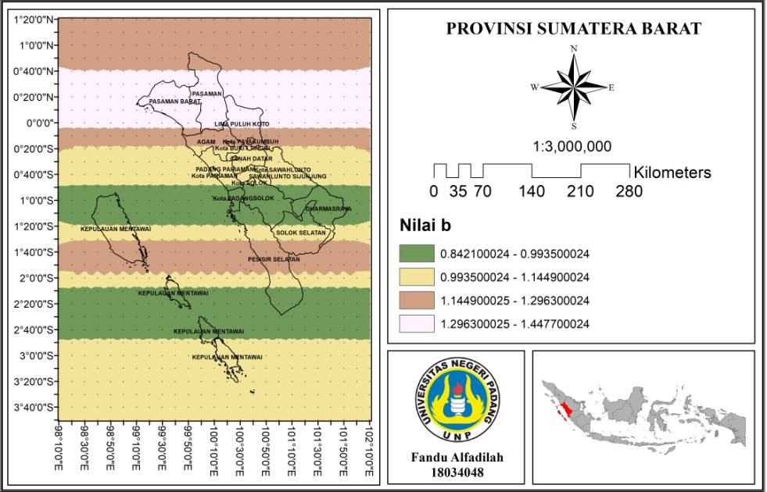
Fig. 3. Map of b-value Distribution in West Sumatra Province.

Figure 3 shows the b-value distribution in the province of West Sumatra with coordinates 3º 50' S - 1º 20' N and 98 10' - 102º 10' E. Based on the b-value distribution map, the area that has the smallest b-value is in region 6, while the largest value is in region 2. B-value is one of the parameters of tectonic conditions in an area where an earthquake occurs and depends on the nature of local rocks and the level of the brittleness of the rock. B-value also reflects tectonic conditions related to rock stress in an area. A high b-value correlates with low rock stress conditions, meaning that the rock's resistance to stress is small and has a high heterogeneity of medium conditions, but a low b-value correlates with high rock stress conditions, meaning that the rock's resistance to stress is large and has low heterogeneity. [7][10].
Deformation or changes in the shape and dimensions of rocks occur due to stress and strain in the earth's layers. The movement of tectonic plates causes strain to occur. The rock strain will continue to increase or accumulate over time until the maximum rock stress is exceeded so that the bearing capacity of the rock will reach its maximum limit and eventually cause sudden fractures or fractures. The accumulated energy is released causing a sudden movement that is an earthquake.
Low rock stress conditions will have a high level of rock fragility. The speed of propagation of seismic waves that propagate in rocks that are not dense or with a high level of rock fragility is greater than that of rocks that have a low level of rock fragility. As a result, the accumulation of energy in the earth is relatively fast or the time it takes to accumulate rock strain until the maximum rock stress is fast, so that the accumulation of energy produced is smaller and results in the possibility of an earthquake with a low level of seismicity. Then the condition of high rock stress will have a low level of rock fragility, meaning that the speed of seismic wave propagation in dense rock is smaller than that of rocks that have a high level of rock fragility. As a result, the accumulation of energy in the earth is relatively long or the length of time for the accumulation of rock strain until the maximum rock stress is slow, so that the accumulation of energy produced will also be greater and result in a great chance of a large earthquake with a high level of seismicity. Based on the results of the calculation, area 6 is an area that has a great chance of a major earthquake occurring. When viewed from the number of earthquakes, this region has a fairly large frequency of earthquakes compared to other regions. Therefore, the b-value in this study depends on the seismic activity in the study area.
The level of seismic activity can be determined by calculating the peak ground acceleration value. The calculation of the peak ground acceleration value in this study uses an empirical formula model that is sought by using the Gaussian elimination application in the Inversion Problem. The empirical formula model obtained is

$\log{α=-1.20543\log{R+-0.839093 M+6.88858}}$ (8)

where α is the peak ground acceleration (gal), M is the magnitude, and R is the distance to the hypocenter (km).
In this study, the data validation process of the peak ground acceleration value was carried out using a new empirical formula with data recorded on the accelerograph. This validation process is carried out to get the RMS error value. The validation process is carried out by comparing the calculation results from the empirical formula with the measured value on the accelerograph. The graph of the comparison of the peak ground acceleration value from the calculation results using the new empirical formula with the data recorded on the accelerograph can be seen in Figure 4.

Fig. 4. Comparison of Peak Ground Acceleration Value.

Figure 4 shows that the difference between the peak ground acceleration value using the new empirical formula and the data recorded on the accelerograph is quite small. This is evidenced by the RMS error value of 0.438937. So, the possibility of error in the new empirical formula is quite small. The results of the calculation of the peak ground acceleration value of the province of West Sumatra are in the range of 1.23-49.43 gal. Map of the distribution of peak ground acceleration values as shown in Figure 5.

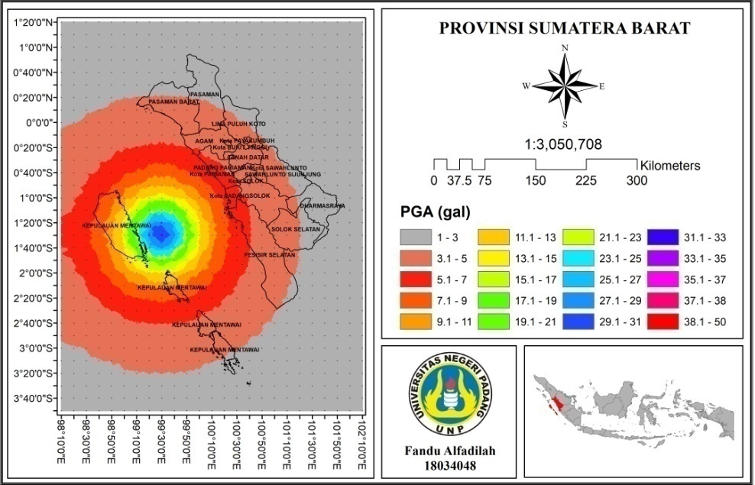
Fig. 5. Map of Peak Ground Acceleration of West Sumatra Province.

Based on Figure 5, the cities/districts with the largest peak ground acceleration values ​​are in the Mentawai Islands Regency, which is in the range of 9-29 gal. This is because the Mentawai Islands are near the epicenter of the earthquake, so they have a high peak ground acceleration value. When viewed from the tectonic condition, the Mentawai Islands Regency is in the Mentawai Fault Zone that extends around the sea of ​​the Mentawai islands, so it can be a threat to the province of West Sumatra in the event of an earthquake. Then the lowest value is in Dharmasraya Regency, which is in the range of 1-3 gal. Apart from being far from the epicenter of the earthquake, Dharmasraya Regency also has a geological structure that is relatively safe from faults or earthquake paths.
The results of this study show the same thing as previous studies. Previous research showed that the highest peak ground acceleration value in the West Sumatra region using the 2007 - 2017 earthquake data period was in the Mentawai Islands Regency, namely 138.79 gals using the Mc. Guirre empirical formula, 348.31 gals using the Si and Midorikawa empirical formula, and 34.47 gals by using Donovan's empirical formulation [12].
The peak ground acceleration value can be used as information on earthquake disaster mitigation, especially for the province of West Sumatra in the process of building earthquake-resistant structures and infrastructure facilities. Buildings built in the Mentawai Islands Regency and Padang City should have met the requirements for earthquake-resistant buildings because they have a fairly high peak ground acceleration value.

CONCLUSION
The results of the b-value and peak ground acceleration (PGA) analysis in the province of West Sumatra using the maximum likelihood method and the empirical formula for the 2007-2020 earthquake data period can be seen that for the b-value due to an earthquake with a magnitude ≥ 5 SR and a depth of ≤ 100 km the value is in each region ranged from 0.8421-1.4477. Based on the map, the area that has the smallest b-value is in region 6, while the largest value is in region 2. Then for the peak ground acceleration value, the value is between 1.23-49.43 gal. Based on the city/district map, the highest peak ground acceleration value is in the Mentawai Islands Regency, which is in the range of 9-29 gal, while the lowest value is in Dharmasraya Regency, which is between 1-3 gal.

ACKNOWLEDGMENT
The authors would like to thank the Badan Meteorologi Klimatologi dan Geofisika (BMKG) and the National Earthquake Information Center U.S. Geological Survey (NEIC/USGS) website which has provided and continues to update the earthquake data catalog especially in the province of West Sumatra which has been used in this study. The authors also thank the MATLAB R2007b and ArcGis 10.8 applications which have provided software to assist the author in the data processing.

REFERENCES
- Sakdiyah, K., & Choiruddin, A. (2020). Model Inhomogeneous Log-Gaussian Cox Process ( LGCP ) untuk Pemetaan Risiko Gempa Bumi di Sumatra. Jurnal Sains dan Seni ITS, 9(2), 108–114.
- Newcomb, K. R., & McCann, W. R. (1987). Seismic History and Seismotectonics of the Sunda Arc. Journal of Geophysical Research, 92(B1), 421–439.
- Madlazim, M. (2013). Kajian Awal tentang b Value Gempa Bumi di Sumatra Tahun 1964-2013. Jurnal Penelitian Fisika Dan Aplikasinya (JPFA), 3(1), 41–46.
- Diament, M., dkk. (1992). Mentawai Fault Zone Off Sumatra: A New Key to the Geodynamics of Western Indonesia. Geology, 20(3), 259–262.
- Triyono, R. (2015). Ancaman Gempabumi di Sumatera Tidak hanya Bersumber dari Mentawai Megathrust. Artikel Stasiun Geofisika Kelas I Padang Panjang.
- Hartuti, Evi Rine. 2009. Buku Pintar Gempa: Mengenal Seluk Beluk Gempa, Jenis-Jenisnya, Penyebab-penyebabnya, dan Dampak-dampaknya. Yogyakarta: DIVA Press.
- Raharjo, F. D., Syafriani, Sabarani, A. Z. (2016). Analisis Variasi Spasial Parameter Seismotektonik Daerah Sumatera Barat dan Sekitarnya dengan Menggunakan Metode Likelihood. Pillar of Physics, 8, 73–80.
- Asnita, W., Sugiyanto, D., & Rusydy, I. (2016). Kajian Statistik Seismisitas Kawasan Sumatera. Jurnal Natural, 16(2), 5–9. https://doi.org/10.24815/jn.v16i2.4917
- Scholz, C. H. (1968). The Frequency Magnitude Relation of Micro Fracturing in Rock and its Relation to Earthquakes. Bulletin of the Seismological Society of America, 58(1), 399–415.
- Gibowicz, S. J. (1973). Variation of the Frequency-Magnitude Relation During Earthquake Sequences in New Zealand. Bulletin of the Seismological Society of America, 63(2), 517–528. https://doi.org/10.1785/bssa0630020517
- Sunardi, B. (2009). Analisa Fraktal dan Rasio Slip Daerah Bali-NTB Berdasarkan Pemetaan Variasi Parameter Tektonik. Jurnal Meteorologi dan Geofisika, 10(1), 58–65. https://doi.org/10.31172/jmg.v10i1.33
- Mandasari, Syafriani, Triyono, R., & Hendra, R. (2018). Analisis Tingkat Kerentanan Seismik di Sumatera Barat Berdasarkan Nilai Percepatan Tanah Maksimum dan Intensitas Maksimum (Periode Data Gempa Tahun 2007-2017). Pillar of Physics. 11(2), 17–24.
- Leviana, M., Syafriani, & Sabarani, A. Z. (2017). Estimasi Nilai Percepatan Tanah Maksimum Wilayah Sumatera Barat Berdasarkan Skenario Gempabumi M 8.8 SR Menggunakan Rumusan Empiris Mc. Guire (1963) dan Donovan (1973). Pillar of Physics, 10, 55–62.
- Netrisa, Z., Syafriani, Triyono, R., & Arifin, H. (2018). Pemetaan Bahaya Gempabumi Deterministik dengan Pendekatan Peak Ground Acceleration ( PGA ) di Kota Padang. Pillar Of Physics, 11(2), 41–48.
- Linkimer, L. (2008). Relationship Between Peak Ground Acceleration and Modified Mercalli Intensity in Costa Rica. Revista Geologica de America Central. 38, 81–94.
- Douglas, John. 2018. Ground motion prediction equations 1964-2018. United Kingdom: Department of Civil and Environmental Engineering, University of Strathclyde.
- Esteva, L., & Villaverde, R. (1973). Seismic Risk, Design Spectra and Structural Reliability. Proceedings of Fifth World Conference on Earthquake Engineering, 2, 2586–2596.
- Lin, T. L., & Wu, Y. M. (2010). Magnitude Determination using Strong Ground-Motion Attenuation in Earthquake Early Warning. Geophysical Research Letters, 37(7), 1–5. https://doi.org/10.1029/2010GL042502

