ANALYSIS OF SOIL ACCELERATION IN THE MENTAWAI REGION WITH THE METHOD HAZARD PROBABILISTIC SEISMIC ANALYSIS (PSHA)
Matias Adam CC Laia¹, Syafriani¹*
¹ Department of Physics, Universitas Negeri Padang, Jl. Prof. Dr. Hamka Air Tawar Padang 25131, Indonesia
Corresponding author. Email: matiasadam86@gmail.com ,syafri@fmipa.unp.ac.id
ABSTRACT
The Mentawai Islands are one of the areas that are active in seismicity. An earthquake measuring 7.2 on the Richter scale on October 25, 2010 resulted in many casualties and material losses. Many buildings collapsed and facilities were damaged so that space managers needed a seismic hazard map to be able to organize the space by considering the disaster aspect. This prompted researchers to conduct research aimed at making seismic hazard maps and knowing the level of earthquake hazard in the Mentawai region. Seismic hazard maps are useful in planning earthquake-resistant buildings and can describe the effects of earthquakes at a location which will help in anticipating community preparedness and earthquake disaster mitigation efforts. Seismic hazard data processing uses the Probabilistic Seismic Hazard Analysis (PSHA) method. PSHA is based on earthquake parameters that produce the largest ground motion. The magnitude of the intensity at a location due to an earthquakein the earthquake source area with a magnitude of M and a distance of R, the attenuation function can be used. The attenuation functions in this study are Joyner-Boore (1997) and Young et al (1997). This type of research is descriptive, namely by collecting NEIC/USGS earthquake catalog data for the period 1950 - 2021 with M 5 SR.The results of this study indicate that the area of ywhich has a high level of seismic hazard is found in the Siberut area with a maximum PGA range of 1.17 g - 3.70 g. The area with a low seismic hazard level is the Pagai area with a PGA range of 0.80 g - 2.86 g. This result represents a 10% chance of being exceeded in 50 years.
Keywords : Earthquake, Hazard, PGA, PSHA
This is an open access article distributed under the Creative Commons 4.0 Attribution License, which permits unrestricted use, distribution, and reproduction in any medium, provided the original work is properly cited. ©2021 by author and Universitas Negeri Padang.

INTRODUCTION
Sumatra Island is one of the regions that has a unique tectonic setting. This is because the island of Sumatra has two geological conditions that can affect the activities and tectonic conditions of the island of Sumatra. First, the subduction zone, which is the boundary between the Indian-Australian plate, which pushes into the Eurasian plate. In this subduction zone, which is the path of plate movement, so that this plate movement has the potential to cause an earthquake with a relatively larger magnitude so that it is very likely to cause a tsunami.[1]. Earthquakes occur due to the movement of rock layers on the earth's surface due to the release of energy in the earth's crust. This release of energy causes deformation of the tectonic plates in the earth's crust [2].
The theory that explains the mechanism of earthquakes is known as the "Elastic Rebound Theory". It is explained in this theory that earthquakes occur in deformation areas where there are two forces acting in opposite directions on the earth's crust rock. The energy stored during the deformation process is in the form of elastic strain and will accumulate until it exceeds the maximum bearing capacity of the rock, eventually causing fractures or fractures. When a fracture occurs, the stored energy will mostly be released in the form of waves in all directions, both in the form of transverse and longitudinal waves. This event is called an earthquake [3].

The Mentawai Islands are one of the areas that are active in earthquakes (seismicity), which is evident from the recording of earthquakes that occurred both small and large during the 2010-2016 period. The Mentawai Islands are included in the tectonic area of ​​Sumatra where there is a subduction of the Indo-Australian tectonic plate to the island of Sumatra.[4]. The Mentawai Islands have the Mentawai Fault which is at the boundary of the Sumatran subduction zone with the Sumatran Fault [5]. An earthquake measuring 7.2 on the Richter scale on October 25, 2010 in the Mentawai Islands resulted in a tsunami that only took 5-10 minutes to reach the coast. Short time to evacuate in ten minutes before tsunami reaches shore. Many casualties reached more than 500 people and large material losses, should be a lesson for space managers to be able to organize space by considering disaster aspects [6].
The sudden movement of rock layers in the earth produces energy that is emitted in all directions in the form of earthquake waves or seismic waves. When these waves reach the earth's surface, the vibrations can damage everything on the earth's surface such as buildings and other infrastructure so that it can cause loss of life and property. [7].An understanding of the risks of living in areas with high disaster vulnerability must be addressed wisely and cleverly in dealing with ways of living side by side with these disaster-prone natural conditions.. Mitigation according to Law no. 24 of 2007 concerning disaster management, is a series of efforts to reduce disaster risk, both through physical development as well as awareness and capacity building in dealing with disasters.
Every damage caused by an earthquake in a certain area is determined by earthquake parameters, one of which is by using the maximum ground acceleration (PGA) value. The maximum ground acceleration (PGA) value is one of the important parameters used in the study of the level of danger and risk of earthquakes that can cause damage. The acceleration value is an important parameter because it is the starting point in making earthquake-resistant building structures and other mitigation measures. So that the maximum ground acceleration data due to earthquake vibrations at a location is important to describe the level of earthquake risk at a certain location [8].The ground acceleration value that will be taken into account in the building design is the maximum ground acceleration value [9].
In Study This method uses the PSHA method, namely Probabilistic Seismic Hazard Analysis, the stages in processing PSHA data are as shown in Figure 1 [9]
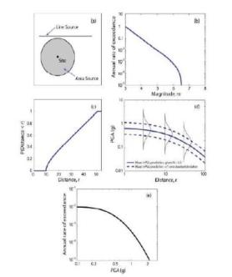
Figure 1. Stages of probability seismic hazard analysis [9]
Stages of probability seismic hazard analysis start from Identify all sources of earthquakes that can cause damage due to ground motion, Characterization of earthquake magnitude distribution, Characteristics of the distribution of the distance from the source to the location associated with a potential earthquake. Predict the resulting distribution of ground motion intensity as a function of earthquake magnitude, distance, etc. At this stage, an attenuation function is used which is considered suitable for the research area, Combining all uncertainties in terms of earthquake size, location, and ground motion intensity using the total probability theorem calculation [8].
PSHA uses uncertainties in its analysis such as the size, location, and frequency of earthquakes. The initial step in the PSHA is declustering, earthquake events recorded on seismographs in the form of a main/mainshock/independent earthquake and a foreshock before the main earthquake and aftershock after the main earthquake which is called a dependent earthquake[10].
Formula base of the total probability theory developed by McGuire in 1976 related to the probability concept developed by Cornell in 1968 [11], which are as follows:

$P\left[I≥i\backslash m,r\right]=\iint{P\left[I≥i;m,r\right] f_{m}}f_{r }dmdr$ (1)

Where fmis the probability density function of the magnitude, fr is the probability density function of the hypocenter distance, = random probability condition of intensity (I) that exceeds the value of (i) at a location due to earthquake magnitude (m) and hypocenter distance (r)$P\left[I≥i\backslash m,r\right]$.
The final result of this hazard analysis includes a map of the maximum acceleration in the bedrock at T = 0 seconds or usually also called PGA (peak ground acceleration) for the probability of exceeding 10% and 2% within 50 years. Earthquake risk is the probability of exceedance of an earthquake with a certain intensity during the life of the building. The value of earthquake risk is mathematically expressed in the following equation.

$R_{n}=1-(1-R_{a})^{N}$ (2)

Where is Rn is earthquake risk, Ra is the annual risk of 1/T, T is the earthquake return period and N is the mass of the building.
Following is attenuation function that can be used in this study [12], namely:
- Youngs, et al (1997)
Attenuation models for subduction zones can generally be divided into 2 (two) categories, namely earthquakes in the megathrust zone (interface) and in the Benioff zone (interslab). The equation form of the attenuation function Youngs et al. that is:
ln (PGA) = 0.2418 + 1.414 MW - 20552ln
[rrup + 1.7818e0.554Mw] + 0.00607 H + 0.3846Zt (3)

From Equality Youngs, et al (1997) obtained the value of ground acceleration. Where PGA is Peak Ground Acceleration (g), Mw is the moment magnitude, rrup is the closest distance to rupture (Km), H is the depth (Km) and Zt is the type of earthquake source (0 for interface and 1 for interslab) [12].

METHOD
Data earthquake This research was obtained from the website of the National Earthquake Information Center US Geological Surveys (NEIC/USGS) that occurred in the period 1950 - 2021. Data thatobtained then transferred to Excel 2010 in accordance with the data format, namely latitude, longitude, magnitude, depth, time of the earthquake.
The data is then processed and modeled according to the standards required in the analyzed area, and calculations are carried out using certain methods to obtain the parameter value of b, maximum magnitude, slip rate, which is in accordance with the research area.. In this study, it has different magnitude scales such as Mb and Ms, so it must be converted to moment magnitude (Mw) before being carried out. analysis.
The next stage after the data is converted is to identify the source of the earthquake. Identification of earthquake sources is carried out to model the earthquake sources used, with certain parameters based on geological, geophysical, and geological conditions. seismotectonic [13]. The earthquake source consists of several classifications, the geometry of the earthquake source in the form of strike direction, dip angle, and depth is needed in the study, and the mechanism of the earthquake source is also needed for identification.
The converted data is then inputted into ZMAP to obtain parameter values of a-value and b-value using MATLAB software. After the ab value parameter is obtained, it can directly process seismic hazard data using the PSHA USGS 2017 software. The final result of data processing from the 2017 USGS is then used to create a seismic hazard distribution map using ArcGis 10.8 software.

RESULTS AND DISCUSSION
Earthquake data used in this study is a significant earthquake that occurred in period 1950 – 2021 with an earthquake magnitude parameter of magnitude M ≥ 5.0 SR and sourced from the US National Earthquakes Information Center catalog Geological survey (NEIC/USGS) and International Seismological Center (ISC) period 1950 to 2021. Region research is in Mentawai Islands at coordinates (98.547° East – 100.767° East and -3.579° N - 0.89° South Latitude). The results obtained from this study are data processing using the PSHA - USGS 2017 software.
The final result from This data processing is in the form of a contour map of the maximum PGA value in the bedrock of the Mentawai region. Processing with the PSHA method produces three contour maps of PGA values, namely a map of the maximum soil acceleration in bedrock in a period of 0 seconds (T = 0 s), a period of 0.2 seconds (T = 0.2 s), and a period of 1 second (T = 1 s). with a probability of exceeding 10% in 50 years or an earthquake return period of 50 years at the age of the building.
The result of acceleration in bedrock at T = 0 seconds with probability exceeded 10% in the 50 year earthquake return period shown in Figure 2. This means that there is a 10% chance that the maximum PGA value of the area will be greater than what is on the map for 50 years.

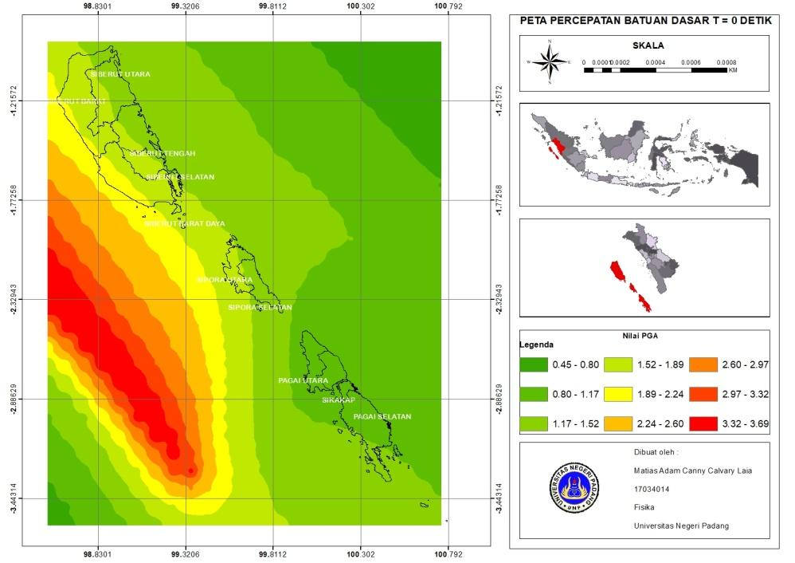
Figure 2. Bedrock Acceleration Map in Mentawai Region T = 0 seconds
Based on scatter Contour map pattern Figure 2. Maximum PGA value, areas with seismic hazard are grouped into 9 colors gradation contour color with PGA value in eachdifferent areas.
Acceleration results in bedrock at T = 0.2 seconds withprobability exceeded 10% in the 50-year earthquake return period shown in Figure 3. This means that there is a 10% probability that the maximum PGA value of the area will be greater than that shown on the map for 50 years.

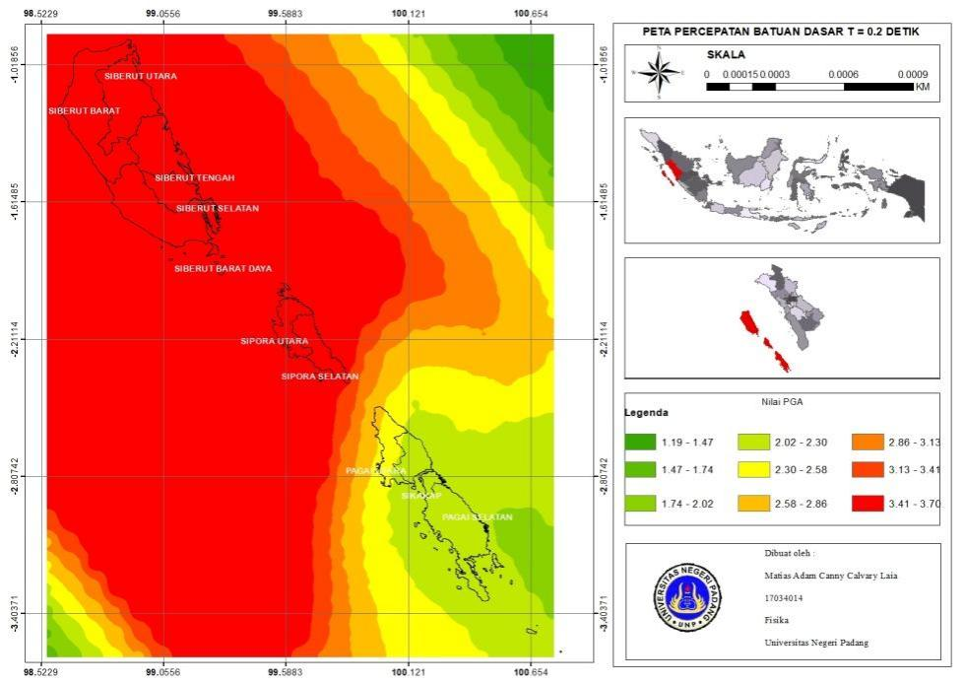
Figure 3. Bedrock Acceleration Map in Mentawai Region T = 0.2 seconds
Based on Figure 3 maximum PGA valuein each the area in the mentawai experience enhancement especially in the Siberut and Sipora areas with a moderate to severe range.
Result of acceleration in bedrock at T = 1 second with probability exceeded 10% in the 50-year earthquake return period shown in Figure 4. This means that there is a 10% possibility that the maximum PGA value of the area will be greater than that shown on the map for 50 years.
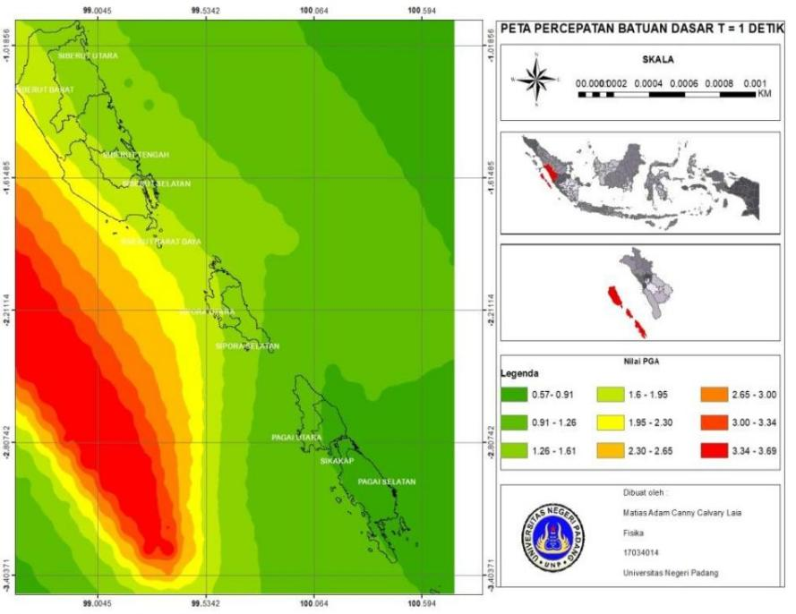
Figure 4. Bedrock Acceleration Map in Mentawai Region T = 1 second
Based on Figure 4. Mark Maximum PGA, seismic hazard areas are presented with acceleration values from 0.57g – 2.30g which are not much different from Figure 1. Seen that hazard seismicity in some areas is almost the same as the acceleration in bedrock at T = 0 s. Level hazard moderate seismic at three locations with acceleration values greater than 2.30g.
Based on Figure 2. we can make a table of acceleration values ​​in bedrock at T = 0 seconds andprobability exceeded 10% within 50 years (earthquake return period 50 years). The resulting coefficients can be used by engineers for the design of building structures or buildings. From Picture1. can be made a table and can be seen in the table1.

No | Region | PGA Max (g) | PGA Min (g)
1 | South Pagai | 1.52 g | 0.80 g
2 | North Pagai | 1.17 g | 0.80 g
3 | West Siberut | 2.24 g | 1.17 g
4 | Southwest Siberut | 2.24 g | 1.52 g
5 | South Siberut | 1.89 g | 1.17 g
6 | Central Siberut | 1.89 g | 1.17 g
7 | North Siberut | 1.89 g | 1.17 g
8 | Attitude | 1.17 g | 0.80 g
9 | South Sipora | 1.89 g | 1.17 g
10 | North Cyprus | 1.89 g | 1.17 g
Table 1. Acceleration of bedrock at T = 0 seconds
Based on the analysis results from Table 1 probability is obtained that the maximum PGA value of 2.24 g is found inregion West Siberut and Southwest Siberut. As for South Siberut, Central Siberut, North Siberut, South Sipora and North Sipora 1.17 g – 1.89 g, North Pagai and Sikakap 0.80 g – 1.17 g. Small maximum PGA of 0.80 g – 1.52 g, namely the South Pagai area.
Based on Figure 3 we can make a table of acceleration values ​​in bedrock at T = 0.2 seconds and the probability of exceeding 10% within 50 years (earthquake return period of 50 years). The resulting coefficients can be used by engineers for the design of building structures or buildings. From Picture2. can be made a table and can be seen in the Table2.

No | Region | PGA Max (g) | PGA Min (g)
1 | South Pagai | 2.30 | 2.30
2 | North Pagai | 2.86 | 2.30
3 | West Siberut | 3.70 | 3.14
4 | Southwest Siberut | 3.70 | 3.41
5 | South Siberut | 3.70 | 3.41
6 | Central Siberut | 3.70 | 3.41
7 | North Siberut | 3.70 | 3.42
8 | attitude | 2.30 | 2.30
9 | South Sipora | 3.70 | 3.13
10 | North Cyprus | 3.70 | 3.41
Table 2. Acceleration of bedrock at T = 0.2 sec
Based on results analysis from Table 2. probability obtained the maximum PGA value for more than half of the Mentawai region, namely West Siberut, Southwest Siberut, South Siberut, Central Siberut, North Siberut, South Sipora and North Sipora 3.41 g – 3.70 g, North Pagai 2.30 g – 2.86 g. Small maximum PGA of 2.30 g – 2.30 g, namely the South Pagai and Sikakap areas.
Based on Figure 4 we can make a table of acceleration values ​​in bedrock at T = 1 second and the probability of exceeding 10% within 50 years (earthquake return period of 50 years). The resulting coefficients can be used by engineers for the design of building structures or buildings. From Figure 11. a table can be made and it can be seen in the Table3.

No | Region | PGA Max (g) | PGA Min (g)
1 | South Pagai | 1.26 | 0.57
2 | North Pagai | 1.26 | 0.91
3 | West Siberut | 2.30 | 1.26
4 | Southwest Siberut | 2.30 | 1.60
5 | South Siberut | 1.95 | 1.26
6 | Central Siberut | 1.95 | 1.26
7 | North Siberut | 1.95 | 1.61
8 | attitude | 1.26 | 0.57
9 | South Sipora | 1.61 | 1.26
10 | North Cyprus | 1.95 | 1.26
Table 3. Acceleration of bedrock at T = 1 second
Based on the analysis results from Table 3. Probably the maximum PGA value of 2.30 g is found in the West Siberut and Southwest Siberut areas. As for South Siberut, Central Siberut, South Sipora and North Sipora it was 1.26 g – 1.95 g, North Siberut 1.61 g – 1.95 g, North Pagai 0.9 g – 1.26 g. Small maximum PGA of 0.57 g – 1.26 g, namely the South Pagai area.
The results of the study in the Mentawai region obtained an a-value of 7,302 and a b-value of 0.97. This is in accordance with Raharjo's research on the year 2016 where the higher the value of the constant a then activity seismicity in an area will also be higher. Region Mentawai also has a maximum PGA value of 3.70 g which, if linked in table 2. has an intensity of VIII MMI where the earthquake caused includes the earthquake felt.
Based on the three PGA values at 0 seconds, 0.5 seconds, and 1 second, the highest PGA values are found in the Siberut area. Although the intensity obtained is the same as in other regions, the earthquake felt differently because the acceleration in the bedrock is 3.41 g – 3.70 g. This is because the Mentawai Islands region is in a subduction zone and is traversed by the Mentawai fault and has a history of seismicity that can be categorized as a destructive earthquake, making this area a high seismic hazard.
The results of Setyanta, B. (2015) research in the Siberut area are covered by accretionary rock (bancuh) a mixture of oceanic crust material and the surrounding rock with a density of about 2.50 gr/cc and andesitic crustal rock with an average density of 2.8 gr/cc, the Siberut Island area which is covered by Bancuh bedrock is not very stable because the lithological consolidation is less compact and the density is rather small as the bedrock is less stable. Based on the results of the PGA the Siberut area shows a high value, this is influenced by one geological factor where the sedimentary rocks in this area are aged and the average mass density value of all segments also affects the undulation of the anomaly value with records of seawater and bedrock giving a larger portion than the sedimentary rock [14].

CONCLUSION
Seismic hazard map for the Mentawai region, an area that has a high level of seismic hazard is in the Siberut region. This region has a maximum PGA value at T = 0 seconds of 1.17 g – 2.30 g, at T = 0.2 seconds of 3.41 g – 3.70 g, at T = 1 second of 1.26 g – 2.30 g. This seismic hazard map also shows areas with low seismic hazard levels, namely the Pagai area. Although the intensity produced is the same, the earthquake felt is different because the acceleration in the bedrock is 0.80 g – 1.52 g at T = 0 seconds, 2.30 g – 2.86 g at T = 0.5 seconds and 0.57 g-1.27 g at T = 1 second.
Areas that have a hazard level seismichow high is in the Siberut area and the area with low seismic hazard is in the Pagai area. The probability of earthquake hazard in the Mentawai region is dominated by subduction zone earthquake sources. Although the intensity of the Mentawai region is at the same level, due to the difference in the value of the acceleration in the resulting bedrock, the resulting earthquake is different.

ACKNOWLEDGMENT
In this study using software ZMAP, MATLAB, ArcGis and USGS 2017 applications. Data earthquake This research was obtained from the website of the National Earthquake Information Center US Geological Surveys (NEIC/USGS) that occurred in the period 1950 - 2021

REFERENCES
[1] Madlazim, “Preliminary Study on b Value of Earthquake in Sumatra in 1964-2013,” J. Phys. Res. Appl., vol. 3, pp. 2087–9946, 2013.
[2] Syafriani, Zalmi. N, Grace. T, “Deterministic Earthquake Hazard Mapping with Peak Ground Acceleration (PGA) approach in Padang City.,” Pillar Phys., vol. 11, p. 2, 2018.
[3] D. Edwiza, Analysis of the Maximum Soil Intensity and Acceleration of the West Sumatra Earthquake. 2008.
[4] M. Rohadi, S., Grandis, H. & Ratag, “Study of Seismotectonic Potential as Precursor to Seismic Levels in Sumatra Region.,” J. Meteorol. Geophys., vol. 9, pp. 101–108, 2008.
[5] H. Mukti, MM, Singh, SC, Deighton, I., Hananto, ND, Moeremans, R. & Permana, “Structural Evolution of Backthrusting in the Mentawai Fault Zone, offshore Sumatran Forearc.,” Geochemistry Geophys. Geosystems, vol. 13, p. 1-21., 2012.
[6] A. P. Son, “District Disaster Mitigation-Based Spatial Planning Mentawai Islands,” , J. Disaster Manag. Dialogue Vol. 2 Number 1, Year 2011, pp., pp. 11–20, 2011.
[7] M. T. G. and S. P. Sunarjo, Earthquakes Popular Edition. 2012.
[8] R. Order, “Peak Ground Acceleration (Pga) Analysis Due to Earthquake East Java 08 July 2013 In the Indian Ocean 9,000LS – 113,010BT,” Indones. J. Phys. Innov., vol. 2, 2013.
[9] W. Baker, An Introduction to Probabilistic Seismic Hazard Analysis, version 1.3. 2008.s
[10] Wiemer, S. and Wyss, M. (1994), “Seismic quiescence before the Landers (M= 7.5) and Big Bear (M= 6.5) 1992 earthquakes”, Bulletin of the Seismological Society of America, The Seismological Society of America, Vol. 84 No. 3, pp. 900–916.
[11] C. Cornell, Engineering seismic risk analysis, Bull.Seism. soc. Am. 1968.
[12] J. L. Tribe, Earthquake Risk Probabilistic Analysis (Probabilistic Seismic Hazard Analysis) in Ende City Based on Joyner-Boore Dan Youngs Attenuation Function. 2014.
[13] P. D. B. Purbadini, “Analysis of Seismic Hazards in the Malang Region Using a Probabilistic Approach. ITS,” J. Sci. Arts, vol. 6, 2017.
[14] Setyanta, B. (2015). The crustal model of the fore-arc region on Siberut Island and the surrounding waters based on gravity anomaly analysis. Journal of Geology and Mineral Resources, 16(2), 55-65.

