ANDROID-BASED MEASUREMENT DESIGN OF LEG MUSCLE POWER
Muhammad Irsyad*, Yohandri, Asrizal, Nurul Ihsan
Department of Physics,Padang State University, Jalan Prof. Dr. Hamka, Air Tawar Barat, Padang, West Sumatra, 25171. Indonesia
Corresponding author. Email: irsyad4621@gmail.com
ABSTRACT
Explosive force (Power) leg muscles are the combination of strength and speed, or the maximum muscle performance at maximum speed. At this time, measuring the leg muscle power still uses manual tools, which requires a lot of people, and the measurement of leg muscle power is still inaccurate, because it can only be seen from the jump distance. Based on the problems obtained, the author makes a production based on the Android Foot Muscle Power Measurement Tool Idea. This study aims to determine the performance and design specifications of an Android-based leg muscle power meter. This research is an engineering study to determine the performance specifications and design of an Android-based leg muscle power measurement tool. The performance specifications of the tool describe the performance of the instrument that measures the explosive force of the leg muscles, while the design specifications describe the characteristics, accuracy, and accuracy of the sensor. There are two ways to collect data, namely direct measurement and indirect measurement. The direct measurement result is obtained from the result of measuring the explosive force of the leg muscles, while the indirect measurement result is obtained from the result of the accuracy and precision of the tool. According to the analysis results of the obtained data, the performance and design specifications of the tool are obtained. The specification of tool performance obtains the mechanical form of the tool. The tool will automatically measure the leg muscle power, and the measurement results can be viewed via Android. The design specification is obtained from the characteristics of the sensor and the precision and precision of the tool. The sensor characteristics can be seen from the load cell and ultrasonic sensor. The accuracy rate of the obtained leg muscle explosive force measurement tool is 99.06%, and the accuracy rate of the obtained instrument is 97.68%, which is derived from the measurement accuracy of subject 1.
Keywords : Leg Muscle Explosive Power, Arduino Uno, Android.
This is an open access article distributed under the Creative Commons 4.0 Attribution License, which permits unrestricted use, distribution, and reproduction in any medium, provided the original work is properly cited. ©2019 by author and Universitas Negeri Padang.

INTRODUCTION
The physical condition in sports is the part that can prevent athletes from being injured and can improve the skills and strength of athletes in the sports controlled by them [1]. The physical condition symbolizes the best condition, which greatly affects the performance of the athlete himself [2]. One physical condition required for exercise is the leg muscle power. The leg muscle power are the combination of strength and speed, or the maximum speed of the largest muscles [3].
The leg muscle power can be increased through good and regular exercise [4]. If you want to train and see the effect of exercise by increasing the explosive power of the leg muscles, you must check to see the effect of the exercise that has been completed. In order to measure the leg muscle power, the Lewis nomogram equation can be used. Equation Lewis nomogram can be seen from the formula:
$$P=(\sqrt{4,9}.\left(weight\right). \sqrt{D})$$
From the equation, the explosive power of the leg muscles is obtained. P is leg muscle power, weight is the body mass obtained from the weight of the jumper, and D is the distance of the jump generated when jumping [5].
With the technology that can help human work, to measure the leg muscle power, an automatic measurement tool can be used, namely the Android-based leg muscle explosive power measurement tool. This tool can measure the leg muscle power muscles automatically and the measurement results can be seen from a distance using Android. Measurements are made with a vertical jump. Vertical jump is a movement to jump as high as vertically with the focus on the strength of the leg muscles in order to achieve the maximum jump [6]. An Android-based leg muscle explosive power measurement tool requires a microcontroller in its manufacture. Microcontroller is an electronic component that can be programmed and has the ability to execute programmed steps [7]. The microcontroller contained in this tool is Arduino uno. Arduino Uno can connect several sensors and electronic components such as ultrasonic sensors, loadcell, bluetooth hc-05, and Android, all of which can measure explosive power of leg muscles automatically.
Arduino Uno is a board based on the microcontroller on the ATmega328. It has 14 digital input/output pins, of which 6 can be used as PWM (pulse width modulation) output, 6 analog inputs, a 16 MHz ceramic resonator, a USB connection, a power jack, an ICSP connector and A reset button. It contains everything needed to support the microcontroller, just connect it to the computer with a USB cable or ACDC adapter or battery to make the tool work [8]. To run Arduino, you need a program designed using the Arduino IDE application program to run it [9]. Ultrasonic sensor is a kind of sensor whose function is to convert physical quantity (sound) into electricity and vice versa. The working method of this kind of sensor is based on the reflection principle of sound waves, so it can be used to explain the existence (distance) of an object with a certain frequency. It is called an ultrasonic sensor because it uses ultrasonic waves (ultrasonic waves) [10]. The ultrasonic sensor is used to measure the distance of the jump.
The loadcell sensor is a weighing module on a digital scale, the loadcell sensor is composed of a strain gauge, conductor, and a Wheatstone bridge. Theoretically, loadcell is used to calculate the mass of an object [11]. The working principle of the loadcell sensor is that during the process of weighing metal elements in the loadcell, a reaction will occur that causes an elastic force. The strain will cause a force which will then be converted into an electrical signal by the strain gauge on the loadcell [12]. The loadcell sensor is used as a subject to measure the mass of the subject.
Bluetooth Hc-05 is a wireless communication protocol that works at 2.4 GHz radio frequency for data exchange on mobile devices such as PDAs, laptops, cellphones, etc. The way Bluetooth works is that it can transmit data with the help of radio signals which are part of electromagnetic waves. Electromagnetic waves are a combination of electric and magnetic fields which are perpendicular to each other and do not require a medium to propagate [13]. The Hc-05 bluetooth device functions as a sender of data signals that are read from the sensor to Android.

METHOD
This research includes engineering research. Engineering research is a non-routine design, where this research will produce new things in the form of products and processes. Engineering research in this study has 6 stages. The first stage is determining ideas and clarity of tasks, the second stage is making a conceptual design, the third stage is making a geometric arrangement and determining the design function, the fourth stage is making a detailed design, the fifth stage is making prototypes, and the sixth stage is tool testing. The final results of this study can be used for improvements in testing methods and procedures and improvements in the design activity itself [14].
In the technique of data collection is done by using the quantities contained in the system. The data collection technique on the tool is seen from the results of the leg muscle power where to measure leg muscle power it is necessary to measure the mass and distance of the jump (height of the jump). All measurements are carried out by sensors namely ultrasonic and loadcell. Next, look at the characteristics of the sensor voltage, program variations, accuracy, and tool accuracy. For the data on the voltage characteristics of the sensor, there are two data, namely ultrasonic sensors and load cells. In ultrasonic sensors, the way to see the characteristics of the sensor is seen from the comparison of the sensor output voltage with changes in distance. For loadcell sensors, it can be seen from the comparison of the output voltage to the given mass. The accuracy data of the tool is taken from the comparison of the Android-based leg muscle explosive power measurement tool with manual measuring tools such as mass scales and meters. To measure the accuracy of the tool, it was obtained from repeated measurements of one subject to measure the leg muscle power.

RESULTS AND DISCUSSION
In this study, two research results were obtained, namely performance specifications and design specifications for Android-based leg muscle power tools.
A. Performance specifications of the Android-Based Leg Muscle Power Tool.
In the performance specifications of the Android-based leg muscle explosive power measurement instrument, it is seen from the series of tools, mechanics of the tool and the Android application for measuring leg muscle explosive power.
1) Mechanics of Android-Based Leg Muscle Power Tool.
The mechanism for measuring leg muscle explosive power based on Android is seen from a series of measuring instruments. This series of android-based limb muscle explosive power measurement is a whole series of sensors ranging from loadcell, ultrasonic, and bluetooth Hc-05 sensors. The series of measuring leg muscle power can be seen in Figure 1.
Figure 1. A series of Android-Based Leg Muscle
Power Measuring Instruments
In Figure 1, you can see the circuit for measuring leg muscle explosive power based on Android. After everything is assembled and the program has been inputted into the Arduino, this circuit can be used to measure the leg muscle power automatically which can be seen the results via Android.
- Development of an Android-Based Limb Muscle Explosion Power Measurement Tool.
The manufacture of this leg muscle explosive power measurement tool is made using iron and wood. iron here as an ultrasonic sensor pole to measure the distance when jumping. The wood here is useful as a footrest and a mass gauge. The mechanism for measuring leg muscle explosive power can be seen in Figure 2.
Figure 2. Design of Leg Muscle Power Measuring Instruments.
Figure 2 you can see the mechanical form of all android-based leg muscle power measurement tools. All sensors are connected to the arduino, and the arduino and electronic components are detonated in the acrylic shell.

- Android Applications Android-Based Leg Muscle Power Measurement Tool.
The Android application is used to display the measurement results that have been read on an Android-based leg muscle explosive power measurement tool. This Android application is designed using the MIT app inventor web. The form of Android application design can be seen in Figure 3.
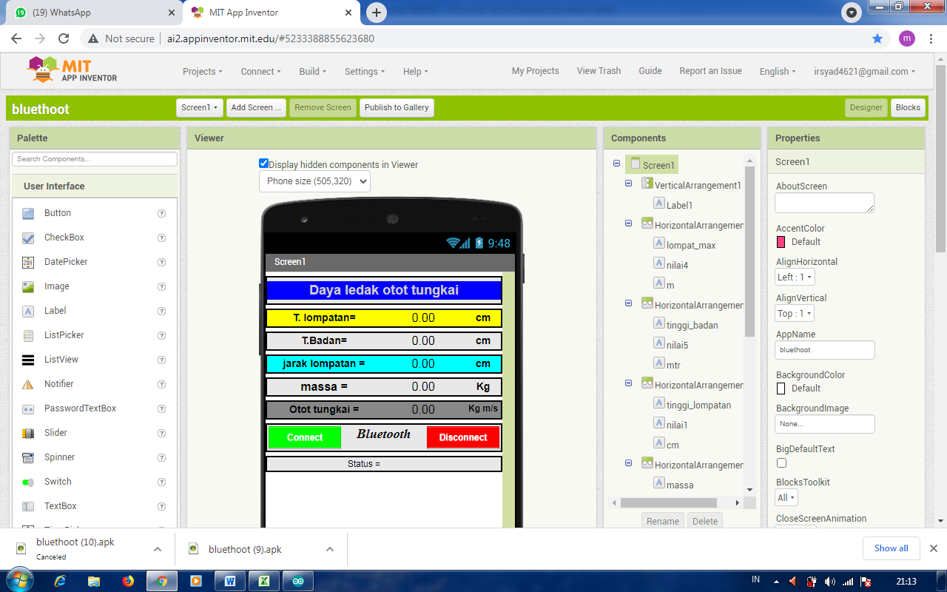
Figure 3. Android Application Design for leg Muscle
Power Measurement
Figure 3 shows the Android application design that has been created. To run an application, a program is needed to run it. The android application program on the MIT app inventor can be seen in Figure 4.
Figure 4. Android Application Program for Measuring
Power of Leg Muscles of Limbs
Figure 4 shows the form of the Android application program. With this program, the application created can be used for Android applications in measuring leg muscle explosive power.
B. Design Specifications for Android-Based Leg Muscle Power Measuring Instruments.
Specifications of Android-Based leg Muscle Explosion Power Measurement Tool based on the sensor characteristics, accuracy and precision of android-based leg muscle explosive power measurement tool.
1) Ultrasonic sensor characteristics.
To see the characteristics of the ultrasonic sensor seen from the change in the output voltage of the ultrasonic sensor to the distance given to the sensor. The characteristics of the ultrasonic sensor can be seen in Figure 5.

Figure 5. Graph of ultrasonic sensor characteristics
Based on the graph in Figure 5 it can be seen that the ultrasonic sensor output voltage is directly proportional to the given distance. The greater the distance given, the greater the output voltage.
2) Loadcell Sensor characteristics
The characteristics of the loadcell sensor are seen from the ratio of the sensor output voltage to the mass. The characteristics of the loadcell sensor can be seen in Figure 6.

Figure 6. Graph of loadcell sensor characteristics
Based on the graph from Figure 6 it can be seen that the loadcell sensor output voltage is directly proportional to the given mass. The greater the mass given, the greater the output voltage.
3) The accuracy of measuring leg muscle power.
The accuracy of measuring leg muscle power is seen from the comparison results. The accuracy of the leg muscle power as measured by the instrument with the measurement results using a manual instrument. The accuracy of leg muscle explosive power can be seen in Table 1.
Table 1. The accuracy of leg muscle power
Sujek | Alat  (Kg m/s) | Manual  (Kg m/s) | % Kesalahan | %Ketepatan
1 | 67,31 | 68,85 | 2,24% | 97,76%
2 | 63,59 | 65,81 | 3,38% | 96,62%
3 | 88,14 | 89,60 | 1,63% | 98,37%
4 | 85,93 | 85,96 | 0,04% | 99,96%
5 | 80,01 | 80,05 | 0,06% | 99,94%
6 | 92,07 | 92,28 | 0,23% | 99,77%
7 | 73,34 | 73,23 | 0,15% | 99,85%
8 | 71,36 | 70,71 | 0,92% | 99,08%
9 | 98,32 | 98,64 | 0,33% | 99,67%
10 | 79,65 | 79,99 | 0,42% | 99,58%
Rata-rata |  |  | 0,94% | 99,06%

In Table 1 can be seen the accuracy of the measuring instrument. Here the accuracy of the measuring instrument is almost close to that of a manual tool where the accuracy obtained is 99.06%.
4) the precision android-based leg muscle power measurement tool.
precision measuring leg muscle explosive power based on Android is seen from the measurement of leg muscle power as many as 10 repeated measurements on one subject. precision will be seen from the results of the leg muscle power of the leg muscles power whether it is close to the actual measurement or not. The precision of the tool can be seen from the results of measuring the leg muscle power of Subject 1. The results of the precision of the tool in Subject 1 can be seen in Table 2.
Table 2. precision of the power of Subject 1 leg muscles on the tool.
Percobaan | Alat  (Kg m/s) | Manual  (Kg m/s) | % kesalahan | %ketepatan
1 | 67,77 | 68,77 | 1,46% | 98,54%
2 | 67,49 | 70,47 | 4,23% | 95,77%
3 | 66,62 | 67,90 | 1,89% | 98,11%
4 | 67,35 | 69,62 | 3,26% | 96,74%
5 | 68,63 | 68,77 | 0,20% | 99,80%
6 | 66,89 | 69,62 | 3,92% | 96,08%
7 | 67,49 | 67,90 | 0,61% | 99,39%
8 | 67,49 | 67,90 | 0,61% | 99,39%
9 | 66,48 | 68,77 | 3,32% | 96,68%
10 | 66,89 | 68,77 | 2,73% | 97,27%
Rata-rata |  |  | 2,22% | 97,78%

The results obtained from Table 2 can be seen that the precision of the instrument from measuring the explosive power of the limb muscles in Subject 1 is very good where the percentage of precision obtained is 97.78%.

CONCLUSION

From the analysis of the data obtained, several conclusions were obtained. First, the sensor characteristics are obtained from the comparison of the output voltages. The ultrasonic sensor compares the change in distance with the output voltage where the distance given to the ultrasonic sensor is directly proportional to the output voltage. The loadcell sensor compares the mass with the output voltage where the mass given is directly proportional to the output voltage. The second is the accuracy of the leg muscle power measuring instrument which has good accuracy where the accuracy value is 99.06%. The three precision values ​​of the leg muscle power measurement instrument were obtained from the measurement of Subject 1 with an precision of 97.78%. The precision of the obtained tools is very good for measuring leg muscle power.

REFERENCES
[1] Pujianto, A. (2015). Profil Kondisi Fisik dan Keterampilan Teknik Dasar Atlet Tenis Meja Usia Dini di Kota Semarang. Journal of Physical Education Health and Sport.
[2] Arizal, Y., & Lesmana, H. S. (2019). Pengaruh Latihan Plyometric terhadap Ketangguhan Smash Bolavoli. Jurnal Patriot.
[3] Nurhasan, dkk. 2005. Pendidikan Jasmani. Surabaya: UNESA Universitas Press.
[4] Alsyahbana, Mardha. 2014. Profil Tinggi Badan, Daya Ledak (Power) Otot Tungkai, Kelincahan (Agility) Dan Daya Tahan (Endurance) Atlet Bulutangkis Pb Surya Baja Surabaya Usia 12-16 Tahun. Surabaya: Universitas Negeri Surabaya.
[5] Yulhendra, dkk. 2017. Kontribusi Daya Ledak Otot Tungkai Dan Daya Ledak Otot Lengan Terhadap Ketepatan Jump Service Atlet Bolavoli Sma N 8 Padang. Padang: FIK UNP.
[6] Widyaratni, A. A. I. F., Wahyuni, N., Muliarta, I. M., & Nurmawan, I. P. S. (2016). Penambahan contrax relax stretching lebih efektif daripada ballistic stretching pada latihan depth jump terhadap peningkatan vertical jump atlet basket SMA (Slua) Saraswati 1 Denpasar: Majalah Ilmiah Fisioterapi Indonesia.
[7] Yohandri. 2013. Mikrokontroler dan Antar Muka : Padang. Universitas Negeri Padang.
[8] Suryanto, Muhamad Juhan Dwi. 2019. Rancang Bangun Alat Pencatat Biaya Pemakaian Energi Listrik Pada Kamar Kos Menggunakan Modul Global System For Mobile Communications(Gsm) 800l Berbasis Arduino UNO. Surabaya: Universitas Negeri Surabaya.
[9] Susanto, Andri dan Jauhari, Ismail Darisman. 2019. Rancang Bangun Aplikasi Android Untuk Kontrol Lampu Gedung Menggunakan Media Bluetooth Berbasis Arduino Uno. Tangerang: Teknik Elektro Universitas Muhammadiyah Tangerang.
[10] Limantara, Arthur Daniel, dkk. 2017. Pemodelan Sistem Pelacakan Lot Parkir Kosong Berbasis Sensor Ultrasonic Dan Internet Of Things (Iot) Pada Lahan Parkir Diluar Jalan. Kediri: Jurusan Teknik Sipil, Universitas Kadiri.
[11] Wahyudi, Abdur Rahman, Muhammad Nawawi. 2017. Perbandingan Nilai Ukur Sensor Load Cell Pada Alat Penyortir Buah Otomatis Terhadap Timbangan Manual. Jurnal. Politeknik Negeri Sriwijaya.
[12] Rosyidi, Muhammad Sa’ad, dkk. 2019. Rancang Bangun Alat Pembersih Dan Penyortir Ukuran Telur Asin Berbasis Arduino Mega 2560. Malang: Institut Teknologi Nasional, Malang.
[13] Timor, Agus R. 2016. Analisis Gelombang Elektromagnetik Dan Seismik Yang ditimbulkan Oleh Gejala Gempa. Jurnal Nasional Teknik Elektro, Vol:5. 3, November 2016.
[14] Umar, F. (1994). Metodologi penelitian untuk insinyur. Bandung: ITB

