THE EFFECT OF VARIATIONS OF COMPOSITION OF FELSDPAR AND THE SHELL OF PENSI SHELL (Corbicula Moltkiana) FROM LAKE MANINJAU ON THE FLEXIBILITY OF DENTURE
Arni Sopianti¹*, Riri Jonuarti¹, Ratnawulan¹, Gusnedi¹
¹ Department of Physics, Universitas Negeri Padang, Jalan Prof. Dr. Hamka, Air Tawar Barat, Padang, West Sumatra,,25171,Indonesia
Corresponding author. Email: ranisofrianti@gmail.com
ABSTRACT
Utilization of waste pensi shells (Corbicula Moltkiana) in Lake Maninjau has not been fully optimal so that a more economical business is needed. One of them is the use of calcium oxide in pensi shells. Calcium oxide is one of the most commonly used calcium in the manufacture of dentures. This study aims to determine the value of the optimum flexural strength of the denture in order to obtain a higher quality denture material on the pensi shell that can be utilized and which has economic value. The method used is the experimental method. The sample used in this study with a size of 90 mm X 18 mm X 8 mm for testing flexibility / flexural strength. The total samples used in this study were 12 samples for testing the flexibility/flexural strength using a bending testing machine. For the use of pensi shell material, a calcination process was carried out at a temperature of 1000℃ on the pensi shell material and then characterized using XRF to determine the ingredients. The results of the characterization using XRF showed that pensi shells contain calcium elements of 97.121% and about 3% other elements such as Si, Al, P, Ag, Mn and Fe. Then the pensi shell material is mixed with other ingredients such as felsdpar, quartz, and kaolin. The material is mixed and then molded for flexural testing specimens. Based on the test results of this study, the highest flexibility value for denture samples was found in sample 4 with the most variations of pensi shell powder. The highest denture flexibility value is 25.778 MPa with a variation of 30 gram pensi shell powder in sample 4. The lowest denture flexibility value is 5.727 MPa with a variation of 0 gram pensi shell powder in sample 1. This is due to the addition of pensi shell powder. can increase the value of flexibility in dentures. The increase in the flexibility value was influenced by the CaO content obtained from the pensi shell powder.

Keywords : Corbicula moltkiana, Denture base, Flexibility
 | This is an open access article distributed under the Creative Commons 4.0 Attribution License, which permits unrestricted use, distribution, and reproduction in any medium, provided the original work is properly cited. ©2019 by author and Universitas Negeri Padang.

INTRODUCTION
Bioceramic is the material most widely used as implant material because it has better biocompatibility properties to the body than other biomaterials, especially as implant material in bones and teeth. Calcium phosphate is biocompatible and bioactive, so it is very good for use as an implant material. One of the calcium phosphate compounds that has been developed to repair damaged bones and teeth is Hydrospatite (HA). Hydrospatite was obtained with phosphorus pentaoxide ($P_{2}O_{5}$) and calcium nitrate tetrahydrate, ultrasonic precipitation with Ca(N$O_{3}$ )2 and N$H_{4}H_{2}{PO}_{4}$ as ${NH}_{4}{CONH}_{2}$ as a precipitator [1].
According to the International Organization for Standardization (ISO), the requirements for an ideal denture base material are:
a. Biocompatible: non-toxic and non-irritant
b. Surface characteristics: smooth, hard and shiny surface
c. Modulus of elasticity : at least 2000 Mpa for heat polymerized polymer and at least 1500 Mpa for polymerization
d. Bioactive, an implant material is expected to be able to blend with the tissue when it has been implanted in the human body.
e. Osteoconductive, a material that can connect or act as an adhesive between bone and implants.
f. Color stability: should not show more than a slight change in color, which can only be seen when observed

One of the hydrospatites from shells that will be developed in this research is pensi clam shells (Corbicula Moltkiana) which have spread to small rivers around Lake Maninjau.
According to research [2] on pensi shells (Corbicula moltkiana), it is known that pensi shells have the potential as a source of calcium with a Ca content of around 26-30% in raw form. The shells of molluscs from the Corbicula family originating from Romania are known to contain 1.83% organic matter and 98.17% CaCO_3 with calcite and aragonite phases after being heated at a calcination temperature of 736℃. Based on the calcium content in the shell of this pensi shell, it is suspected that this material will be a reinforcement of the denture so that its flexural strength can be tested in this study.
Based on research by [3], which states that the material for making dentures contains a lot of calcium and silicon so that good quality materials are obtained in the manufacture of dentures. The study used egg shells so that it was modified by using pensi shells which also contain a lot of calcium.
Based on the purification of pensi shells (Corbicula moltkiana) to obtain CaO, it is carried out by the calcination process. This process uses a furnace at a temperature of 1000℃ for 4 hours. During the combustion process, the temperature rises every 10℃/minute to reach the calcination temperature.
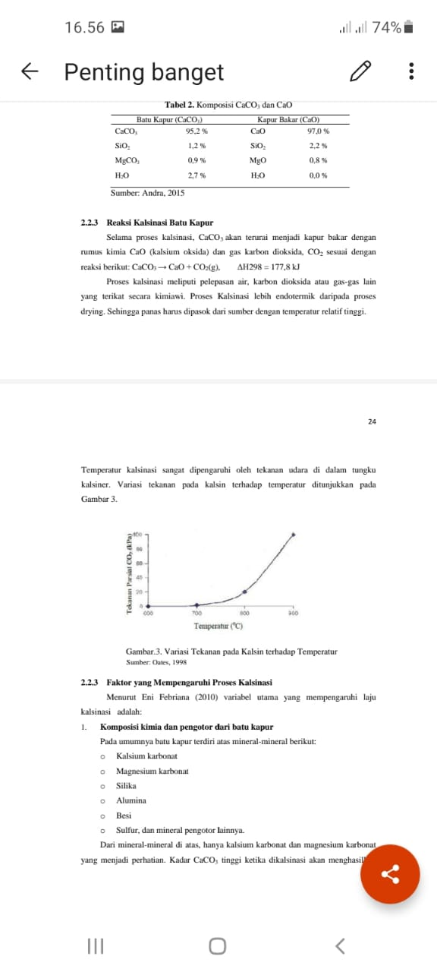
Figure 1. Kalination Process

Based on ISO 1567:1999 flexural/flexibility, the most important tool used to measure flexural strength/flexibility is the Three-point bending flexural test [4]. Flexural strength is a combination of tensile strength and compression strength. Flexural/flexural strength is associated with intraoral denture fracture when used in the oral cavity due to flexural fatigue because the denture base receives repeated masticatory loads [5]. High flexural/flexural strength is very important in successful denture fabrication because alveolar bone resorption is a gradual and irregular process that can lead to unbalanced denture support [6].

Measurement of flexural strength/flexibility of research samples using Bending Testing Machine. The research sample was given a center line as the point of emphasis of the test. Then the research sample will be supported at both ends with a pedestal distance of 40 mm. The pressure is applied in the middle by the Bending Testing Machine until the sample breaks and the tool shows the maximum pressure value23. Then the flexural strength/flexibility will be calculated using the formula [7] :

$$s=\frac{3 P×L}{2 b×d^{2}}$$

description :
s = flexural strength/flexibility (MPa)
P = maximum load (N)
L = support distance (mm)
b = sample width (mm)
d = sample thickness (mm) [8]

METHOD
The method used in this research is the experimental method. This study aims to determine the quality of the materials used in flexural testing. Pensi shells are mostly obtained from around the lake. This study varied the composition of the pensi shell and felsdpar in the manufacture of dentures for flexibility testing where the content of the pensi shell was Cao which had been calcined.
Research preparation includes the preparation of tools and materials that will be used for research. The material used in this study was pensi shell waste taken from around Lake Maninjau, felsdpar, quartz, and kaolin. The shells of the pensi shells were cleaned with water and distilled water, then dried in the sun. The tools used in this research include XRF, Bending Testing Machine, oven, furnace, mortar and pestle, sieve, and evaporating dish.
- Material Preparation
The materials used in the research in the manufacture of dentures are based on materials that contain a lot of CaO. The main ingredients in its manufacture are pensi shell, felsdpar, and quartz, and kaolin.
1) Repair of the pensi shell
At this stage the pensi shells are cleaned of the remaining dirt and pensi meat left on the shells. Pensi skin is washed clean with running water many times. After that, it was dried under the sun, referring to the method developed by [9].

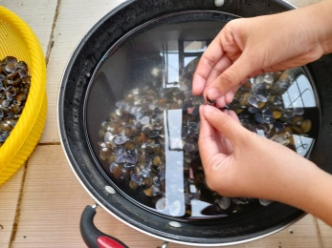
Figure 2. Cleaning the shell of the pensi clam (Corbicula moltkiana)

The calcination process of pensi shells refers to research conducted by [10]. The calcination process was carried out at 1000℃ for 4 hours, which increased at this point at a rate of 10℃/min every 1 hour. Calcination process to obtain CaO content in pensi shells with a melting point of 825℃. The cured material is then mechanically milled before sieving to obtain material that passes through a 200 mesh sieve. This fine powder was analyzed by XRF to obtain the content contained in the pensi shell.

2) Preparation of denture materials
Prepare all materials for making dentures including calcined pensi shell powder, felsdpar, quartz, and kaolin. All ingredients are first sieved with a 200 mesh (0.75 $μ$m) sieve. after that, mix all the ingredients, stir until homogeneous then printed with a mold, then dry the sample for 24 hours.

- Formulation and manufacture of denture samples
The sample size of denture research, which is 90 m m × 18 mm × 8 mm, was found in the research of [11]. On the denture base there are 4 samples with variations in the composition of 1 sample without using pensi shell powder and 3 samples varying with pencil shells. for variations in the composition of the pensi shell including 0 grams, 20 grams, 25 grams, and 30 grams. All materials are mixed and added resin and molded in the mold. The composition of the sample can be seen from the table below.

Table 1. Denture Material Composition
No | Total mass of ingredients 100 grams
No | Feldspar (grams) | Quartz  (grams) | Kaolin  (grams) | CaO  (grams) | Acrylic Resin
S1 | 50 | 20 | 30 | 0
S2 | 30 | 20 | 30 | 20 | 30 ml
S3 | 25 | 20 | 30 | 25
S4 | 20 | 20 | 30 | 30

After the printed sample dries, then the sample is mashed first using sand paper. Then the sample is labeled with a name before characterization testing with the Bending Testing Machine. Samples can be seen in the image.

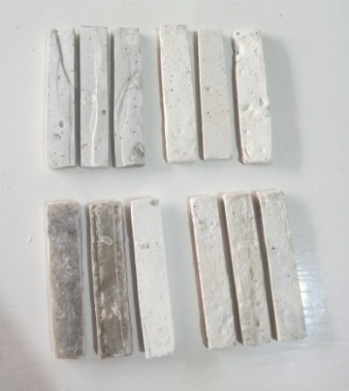
Figure 3. Smooth specimen surface
- Flexibility testing with bending testin machine

In testing the flexibility using the Bending Testing Machine. The test uses a bearing distance of 40 mm at a speed of 20 meters/second [12]. After that, the sample is tested until it breaks. Flexibility testing can be seen as follows.
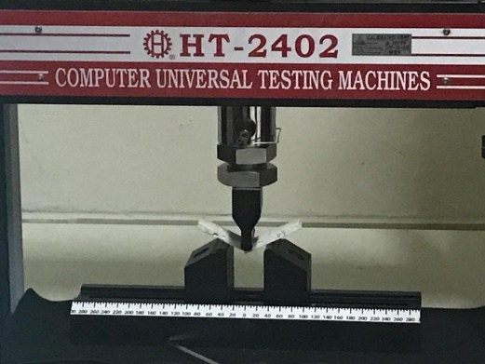
Figure 4. Sample characterization test

After the test is carried out, the results of the sample fracture are obtained, and the data will be displayed on the monitor screen, which can be seen in the figure.

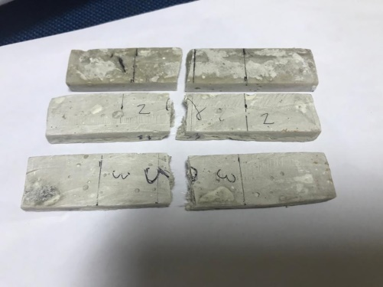
Figure 5. Samples that have been tested

RESULTS AND DISCUSSION
The results of this study are in the form of identification data on the material content tested using XRF, flexural strength using a Bending Testing Machine. Based on the value of flexibility to dentures, with variations in composition between feldspar, koalin, quartz, and pensi shells. The value of flexibility is seen from how much of the composition of the oxide compound is used in each material, especially in the pensi shell powder which is processed by testing using X-Ray Fluorescence. Then, all the materials will be printed according to the size used and the flexibility value is tested using the Bending Testing Machine.
Based on table 7. it can be seen that the content of pensi shell shell material (Corbicula Moltkiana) is CaO, Ag2O, P2O5, Al2O3, SrO and so on. Where the content of the element CaO oxide is more than other elements.
The results of the data obtained that the value of flexibility for all samples of material content in pensi shell powder after calcining at a temperature of 1000℃ for 4 hours. For pensi shell data (Curbicula Moltkiana) the elements were CaO 97.121%, Ag2O 0.643%, P2O5 0.588%, Al2O3 0.59%, SrO 0.108%. From the data it is observed that
the lowest is in sample 1 and the highest flexibility value is in sample 4. The flexibility value for each sample can be seen in table 2.

Table 2. Results of Flexibility Measurement
Sample | Flexibility value (MPa)
1 | 5,727
2 | 12,170
3 | 15,034
4 | 25,778

From the data above, it can be obtained that the value of the smallest denture flexibility is 5,727 MPa, namely in sample 1 with variations of pensi shell powder and 20 grams, felsdpar is 30 grams, while for the highest denture flexibility value is 25.778 MPa which is shown in the sample. 4 with a variation of 30 grams of pensi shell and 20 grams of felsdpar. The results of the flexibility value in each sample increased with increasing variations in the given shell. Therefore, the increase in the value of denture flexibility is influenced by the high CaO content in the pensi shell which functions as a reinforcement. The increase can be seen in the graph.

Figure 6. Graph of Increase in Flexibility in Dentures

The results of this study indicate that the value of flexibility in denture samples without additional pensi shell (CaO) is smaller than denture samples given additional pensi shell powder (CaO). This is because the CaO content in the pensi shell has become a reinforcement in the denture samples formed by the calcination process. While in the manual mixing process, the printed material is not mixed evenly, so the resulting sample has an uneven surface but is smoothed first.

CONCLUSION
Based on the research that has been done, some conclusions can be drawn as follows, Flexibility of the denture without the addition of CaO Pensi shells have the smallest average flexibility of 5.727 MPa. While the flexibility of dentures with the addition of CaO pensi shells has the largest average flexibility of 25.778 MPa. The addition of CaO from the pensi shell affects the flexibility value of the denture. The more CaO added, the higher the flexibility value produced. The CaO content obtained in this study was 97.121%.

.

REFERENCES
- Riyanto, B., & Maddu, A. (2014). Material of Hydroxyapatite-Based Bioceramics from Tuna Fishbone. Jurnal Pengolahan Hasil Perikanan Indonesia, 16(2), 119–132.
- Wahyuni, S., Darvina, Y., & Ramli. (2015). Optimalisasi Temperatur Kalsinasi Untuk Mendapatkan Kalsit- Mahasiswa Jurusan Fisika FMIPA UNP Staff Pengajar Jurusan Fisika FMIPA UNP. Pillar of Physics, 6, 81–88.
- Rauf, N., Suryani, S., & Saputra, S. (2013). Pengaruh komposisi bahan terhadap kekerasan gigi tiruan berbasis keramik. 65–67.
- Sakaguchi R, Ferracane J, Powers J. Craig’s restorative dental materials. 14th ed. St.Louis: Elsevier, 2018: 136-54.
- Naji A, et al. Recent advances and future perspectives for reinforcement of poly(methyl methacrylate) denture base materials: A Literature Review. Journal of Dental Biomaterials 2018; 5(1): 490-8.
- Ajaj-alkordy NM, Alsaadi MH. Elastic modulus and flexural strength comparisons of high impact and traditional denture base acrylic resins. The Saudi Dental Journal 2013; 26: 15-8.
- Cevik P, Yildirim-Bicer AZ. The effect of silica and prepolymer nanoparticles on the mechanical properties of denture base acrylic resin. Ankara: Journal of Prosthodontics 2016: 1-8
- Fatihallah AA. Comparison of some mechanical properties of silanated sio2 and polyester fiber incorporation into heat cured acrylic resin. Iraqi Dental Journal 2015; 7(3): 90-6.
- Fadhilah, M., & Ramli, R. (2019). Pengaruh Suhu Sintering Pada Penyerapan Gelombang Mikro Nanokomposit Nife 2 O 4 / Pvdf Untuk Material Penyerap Radar Mahasiswa Fisika , FMIPA Universitas Negeri Padang Staf Pengajar Jurusan Fisika , FMIPA Universitas Negeri Padang. 12, 98–103.
- Ramakrishna, Chilakala, et al. "Extraction of Precipitated Calcium Carbonate from Oyster Shell waste and Its Applications." Journal of Energy Engineering 27.1 (2018): 51-58.
- Suryaningsih, I. W., & Kaelani, Y. (2016). Studi Eksperimental Kekuatan Bending Material Gigi Tiruan Dari Resin Akrilik Berpenguat Fiber Glass Dengan Variasi Susunan Serat Penguat. Jurnal Teknik ITS, 5(2), 171–175. https://doi.org/10.12962/j23373539.v5i2.20790
- Sundari, I., Sofya, P. A., & Hanifa, M. (2016). Studi kekuatan fleksural antara resin akrilik heat cured Dantermoplastik nilon setelah direndam dalam minuman kopi Uleekareng (Coffea robusta). Journal of Syiah Kuala Dentistry Society, 1(1), 51-58.

