SEISMIC RATE CHANGE ANALYSIS BASED ON SPATIAL DISTRIBUTION OF SEISMOTECTONICS IN NORTHERN SUMATRA
Vicky Fikrotu Zakiyah¹, Syafriani¹*
¹ Department of physics, Universitas Negeri Padang, Jalan Prof. Dr. Hamka Air Tawar Barat, Padang, 25171, Indonesia
Corresponding author. Email: syafri@fmipa.unp.ac.id
ABSTRACT
The northern Sumatra has a high level of seismic activity. Before a significant earthquake occurs, there is a seismic quiescence phenomenon that precedes a significant earthquake.This phenomenon can be observed in seismic rate changes based on the spatial distribution of z-value. The data used are from the NEIC/USGS website, period 1990-2021. The study was conducted in five focus zones, three zones in the 2004 (9.2 SR), 2005 (7.8 SR) 2010 (7.1 SR) earthquake, two zones with coordinates 0.6-1.8 North Latitude and 96.8-97.6 East Longitude and zones with coordinates 3.6-4.8 North Latitude and 97.8-98.6 East Longitude. Using the z-value spatial distribution method, the region is divided into several grids. Z-value is calculated for each grid and describes the seismic rate change in the northern Sumatra. Based on the results obtained, before the 2004, 2005, and 2010 earthquake events, there was a seismic quiescence phenomenon that preceded the earthquake event. The seismic quiescence phenomenon appears a few years in early 2021 in a zone that has high seismic activity. Meanwhile, in zones that have low seismic activity, the increase seismic activity appears six years before the beginning of 2021. The spatial distribution of z-values ​​in early 2021, there is a phenomenon of a decrease in seismic activity in several areas of northern Sumatra.
Keywords : earthquake, seismic quiescence, seismic rate change, z-value
 | This is an open access article distributed under the Creative Commons 4.0 Attribution License, which permits unrestricted use, distribution, and reproduction in any medium, provided the original work is properly cited. ©2019 by author and Universitas Negeri Padang.

INTRODUCTION
Earthquakes are vibrations or shocks that occur on the earth's surface as a result of sudden release of energy in the earth [1]. An American seismologist, Reid (K.E Bullen, 1965; B and Bolt, 1976) stated a theory known as the "Elastic Rebound Theory". According to this theory, earthquakes occur in deformed areas. Where deformation occurs due to stress and strain in the earth's layer [2].
Rock deformation is a change in rock shape caused by external forces acting on the rock. The stress applied to the rock is in the form of a force that causes changes in the rock. As a result of the force, the rock undergoes a change or strain. Changes that occur in rocks in the form of shape and volume during the deformation process [3]. When there is deformation in an area, this indicates seismic activity in the area.
Seismic activity can be analyzed based on the magnitude-frequency distribution relationship. This can be seen based on the characteristics of the seismotectonic parameters, namely a-value and b-value [4]. A-value describes the condition of the area that is affected by the number of earthquake events and the area. While the b-value describes the local tectonic stress state of rocks in an area [5]. B-value is obtained from the relationship between the magnitude and frequency formulated by Gutenberg and Richter using the following linear equation [6]:
Log N = $a-bM$ (1)
Where N is the frequency of earthquakes and M is the magnitude of earthquakes, a and b are constants. A large a-value indicates the area has high seismic activity, while a smaller a-value indicates low seismic activity [7].
A low b-value is directly proportional to the increase in the stress level before the earthquake. The greater the b-value of an area, the higher the level of rock fragility. This shows the resistance of rocks to the pressure received by endogenous forces on the earth's layer [8].
The Sumatra region has 2 tectonic conditions that affect seismic activity, namely the Subduction Zone and the Sumatran Fault [9]. The fault is the place where the earthquake occurs, because the resistance to stress on the fault is relatively weak [10]. The northern Sumatra is one of the seismically active areas and has high seismic activity.
Based on the catalog of significant and damaging earthquakes from the BMKG, many significant earthquakes have occurred in the northern Sumatra, including; the North Sumatra earthquake (1984) with a magnitude of 7.4 SR that occurred in the high seas near Nias Island; the 1843 Gunung Sitoli earthquake and the 1861 Tapanuli-Sibolga earthquake with the potential for a tsunami; the Gunung Sitoli earthquake (2005) with a magnitude of 8.6 SR which has the potential for a tsunami; the devastating Meulaboh (2010) earthquake with a magnitude of 7.4; the Nias Islands earthquake (2005) with a magnitude of 7.8 SR did not have the potential for a tsunami and the Aceh earthquake (2004) with a magnitude of 9.2 SR had the potential for a tsunami and claimed more than 150,000 lives [11].
Efforts are made to reduce the risk and impact of large earthquakes, namely monitoring precursors in areas considered to have the potential for a large earthquake. In observing the symptoms that appear before a large earthquake occurs, it can be done by analyzing the seismic quiescence phenomenon [12].
Seismic quiescence precursor is a relative decrease in the number of earthquakes or energy in a seismically active area in a certain time interval [13]. The area where the seismic quiescence phenomenon occurs still has stress and strain in the rock, but in a small amount and does not cause rock deformation but energy accumulation still occurs. There was a seismic quiescence phenomenon around the mainshock several years before the large earthquake event [1]. This phenomenon can be observed based on seismic rate changes.
Seismic rate changes are changes in the number of earthquakes or energy in a seismically active area per unit time. Changes in the number of earthquakes that occur depend on the level of stress and strain in the rocks in the area. Energy stored under the earth's crust for a certain period of time is potential energy which can be released at any time in the form of an earthquake. The energy released can be large or small depending on the characteristics of the rock present and the magnitude of the pressure supported by the geological structure of the area. The level of rock fragility of an area can be known by looking at the seismotectonic parameters of the earthquake [10]. Brittle rock (heterogeneous) contains little energy because it is immediately released in the form of small earthquakes. Strong rock contains a lot of energy because earthquakes are rare and the accumulation of energy occurs over a long period of time. An earthquake with a large magnitude will occur because the aid is no longer able to withstand the stress on the rock [1].
Seismic rate change analysis can be done by determining the standard deviation of Z in the region. This method aims to detect the possibility of a period of low seismicity anomaly before the mainshock near the earthquake epicenter. A z-value positive describes a decrease in seismic activity, while a z-value negative describes an increase in seismic activity. The decrease in the average level of seismicity in the years leading up to the occurrence of a strong earthquake should be suspected as a seismic quiescence phenomenon [15]. The calculation of the z-value in the northern Sumatra will result in the seismic rate changes and a seismic quiescence phenomenon will be obtained that precedes a large earthquake event.

METHOD
Earthquake data used sourced from the website of the National Earthquake Information Center US Geology Survey (NEIC/USGS) for the period 1990-2021. The area used is at coordinates 0.5°-6° North Latitude and 94°-100° East Longitude. It has a magnitude of 8.1 ≥ M ≥ 3 SR with a magnitude of type mb (magnitude body). Data processing is processed using the ZMAP V 6.0 program [15].
Before the earthquake data is processed, the magnitude of each earthquake data is converted first. This is because the data has different magnitude types. Because a lot of data with magnitude mb type, then the data is converted into magnitude body (mb). Once converted, the data is then inputted into the ZMAP software. Then, declustering of the earthquake data was carried out using the Reasenberg algorithm (1985), which aims to eliminate the effects of foreshocks and aftershocks. ZMAP tools can display seismicity distribution maps for the northern Sumatra region. In ZMAP, the a-value and b-value can be obtained by looking at the frequency magnitude distribution on the z-tools menu.
Seismic rate changes were analyzed using the spatial distribution z-value method. Before doing the calculations, the research area is divided into several grids, then each grid has a grid spacing of 0.1 x 0.1. The number of earthquake events in one grid is set to 100 events. Z-value is calculated using equation (2) [16]
$z\left(t\right)=\frac{{(R}_{bg}-R_{w})}{\sqrt{\frac{S_{bg}}{n_{bg}}+\frac{S_{w}}{n_{w}}}}$ (2)
Where $R_{bg}$is the average seismicity level of all data except the selected period interval. $R_{w}$ is the average seismicity level of the selected data. $S_{w}$ is a variation of the selected period. $n_{bg}$ and $n_{w}$ are the number of events in all selected data [16].
The calculation of the z-value is carried out according to the number of selected earthquakes in each nude $N_{ZMAP}$. The time period of $T_{start}$ and $T_{end}$ are divided into $N_{∆t}$ short time (ST) time window with the width of each $N_{∆t}$ is $∆t$. The background seismicity level is calculated as follows.
$R_{bg }=\frac{1}{n_{bg}}\left(\sum_{i-1}^{N_{1}}{n_{i}}+ \sum_{i=N_{2}+1}^{N_{∆t}}{n_{i}}\right) n_{i}=1,…….,N_{∆t}$ (3)
Where $n_{i}$ is the amount of earthquake data calculated in the ST time window and $n_{bg}$ in equation (2) has the same value as $N_{1}+$ $N_{∆t}$ - $N_{2}$ is the last ST time window before entering the long-term (LT) time window, LT time window has a width $∆t$. The seismicity level $R_{w}$ in the (LT) time window is calculated using the following equation.
$R_{w}=\frac{1}{n_{w}}\sum_{i=N_{1}+1}^{N_{2}}{n_{i}}$ (4)
Where $n_{w}$ = ${∆T}/{∆t}$ then $R_{w}$ is compared with $R_{bg }$ using the previous equation (1), for $S_{bg }$and $S_{w }$ is the variation calculated using the following equations (5a) and (5b).
$S_{bg }= \frac{1}{n_{bg}}\left\{\sum_{i=1}^{N_{1}}{{\left(n_{i}+R_{bg}\right)}^{2}}+\sum_{i=N_{1}+1}^{N_{∆t}}{{\left(n_{i}-R_{bg}\right)}^{2}}\right\}$ (5a)
$S_{w=\frac{1}{n_{w}} }\sum_{i=N_{1}+1}^{N_{2}}{{\left(n_{i}-R_{w}\right)}^{2}}$ (5b)
The decrease in the average seismicity level at the selected interval, compared to the overall average seismicity level of the data represents a positive z-value . A negative z-value describes an increase in the average level of seismicity in the selected interval [14].

RESULTS AND DISCUSSION
Many earthquake events that can be used as many as 5270 earthquake events during the period 1990-2021. The magnitude of the earthquake used is 9.1 ≥ M ≥ 3 SR with a depth of 10 ≤ D ≤ 300 km. Figure 1 below illustrates a map of the distribution of seismicity in the northern Sumatra
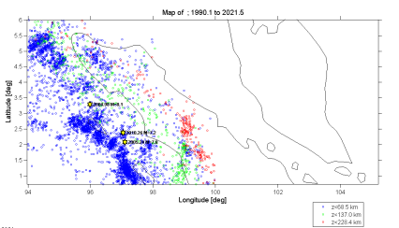  (a) | 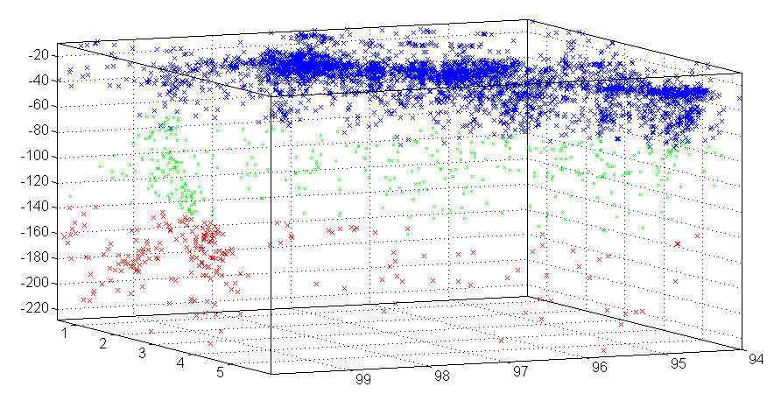  (b)
Figure 1. Regional Seismicity (a) Seismic distribution map of northern Sumatra (b) three-dimensional variation of latitude and longitude with respect to depth
Based on Figure 1 (a), it can be seen that during this period there were many earthquakes, which were dominated by medium earthquakes. There are 3 earthquake events with magnitude D ≥ 7.1 M. Based on Figure 1 (b) earthquakes with a depth of D < 68.5 km are marked in blue, earthquakes with a depth of D < 137 km are marked in green, earthquakes with a depth of D < 228.4 km are marked in red. It can be seen in Figure 1 that many shallow earthquakes occur in the waters of the Nias Islands. These earthquakes usually originate in the Subduction Zone. Earthquakes that occur on the mainland of Sumatra Island with a depth of D < 137 km are usually sourced from faults on the island of Sumatra. While earthquakes with a depth of D ≤ 300 km usually originate from the Subduction Zone.
The number of earthquake occurrences in the northern part of Sumatra can also be shown by using a cumulative curve which can be seen in Figure 2. The cumulative curve depicts the number of earthquakes that occur with time for the data used. The frequency–magnitude indicates the relationship between the magnitude and the number of earthquakes that occur. Frequency-magnitude distribution curve in the northern Sumatra is shown in Figure 3.
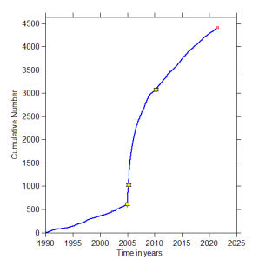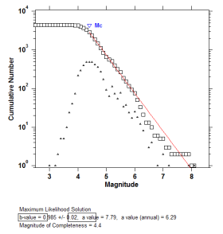
Gambar 2. Cumulative Number curve Gambar 3. Magnitude frequency distribution

As seen in Figure 2 earthquake events are increasing from year to year. Based on Figure 2 in the period of 1 year between 2004 and 2005, there was an increase in seismic activity. Towards the year 2010 also experienced an increase in seismic activity. Figure 3 shows the regional distribution curve, where the magnitude of completeness (Mc) of this region according to the data used is 4.4. This shows that the recording capability of the earthquake data catalog is relatively good at a minimum magnitude of 4.4. Processing b-value for the northern Sumatra is obtained, the b-value in the northern Sumatra is 0.985 with an error rate of approximately 0.02 and an a-value of 7.79 with a-annual value of 6.29.
The spatial distribution of z-value in the North Sumatra region before the 2004 earthquake with a magnitude of 8.1 SR can be seen in Figure 4.
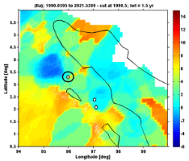  (a) | 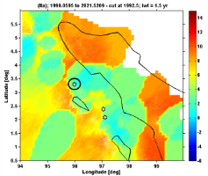  (b) | 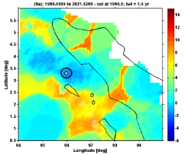  (c)
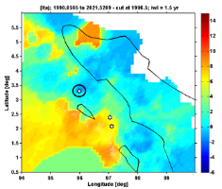  (d) | 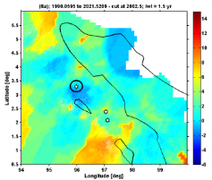  (e) | 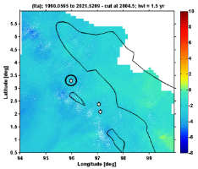  (f)
Figure 4. Spatial distribution z-value before the 2004 earthquake event (8.1 SR) with iwl 1.5 years (a) cut at 1990.2 (b) cut at 1992,5 (c) cut at 1994,5 (d) cut at 1996,5 (e) cut at 2002,5 (f) cut at 2004,5
Distribution z-values ​​before the 2004 earthquake event are presented in several time slices starting from the cut at 1990.2 using iwl of 1.5 years. Based on Figure 4 the spatial distribution of the z-value shows a seismic quiescence phenomenon before the 2004 earthquake event. Figures 4 (a) and 4 (b) depict negative z-values ​​which indicate a seismic quiescence phenomenon decrease in seismic activity. Where a decrease in seismic activity indicates the presence of energy accumulated in the area. At the cut at 1994,5 the area around the mainshock began to occur on a small scale seismic activity until a large earthquake occurred in 2004 which can be seen in Figure 4 (f).
The distribution of z-value in the North Sumatra region before the 2005 earthquake with a magnitude of 7.8 SR can be seen in Figure 5.
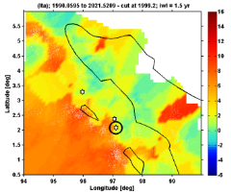  (a) | 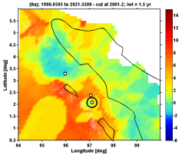  (b) | 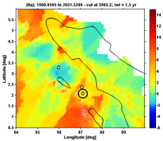  (c)
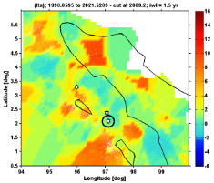  (d) | 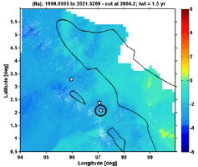  (e) | 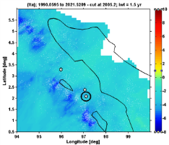  (f)
Figure 5. The spatial distribution of z-value before the 2005 earthquake event (7.8 SR) with an iwl of 1.5 year (a) cut at 1999.2 (b) cut at 2001,2 (c) cut at 2002,2 (d) cut at 2003,2 (e) cut at 2004,2 (f) cut at 2005,2
Distribution z-value in the area before the 2005 earthquake event is displayed in several time slices starting at the cut at 1999.2 using iwl of 1.5 years. Based on Figure 5 before the 2005 earthquake, there was a decrease in seismic activity around the mainshock. After the 2004 earthquake with a magnitude of 8.1, the northern Sumatra experienced an increase in seismic activity and another earthquake occurred in 2005. This can be seen from the spatial distribution of z-value cut at 2004.2 and 2005.2. The anomaly found in the 2005 earthquake is the same as the anomaly in the 2004 earthquake. This is because two adjacent earthquake events will cause the seismic quiescence anomaly to merge into one anomaly [14].
The distribution of z-value in the North Sumatra region before the 2010 earthquake with a magnitude of 7.1 SR can be seen in Figure 6.
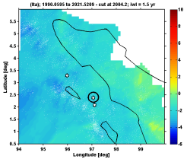  (a) | 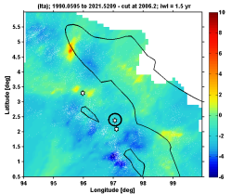  (b)
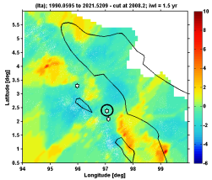  (c) | 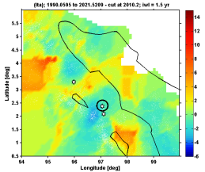  (d)
Figure 6. Spatial z-value distribution before the 2010 earthquake (7.1 SR) with an iwl of 1.5 years (a) cut at 2004.2 (b) cut at 2006,2 (c) cut at 2008,2 (d) cut at 2010,2
The z-value distribution in the area before the 2010 earthquake is shown in multiple time slices starting at the cut at 2004.2 using iwl of 1.5 years. Based on Figure 6 after the 2004 and 2005 earthquakes around the study area there was a decrease in seismic activity. As shown in Figure 6, the 2010 earthquake in northern Sumatra was preceded by a seismic quiescence phenomenon, this can be seen in the decrease in seismic activity around the mainshock.
The distribution of z-value in North Sumatra which has high seismic activity with coordinates 0.6°-1.8° North Latitude and 96.8°-97.6° East Longitude can be seen in Figure 7.
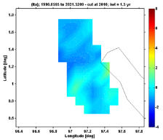  (a) | 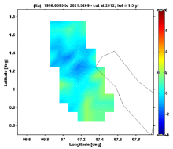  (b) | 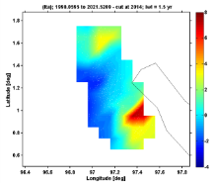  (c)
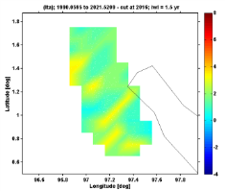  (d) | 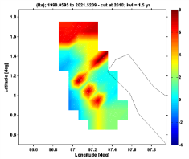  (e) | 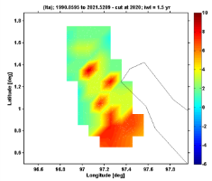  (f)
Figure 7. Spatial distribution of z-value in the area of ​​activity high seismicity with iwl 1.5 years (a) cut at 2010 (b) cut at 2012 (c) cut at 2014 (d) cut at 2016 (e) cut at 2018 (f) cut at 2020
Distribution of z-value in areas with high seismic activity are shown in multiple time slices starting at the cut at 2010 using iwl of 1.5 years. Based on Figure 7 at the beginning of 2020 there was a phenomenon of a decrease in seismic activity. This can be observed from the spatial distribution of z-values, it appears that there is a decrease in seismic activity a few years before the beginning of 2021.
The distribution of z-values ​​in the North Sumatra region which has low seismic activity with coordinates 3.6°-4.8° North Latitude and 97,8°-98.6° East Longitude can be seen in Figure 8.
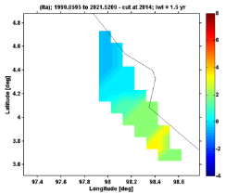  (a) | 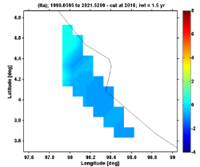  (b)
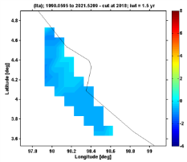  (c) | 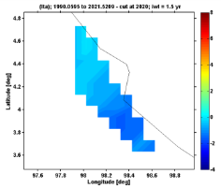  (d)
Figure 8. Spatial distribution of z-value in areas of high seismic activity with an iwl of 1.5 years (a) cut at 2014 (b) cut at 2016 (c) cut at 2018 (d) cut at 2020.
The distribution of z-value ​​in areas with low seismic activity is shown in several time slices starting at the cut at 2010 using iwl of 1.5 years. Based on Figure 8 the spatial distribution of z-values ​​in the northern Sumatra region shows an increase in seismic activity starting six years before the beginning of 2021.
The distribution of z-value in the northern Sumatra region in early 2021 can be seen in Figure 9.
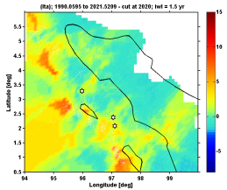  (a) | 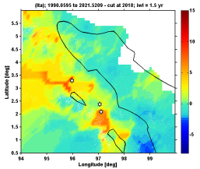  (b)
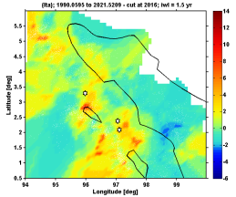  (c) | 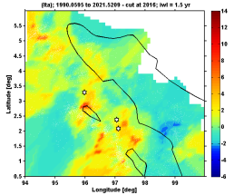  (d)
Figure 9. The z-value distribution of the northern Sumatran region at the beginning of the beginning of 2021 (a) cut at 2020 (b) cut at 2018 (c) cut at 2016 (d) cut at 2014
The distribution of z-value in the northern Sumatra region at the beginning of early 2021 is shown in several time slices starting at cut at 2020 using iwl of 1.5 years. Based on Figure 9 in the northern Sumatra at the beginning of early 2021 there was a seismic quiescence phenomenon in several areas of northern Sumatra. The decline in seismic activity in the years leading up to a large earthquake should be suspected as a precursor to a medium-scale earthquake.
Areas where there is a phenomenon of a decrease in seismic activity are marked with a positive z-value. This indicates the accumulation of energy in the region. When energy is accumulated, the stress on the rock has not exceeded the rock's elastic capacity. So that the accumulated energy can not be released. Areas experiencing increased seismic activity are marked with a negative z-value. This indicates the release of energy in the region. When experiencing increased seismic activity, the stress on the rock exceeds the maximum bearing capacity of the rock and the energy within the earth is released slowly. Areas that experience a full increase in seismic activity, this indicates a sudden release of large amounts of energy with a large-scale magnitude.
Seismic rate changes are changes in the number of earthquakes or energy in the seismically active region per unit time. Based on the results obtained, seismic rate changes are seen at the time of an earthquake and after an earthquake. Prior to the earthquake, a decrease in seismic activity will be seen in the years before the earthquake. After an earthquake, an increase in seismic activity will be seen, this is because the energy has been released in the form of an earthquake. The amount of energy released can be seen in the strength of the earthquake magnitude.

CONCLUSION
Based on the research that has been done, the northern Sumatra in 1990-2021, has a high level of seismic activity. This is indicated by the number of earthquakes that occur in the area. In determining the spatial distribution of z-value for the period 1990-2021, the northern Sumatra has three large earthquake events and areas with high and low seismicity levels. From the results of the study, the three epicenter zones of the 2004, 2005 and 2010 earthquakes, before a large earthquake occurred, were preceded by a seismic quiescence phenomenon. Then there is a seismic quiescence phenomenon for about few years in early 2021 in an area that has high seismic activity. Meanwhile, in zones that have low seismic activity, the increase seismic activity appears six years before the beginning of 2021. General view of distribution z-value for the northern part of Sumatra in early 2021, there was a decrease in seismic activity in several areas of northern Sumatra which should be suspected as one of the precursors of earthquakes in the future. Based on the analysis of seismic rate changes, there is a seismic quiescence phenomenon several years before the occurrence of a large or significant earthquake. Meanwhile, areas where earthquakes have occurred will experience an increase in seismic activity.

REFERENCES
- Sunarjo, M. T. 2012. “Gempabumi Edisi Populer”. Jakarta : Badan Meteorologi Klimatologi dan Geofisika
- Linda, N. I. 2019. “Analisis Distribusi Spasial dan Temporal Seismotektonik Berdasarkan Nilai B-Value Dengan Menggunakan Metode Likelihood Di Pulau Jawa”. Jurnal Sains dan Pendidikan Fisika Jilid 15, Nomor 1, 16-31.
- Lowrie, W. 2007. Fundamental Geophysics. New York : Cambridge : University Press
- S. Syafriani, “IOP Conference Series: Materials Science and Engineering 335.” An Investigation of Seismicity for the West Sumatera Region Indonesia, p.2, 2018.
- Nugroho Budi W, J. N. 2017. “Analisis Seismisitas Dan Energi Gempabumi di Kawasan Jalur Sesar Opak-Oyo Yogyakarta”. J. Sains Dasar.
- Gutenberg, B., and Richter, D. C. (1942). Earthquake Magnitude, Intensity, Energy, and Acceleration. Bulletin of the Seismological Society of America, 32(3), 163-191.
- Jihan Nia Shohaya, U. C. 2013. “Survey dan Analisis Seismisitas Wilayah Jawa Timur Berdasarkan Data Gempa Bumi Periode 1999-2013 Sebagai Upaya Mitigasi Bencana Gempa Bumi”. Jurnal Penelitian Fisika dan Aplikasinya (JPFA).
- Ramadhan Priadi, J. A. 2017. “Penentuan Nilai B-value Untuk Identifikasi Kerentanan Batuan Dengan Mempertimbangkan Nilai Slowness Pada Wilayah Pidie Jaya”. Jurnal Fisika.
- Naryanto, H. S. 2008. “Analisis potensi Kegempaan dan Tsunami di Kawasan Pantai Barat Lampung Kaitannya Dengan Mitigasi dan Penataan Kawasan”. Jurnal Sains dan Teknologi Indonesia.
- Andrean V. H. Simanjuntak, O. 2017. “Perbandingan Energi Gempa Bumi Utara dan Susulan”. Jurnal Fisika FLUX.
- BMKG. 2010. “Katalog Gempabumi Signifikan dan Merusak 1821-2009”. Jakarta : Sub Bidang Mitigasi Gempabumi dan Tsunami.
- Puslitbang BMKG. 2010. “Integrasi Pengamatan Parameter Geofisika Dalam Usaha Prediktabilitas Gempabumi”. Laporan Akhir, Program Intensif Kementerian Negara Riset dan Teknologi Tahun 2010.
- Bambang Sunardi, S. D. 2013. “Analisis Periodesitas dan Perubahan Tingkat Kegempaan Wilayah Jawa Barat Berbasis Statistik.” Meteorological Climatological and Geophysical Agency.
- Ardiansyah, S. 2014. “Siklus dan Model Perkiraan Kejadian Gempabumi di Daerah Bengkulu”. Jurnal Fisika dan Aplikasinya.
- Katsumata, K. 2011. A Long-Term Seismic Quiescence Started 23 Years Before The 2011 of Pacific of Tohoku Earthquake ( M=9.0). Earth Planets Space 63(7), 709-712.
- Wiemer & Wyss, dkk. 2001. ZMAP a Tools For Analyses Of Seismicity Patterns, Typical Application and Uses : A Cookbook.
- Wiemer, S. 2001. A Software Package to Analyze Seismicity: ZMAP. Seismological Research Letters, Vol. 72, 373-382.

