THE EFFECT OF THE AMOUNT OF IMMERSION OF ZnO DOPING Ag THIN LAYER ON BAND GAP WITH DIP COATING METHOD
Farhan El Maulid^{1*}, Yohandri¹, Hary Sanjaya²
¹ Deparement of Physics, State University of Padang, Jalan Prof. Dr.Hamka, Air Tawar Barat, Padang, West Sumatera, 25171, Indonesia
²Deparement of Chemical, State University of Padang, Jalan Prof. Dr.Hamka, Air Tawar Barat, Padang, West Sumatera, 25171, Indonesia
Corresponding author. Email: farhanmaulid27@gmail.com
ABSTRACT
The availability of fossil energy is decreasing day by day. Therefore, a New Renewable Energy solution is needed. One of the renewable energy is DSSC. DSSC is a photoelectrochemical-based solar cell that has a lower cost, less difficult preparation, and is environmentally friendly. DSSC be composed of working electrode, dye, electrolyte, and counter electrode. This research intend to investigate the performance of the working electrode where the manufacture of a thin film using the dip coating method with variations in immersion and its effect on the efficiency of DSSC. This research is an experimental research. In this study, the semiconductor working electrode was made based on 9% ZnO/Ag synthesis by going through a sol-gel process. The working electrode was coated with variations of immersion 1, 3 and 5 times. The 9% ZnO/Ag thin layer was characterized by UV-DR Spectrometer. Based on the results, 9% Ag doped ZnO deposited on the ITO substrate with variations of immersion 1, 3 and 5 times showed, a band gap of 3.09 eV, 3.10 eV and 3.12 eV, respectively. Based on these data, it was applied to DSSC with the optimum efficiency shown at the electrode 1 time dip. Therefore, the greater the amount of immersion, the lower the efficiency of the DSSC..
Keywords : Sol-gel, thin film, dip coating, and DSSC
 | This is an open access article distributed under the Creative Commons 4.0 Attribution License, which permits unrestricted use, distribution, and reproduction in any medium, provided the original work is properly cited. ©2019 by author and Universitas Negeri Padang.

INTRODUCTION
Energy can be renewed repeatedly without fuel limit, called renewable energy. Renewable energy can be expected to replace fossil energy. In increasing renewable energy, the Indonesian government supports and issues government regulation No. 79 of 2014 which contains the national energy regulations. The arrangement targets that by 2025 the dependence on energy sources is estimated to be reduced by around 31% [1]. Meanwhile, alternative power plants that already exist in Indonesia include hydroelectric, steam power, geothermal energy, biomass energy and solar energy. One of renewable energi is solar power plants. Solar cells have several generations in a row, namely the first generation of sillicon fuel with sillicon water, thin film based solar cells and DSSC. One of the interesting solar cell generations to be developed is Dye Sensitized Solar Cell (DSSC).
DSSC uses photoelectrochemical working principle. DSSC was invented in 1991 by Michael Gratzel. DSSC uses ingredients that easy to find, which is dye from plant extracts [2]. DSSC working principle, when sunlight hits the surface of the substrate, photons will be forwarded to the dye which will absorb sunlight. After being absorbed by the dye, electrons are excitation in the valence band to the conduction band in the semiconductor layer. When the dye is oxidized it will form a hole. In an electrolyte solution, iodide will transfer electron to fill holes in the dye. Electrons will be excited in the ZnO layer will be transferred to the counter electrode with an external circuit. Where the counter electrode, one of which can be coated with platinum or carbon, serves as a catalyst in the reaction. Then the triiodide will recive electrons from the counter electrode as shown in figure 1.
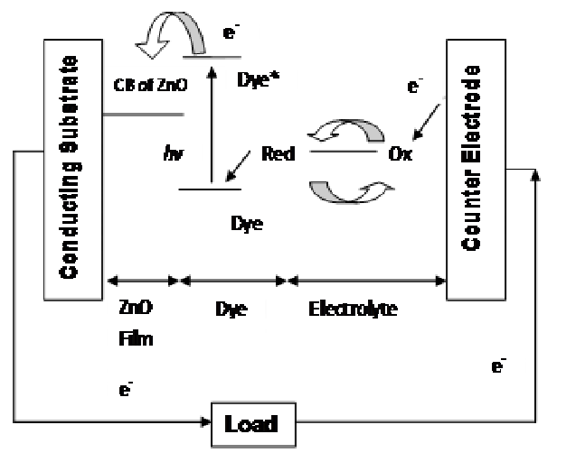
Fig. 1. DSSC
(Source: Reff. [3])
DSSC research that was developed in 2019, Motlan made a thin layer for DSSC using a ZnO thin film without doping, using hibiscus flower dye which has a band gap of 3,14 with an efficiency of 0,2427% [4]. In this study using a spin coating technique varying the rotational speed up to 1200 rpm. In this study, it is still seen that the efficiency has a low value and is in the form of an uneven structure. In 2020, Anla made a thin layer of ZnO doped with aluminum using the Liquid Phase Deposition (LPD) method to increse the efficiency of DSSC by producing the highest efficiency of 1,51% with an aluminum doping precentage of 1,5%[5]. In the research that was developed, there is still low efficiency.
The DSSC that has been developed still has an efficiency lower than the efficiency of the first generation solar cells [6]. As for factor that can affect efficiency, such as the type of substrate, the type of semiconductor, the sensitizer, the redox reaction and the counter electrode [7]. One of the influencing factor is the semiconductor. The semiconductor that is often used in DSSC aplication is TiO2. However, the semiconductor that can be replace${TiO}_{2}$is ZnO. Where the band gap of 3.37 eV is ZnO is not doped and has a binding energy of 60 MeV which can bind more energy. ZnO has a resistivity value in the range${10}^{-4}$ – 1012 Ω.cm [8]. In visible light (400 -800 nm) ZnO will be more easily excited and ZnO will be more conductive.The type of ZnO that often used in DSSC is ZnO wuritze hexagonal.
To improve the characteristics of ZnO, doping can be given with the aim of changing the optical physical properties and electrical conductivity for the better. The best doping to improve the performance of ZnO is silver (Ag). Where Ag is classified as a transition metal, it is very well used during solar radiation so that the number of electrons will increase so that there is no recombine between electron-holes and photocatalytic activity increases. [10]. Ag is very well used for ZnO doping material because Ag can minimize energy levels in ZnO, reduce recombination and can increase photocatalytic [11]. However, there are other factors that can affect the efficiency of DSSC, namely the thin film coating method as DSSC fabrication. If the morphological structure is uneven and there are cracks or grain boundaries on the thin film, the electrons are not working optimally.The grain boundary affects the diffusion process of electrons moving to the electrodes. As a result, the electrode does not work optimally and only a few electrons reach the electrode [12]. Thin film manufacture aims to have a homogeneous and even surface by minimizing unevenness in a layer. Therefore, the method that has been developed still does not have an even and homogeneous structure [13].
One of the development of substrate coating using dip coating method. The dip coating method is a thin film coating technique by dipping the substrate into a container containing a solution. The substrate is immersed at the specified time then immersed and pulled vertically [14]. The benefit of this method are low cost, have a high level of precision and do not damage the environment [15]. The solution that sticks to the substrate will stick perfectly when it is pulled up vertically at a constant speed and the solution will go down due to the gravitational force of the earth. [16]. At the time of withdrawal can affect the thickness of the layer attached to the substrate [17]. Due to the influence of the earth's gravitational force when pulling vertically it will be easier to make thin films that are more evenly distributed and homogeneous on the substrate. When pulling with the substrate will experience evaporation from the rest of the solution. The adhering solution partially evaporates and partly will settle on the substrate as shown in Figure 2 [18].
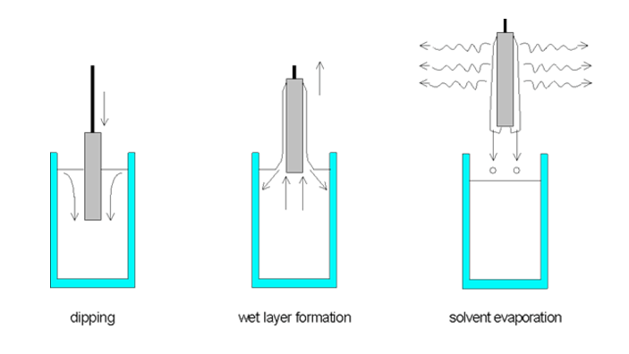
Fig. 2. Dip coating
(Source: Reff. [17])
This research aims to find out the effect of variations in the amount of ITO substrate immersion on the band gap of a thin layer of ZnO doping Ag with the dip coating method as the working electrode on the DSSC.

METHOD
- Instruments and materials
The instruments used in this research are magnetic stirrer, scales, ultrasonic cleaner, furnace, Dip Coating, digital multimeter, oven, beaker, stirring rod, vaporizer cup, UV-DR Spectrometer. While the materials used during the research are Silver Nitrate (AgN$O_{3}$), Zinc Asetatate Dihydrate (Zn($O_{3}$CC$H_{3})_{2}$ ($H_{2}$O$)_{2}$), Isopropanol (C$H_{3}O_{8}$), monoethanolamina and 70% aquadest alcohol, Potassioum iodide(KI), Iodide($I_{2}$), PEG. carbon dan Acetonitrile.
B. Research stages
The stages of implementation in this research go through several stages which can be seen in Figure 3.
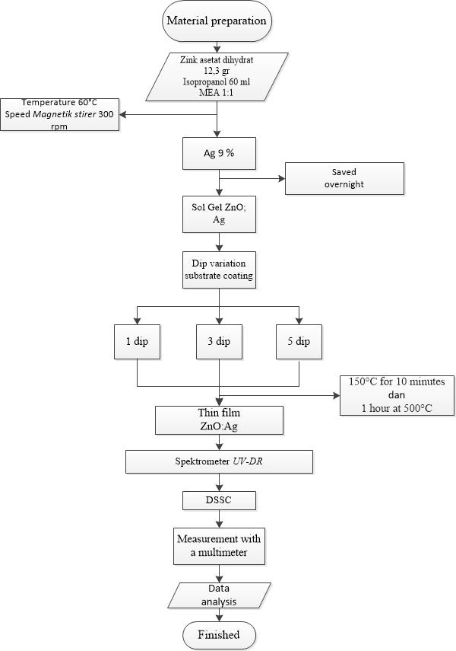
Fig. 3. Research flowchart

C. Synthesis Preparation ZnO/Ag 9%.
For the manufacture of ZnO sol gel, the raw material used is 12.3 grams of zinc acetate dihydrate which will be mixed in 60 ml of isopropanol. Then stirred with a magnetic stirrer at a speed of 300 rpm with a temperature of 60 ° C stirred until evenly distributed. Then the Mono Ethanol Amine (MEA) solution as (additive) to stabilize and homogeneous when stirred in a ratio of 1:1 with zinc acetate dihydrate (until yellowish transparent) is added to the solution. Then drop by drop mixed and stirred until it turns yellowish [9]. After evenly, it is continued to add 9% Ag doping, stirred at the same speed until the solution is transparent for 2 hours [3]. After the solution is mixed and has a transparent color, the condensation process changes from sol to gel at room temperature for 24 hours, Where during condensation the viscosity of the sol-gel increases.

D. ITO ZnO/Ag 9% substrate layer
After the sol gel is made, the glass used consists of two substrates, namely a substrate that functions as a cathode and as an anode. The size of the glass used is 2.5 cm × 2.5 cm and 1 mm of thickness. The substrate was sterilized with 7% alcohol using ultrasonic with a duration of 30 minutes, after that it was dried and continued with distilled water then rinsed at 100°C until dry. After cleaning, the glass is tapered on the part that is not coated with gel so that the coated area is only 2.5 cm × 1.5 cm. The substrate coating was carried out using a speed of 3.3 mm/s [16], a deposition time of 6 seconds, and the number of immersions to be varied on the dip coating tool. After doing the immersion variation, then calcination in the furnace within 60 minutes at a temperature of 500°C. The coated substrate was then calcined. After the working electrode has been prepared, the thin layer characterization is continued with a UV-DRS spectrometer.
E. Dye making
Making dye is done by dissolving anthocyanin substances that have been extracted as much as 0.2 grams in 100 mL of distilled water. Dissolved with a measuring flask, stir until evenly distributed and stored in a dark place so that it is not easily degraded.
F. Electrolyte manufacture
Potassium Iodide (KI) as much as 0.496 grams is dissolved in 6 mL acetonitrile. Iodine ($I_{2}$) as much as 0.076 grams is dissolved in a solution in 6 mL acetonitrile. After being prepared, the two solutions were mixed together. Then add 2.4 grams of PEG, stir until it becomes a gel [19].
G. Working electrode manufacture
On the counter electrode, use the same size of glass as the working electrode and coated with tape and cleaned as the cleaning process for the working electrode. The counter electrode is catalyzed in the form of carbon by coating the glass on the black smoke of the candle. The edges of the glass are cleaned with a tissue or cotton bod to the appropriate size for the working electrode.
F. DSSC assembly
The working electrode that has been prepared with the arrangement of Ag doped ZnO is pre-soaked in the prepared dye for 30 minutes. After soaking, it is dried and given the electrolyte above the working electrode and the counter electrode which has been coated with carbon is arranged opposite to the two electrodes flanked with paper clips so that the arrangement does not shift.
G. Characterization and measurement
This research uses a UV-DR Spectrophotometer characterization tool. The measured band gap is the effect of the addition of Ag and the effect of the amount of immersion in the thin layer. To determine the band gap can use Equation (1).
${F(R)}^{2}$ = $\frac{A^{2}}{S^{2}}$ hv - $\frac{A^{2}}{S^{2}}$ Eg (1)
Where, F(R) is the Kubelka-Munk factor, S is the scattering coefficient, R is the measured reflectance value, A is the proportional constant, and Eg is the band gap [20].
For the measurement of current and voltage on the DSSC measured by a light source carried out in sunny conditions. The DSSC measurement is carried out using Equation (2) at 11.00 WIB with a measurement time of 5 minutes.
ɳ (%)= [ $\frac{V × I }{P_{in}}$] × 100% (2)
Where η is efficiency, Pmax maximum power (Vmax × I), and Pin resource.

RESULTS AND DISCUSSION
Based on research on the synthesis of ZnO doping Ag 9% showed a decrease in the band gap in ZnO. ZnO have band gap of 3.37 eV, when doped with Ag shows a band gap of 3.00 eV as shown in Figure 4. Ag doped ZnO can minimize the band gap [3]. Because Ag is a metallic impurity atom, itu dapat meminimalkan celah pita semikonduktor ZnO.

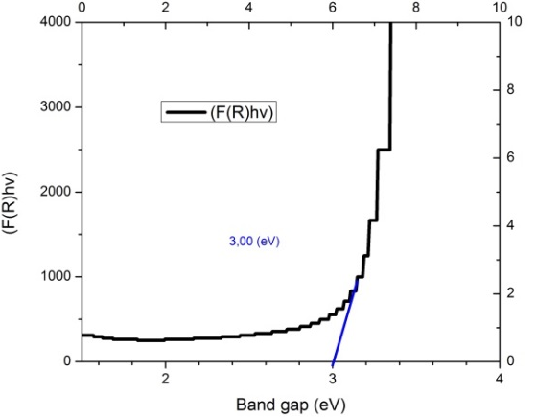
Fig. 4. Band gap ZnO/Ag 9 %
Furthermore, to determine the effect of immersion of the silver-doped ZnO substrate on the band gap using a spectrophotometer. ZnO has a band gap of about 3.37 eV when testing the UV-DR Spectrometer with 9% ZnO/Ag powder samples, the band gap value is around 3.00 eV. However, it is different from after being coated on an ITO substrate, the band gap values vary as shown in Figure 5.
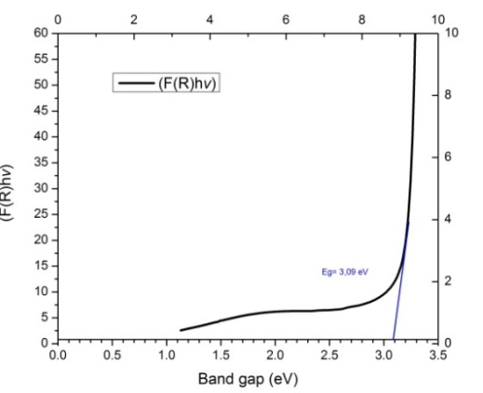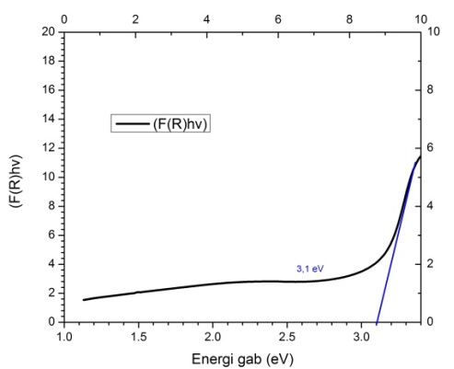
- (b)
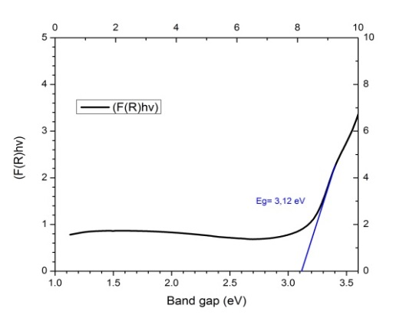
(c)
Fig. 5. Thin film band gap curve : ZnO/Ag 9% (a) 1 × dip, (b) 3 × dip, (c) 5 × dip.
UV-DRS spectrometer was used to determine the band gap value by utilizing the reflectance value by combining it with the Kubelka-Munk formula for each immersion variation. In DSSC band gap value is very influential on the performance of the working electrode. The smaller the band gap value at the working electrode, the electrons are very easy to move from valence band to conduction band. The slight band gap is found in the immersion variation 1 as shown in Table 1.

Table 1. Band gap of immersion variation in thin layer
Numer of Immersion | Band gap
1 × dyeing | 3,09 eV
3 × dyeing | 3,10 eV
5 × dyeing | 3,12 eV
The more immersion in the ITO substrate, the greater the band gap value will be. This is influenced by evenness when coating on immersion in the presence of uneven parts so that the band gap value that appears is close to the band gap value of the ITO substrate at a band gap of 3.0 eV. The number of coatings also affects the evenness of the coating, the homogeneity and transparency of the material [16]. Based on the results, one application of thin film is DSSC as shown in Figure 6.
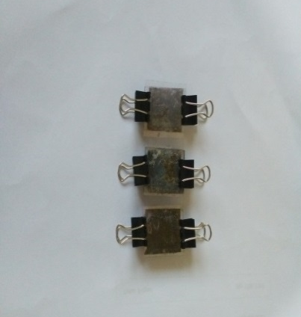
Fig. 6. DSSC with various immersion working electrode variations
Testing of electrical properties is carried out by measuring with sunlight. The effect of immersion variations on electrical properties is shown in Table 2.
Table 2. DSSC test voltage of dyeing variation on manufacture
working electrode ZnO/Ag 9%
NO | Number of immersion | Band gap (Ev) | voltage(mV) | current (mA) | Efficiency(%)
1 | 1 | 3,09 | 7,0 | 0,492 | 1,1 ${×10}^{-4}$ %
2 | 3 | 3,10 | 0,5 | 0,032 | 4,53 × ${10}^{-5}$ %
3 | 5 | 3,12 | 0,2 | 0,001 | 7,33 × ${10}^{-6}$ %

Based on Table 2, the optimum stress on DSSC 1 was obtained in a variation of 1 dip with the dip coating method.The output voltage value is still low so it affects the efficiency. Thickness can also affect efficiency. The thicker the working electrode, the lower the efficiency.This is in accordance with Ardianto's research, 2015 which shows that the thicker the working electrode coating, the lower the efficiency [21]. In this study, the decrease in efficiency can also be caused by the electrolyte, dye and catalyst used, therefore it is necessary to investigate further.

CONCLUSION
A thin layer of 9% ZnO/Ag through the sol-gel process was deposited with the dip coating method on the variation of the immersion having the optimum resistivity and band gap values, namely 1 time immersion with a band gap value of 3.09 eV.The more the number of immersion, the value of the band gap will increase. Making a thin layer as a working electrode on the DSSC by varying the immersion the more the number of immersion the efficiency on the DSSC will decrease.

REFERENCES
- Setyono., Jawoto Sih., et al., 2019. Potential Development of New Energy and Renewable Energy in Semarang. Journal Riptek. Volume13. Number 2. Page 177-186.
- Hardani. 2019. Dye Sensitized Solar Cell (DSSC) Theory and its application. Surakarta: Sebelas Maret University.
- Lanjewar, Mangesh dan Jignasa V Gobel. 2016. Encehanced Performanced of Ag Doped ZnO Thin Film DSSCs Prepared By Sol Gel Spin Coating. Chemical Engineering Departement
- Motlan, Lelyana, Nurdin. 2019. Dye Sensitized Solar Cell (DSSC) Using ZnO Thin Film With Variaton of Ration Speed Made of Hibicus Flower Dye. Journal physics. 7 (2): 13-17.
- Hardi, Anla Fet, Dahyunir Dahlan. 2020. Effect of Al Doping on ZnO Using LPD Method on Dye Sensitized Solar Cell (DSSC). Journal physics. Volume 9. Number 3. Padang: Andalas University.
- Hardeli. 2013. Dye Sensitized Solar Cells (DSSC) Berbasis Nanopori TiO2 Menggunakan Antosianin dari Berbagai Sumber Alami. Jurnal Kimia. Prosiding simirata : State University Lampung.
- Harianto, B. 2014. Preliminary Study of Dye Sensitized Solar Cell (DSSC) Fabrication Based on Erythrosine Sensitivity.(Thesis). Faculty of math and science. Bandung: Bandung Institute of technology.
- Hanavi, Davi Putri, dkk. 2019. Synthesis of ZnO Powder and its Use a Photoanode in Solar Cell. Indonesian Journal of Materials and Energy. Volume 9, Number 01.
- Sutanto, Heri, Iis Nurhasanah, dan Eko Hidayanto. 2015. Synthesis of Silver Doped Zinc Oxide (ZnO:Ag) Thin Layers and Its Application for Water Organic Pollutants Degradation. Physics Periodic. Volume 18. Number 4.
- Anggita, Sheilla Rully. 2020. ZnO Doping Ag Deposition on Aluminum Foil Substrate for Methylene Blue Degradation. Theory and Application of Physics. Volume.8. Number 01.
- Thongsuriwong, K, P. Amornpitoksuk and S. Suwanboon. 2012. Photocatalytic and antibacterial activities of Ag-doped ZnO thin ﬁlms prepared by a sol–gel dip-coating method. J sol-gel Sci technol. 62:304-312.
- Pang, Y. Paul Wynblatt. 2006. Effects of Nb-doping and Segregation on the Grain Boundary Plane Distribution in TiO2. Journal of the American Ceramic Society, volume 89.
- Zhao, Lei. Qing Jiang, and Jianshe Lian. 2008. Visible-light photocatalytic activity of nitrogen-doped TiO2 thin film prepared by pulsed laser deposition. Ministry of Education. China: Materials Science and Engineering, Jilin University.
- Yohandri. 2019. Development of a Digital Dip Coating System Based Microcontroller. Eksakta. Volume 20. Number 2.
- Mukhsinin, Ahmad, Nehru, M Ficky Afrianto. 2019. Ardiuno-Based Dip Coating Method for Thin Coating Maker. Journal of Physics and Learning. Volume 3. Number 2.
- Sanjaya, Hary, dkk. 2013. Making TiO2 Thin Layers on Glass Plates with Dip Coating Method and Testing its Photocatalyst Activity on Peat Water. Ejournal. Vo.7. No.1
- Kuriah, Yayah dan Iwan Sugihartono. 2018. ZnO Thin Layer Deposition Study Using Dip Coating Technique. Ejournal. Volume 3. Number 1.
- Mardhiyah, Inandita, Yohandri. 2020. Development of a Dip Coating Tool for Thin Layer Growers Based on The Raspberry Pi 3. Pillar of Physics. Volume 13. Number 2.
- Mayenti, Yusnita Pitri, dkk. 2021. Effect of Crosslinking Agent and Polymerization Time of Poly Tannic Acid on Dye Sensitized Solar Cell Efficiency (DSSC Effect of Crosslinking Agent and Polymerization Time of Poly Tannic Acid on Dye Sensitized Solar Cell (DSSC) Efficiency. Chemistry Journal of State University of Padang. Volume 10. Number 2.
- Karim, Slamet, Pardoyo, dan Agus Subagiyo. 2016. Synthesis and Characterization Ti$O_{2}$ doped Nitrogen (N-Doped Ti$O_{2}$) with the Sol-Gel Method. Journal of Science Chemistry and Applications. Volume19, Number 2. Semarang: Diponegoro University.
- Ardianto, Rino. 2015. Performance Test of Dye Sensitized Solar Cell (DSSC) Using Capacitive Touchscreen Coating as Substart and Chlorophyll Extract of Nannocholoropsis Sp. As a Dye Sensitizer with TiO2 . Paste Thickness Variations. Journal of Tropical Agriculture and Biosystems Engineering. Volume 3, Number.3. Page 325-337.

