MAPPING OF THE PEAK GROUND ACCELERATION AND EARTHQUAKE INTENSITY IN PADANG CITY USING EMPIRICAL FORMULATION WITH ACCELEROGRAPH DATA VALIDATION
Adya Mustika Sari¹, Syafriani¹*, Fajri Syukur Rahmatullah²
¹ Department of Physics, Universitas Negeri Padang, Jalan Prof. Dr. Hamka Air Tawar Barat, Padang, 25171, Indonesia
² Badan Meteorologi Klimatologi dan Geofisika, Jalan Angkasa 1 No.2, Kemayoran, Jakarta Pusat, 10610, Indonesia
Corresponding author. Email: syafri@fmipa.unp.ac.id
ABSTRACT
The city of Padang is an area severely affected by the earthquake that occurred in the Subduction zone. Earthquakes with large magnitudes greatly affect the damage to buildings, one of the factors that can determine the size of the damage is the peak ground acceleration. The peak ground acceleration and earthquake intensity in Padang City can be calculated using an empirical formula. The research area is on the grid with a distance of 0,02°, in order to obtain 196 calculation points. The empirical formula used is Mc. Guire, Si and Midorikawa, Fukushima-Tanaka, and Donovan which were validated with peak ground acceleration data from accelerographs so as to produce an appropriate empirical formula used to calculate the peak ground acceleration value in Padang City. From the validation process it was found that the Fukushima-Tanaka formula is the appropriate formula used to calculate the peak ground acceleration value in the city of Padang with the lowest average error percentage. The results of the calculation show that the highest peak ground acceleration value is in Bungus Teluk Kabung District, which is 69-73 gal, while the lowest peak ground acceleration value is in Koto Tangah District, which is 60-65,5 gal. Based on the peak ground acceleration value, it is known that the intensity of the earthquake in Padang City has a scale of VI MMI.
Keywords : Earthquake; PGA; Empirical Formulation; Fukushima-Tanaka; Accelerograph.
 | This is an open access article distributed under the Creative Commons 4.0 Attribution License, which permits unrestricted use, distribution, and reproduction in any medium, provided the original work is properly cited. ©2019 by author and Universitas Negeri Padang.

INTRODUCTION
Padang is one of the areas most affected by the earthquake. This is because the city of Padang is located at the confluence of the Indo-Australian plate which subducts under the Eurasian plate, as a result of the subduction three zone are formed which are the source of the earthquake, namely the Subduction Zone, Mentawai Fault, and Sumatran Fault [1]. Regionally, Padang City is an inseparable part of the Sumatran great fault system. The Semangko Fault which is located in the middle of Sumatra Island and the sea trench in the west of Sumatra Island which flank the Padang City area is also the center of tectonic activity in this region [2]. This condition causes the Padang City area to become a disaster-prone area with a destructive earthquake source.
An earthquake is an event that vibrates the earth caused by the sudden release of energy that occurs in the earth and is characterized by the fracture of the rock layers in the earth’s crust. The accumulation of energy that causes earthquakes and the release of that energy is the result of the movement of the tectonic plates. The release of this energy results in the deformation of the tectonic plates in the earth’s crust [3]. An earthquake of a large magnitude has an impact on building damage. One of the factors that can determine the size of the damage is the peak ground acceleration [4].
Peak ground acceleration is the greatest ground acceleration that can be felt on the earth’s surface due to the propagation of seismic waves [5]. This peak ground acceleration cannot be calculated directly using velocity equations, because the peak ground acceleration value is determined by earthquake parameters such as magnitude, the position of earthquake epicenter and hypocenter, and depth of hypocenter [1]. The peak ground acceleration value is directly proportional to the level of earthquake intensity. Whereas the greater the value of peak ground acceleration caused by an earthquake, the greater the intensity of the earthquake felt by the community [6]. Earthquake intensity is a measure of the level of damage to an area due to vibrations originating from an earthquake [7]. The intensity level of the earthquake can be calculated based on direct observations of the damage caused by the earthquake and can be used as an illustration of the earthquake strength value at the epicenter.
The peak ground acceleration value can be obtained from the measurement results either directly using an accelerograph or through calculations using an empirical formula using earthquake data commonly known as the Ground Motion Prediction Equation (GMPE) [8]. Accelerograph is an instrument used to record ground shaking which is very accurate in measuring the acceleration of ground vibration [1]. Recordings from accelerographs are very useful, one of which is to design earthquake-resistant buildings.
Several empirical formulas that can be used as an approach to estimate the peak ground acceleration value in an area, include :
- Mc. Guire
This formula is set in the Southern California region in the form of equations.
(1)
With:
a = Peak ground acceleration value (gal)
Ms = Surface magnitude
R = Hypocenter distance (km) [9].
- Si and Midorikawa
Si and Midorikawa empirical formula in determining the value of ground acceleration using a moment of magnitude in the form of an equation.
(2)
With :
A = Peak ground acceleration value (gal)
Mw = Moment of earthquake magnitude (SR)
D = Earthquake depth (km)
X_{eq} = Hypocenter distance (km)
d = Distance from earthquake center to location (km)
S = Dummy’s variable for the type of fault (S=1)
e = Coefficient regression (0.6)
ɛ = Standard deviation (0.24) [10].
- Fukushima-Tanaka
This formula uses 1372 components of horizontal peak ground acceleration of 28 earthquakes in Japan originating from the Subductions Zone. This formula is applied in Japan in the form of an equation.
(3)
With :
a = Peak ground acceleration value (gal)
Ms = Surface magnitude
R = Hypocenter distance (km) [11].

- Donovan
The empirical formulation has been carried out using recorded data of an earthquake that occurred on February 9, 1971, in San Fernando [12]. The following is the form of the equation of this formula.
(4)
With :
a = Peak ground acceleration value (gal)
Mw = Moment of earthquake magnitude (SR)
R = Hypocenter distance (km) [13].
Calculating the peak ground acceleration value using an empirical formula is one alternative to determine the level of earthquake hazard in an area. Considering the frequent occurrence of earthquakes in the city of Padang, a calculation of the peak ground acceleration value is needed to minimize the impact caused by earthquakes. The mapping of the peak ground acceleration value will be very important information in supporting the development and spatial planning in the Padang City area.

METHOD
This research is a descriptive type of research using secondary data in the form of earthquake data that occurred in the Mentawai Segment in the 2015-2020 period. Data is earthquake downloaded from the catalog National Earthquake Information Center US Geological Survey (USGS). This study examines the peak ground acceleration value in the city of Padang to identify areas that are prone to damage from earthquakes. The earthquake parameters used in this study were the position of the epicenter, the magnitude, the depth of the hypocenter of the earthquake, and the peak ground acceleration value obtained from the measurement data using an accelerograph. The data used is the peak ground acceleration value recorded at the BMKG Teluk Bayur. The magnitude earthquake used in this study is 5 SR and has a maximum depth of 300 km.
The method in this study was carried out in several stages, namely calculating the distance between the epicenter coordinates of each earthquake that occurred using the coordinates of the earthquake and the coordinates of the accelerograph using equation 5.
(5)
Where D is the distance from the earthquake epicenter to the coordinates of the calculation area, x₁ is the latitude of the epicenter, x₂ is the latitude of the reference point of the calculation area, y₁ is the longitude of the epicenter and y₂ is the longitude of the reference point of the calculation area. The units for D, x₁, x₂, y₁, and y₂ are in the form (°). The obtained epicenter distance is converted into km, where 1° = 111km.
Calculate the hypocenter distance of each earthquake that occurs using the coordinates of the earthquake and the coordinates of the accelerograph using the theorem Pythagorean as equation 6.
(6)
Where R is the distance to the hypocenter (km), D is the distance to the epicenter (km), and H is the depth of the earthquake (km).
After obtaining the value of the epicenter distance and the value of the hypocentre distance from each earthquake that occurs, then these values are substituted into the empirical formula used, namely the empirical formula Mc. Guire, Si and Midorikawa, Fukushima-Tanaka, and Donovan. The peak ground acceleration value obtained from the calculation results using the four empirical formulas is validated with the ground acceleration value measured on the accelerograph. The validation process is carried out by comparing the calculation results from the empirical formula with the values measured on the accelerograph. This validation process produces an empirical formula that is suitable for use in calculating the peak ground acceleration value in the Padang City area.
Before calculating the peak ground acceleration value, first, the research area is on a grid with a distance of 0.02° shown as in Figure 1, this is to ensure that the peak ground acceleration value obtained is accurate. From the process of dividing the research area, it was found that 196 calculation points were used to calculate the peak ground acceleration value in Padang City.
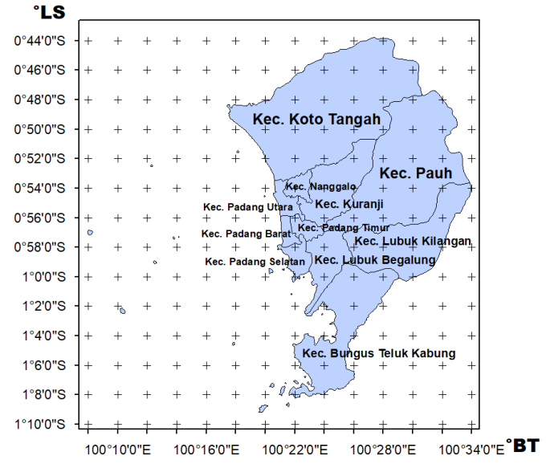
Fig.1. Padang City area grid map
The distance of the earthquake epicenter coordinates to the coordinates at each grid point, calculated using equation 5 while the hypocentre distance from the earthquake source to the coordinates at each grid point is calculated using equation 6.
Peak ground acceleration value for the Padang City area was calculated at each grid point using an empirical formula that is following the tectonic conditions of the City of Padang from the validation results of the data accelerograph. The peak ground acceleration value obtained is converted to the MMI scale (Modified Mercalli Intensity) to determine the intensity of the earthquake that occurred.
(7)
The next step is to make a contour map of the peak ground acceleration value and earthquake intensity for the city of Padang, using the peak ground acceleration value obtained from the calculation using an empirical formula that is close to the peak ground acceleration value measured on the accelerograph. The map was created using the help of ArcGIS software and Surfer.
The size of the peak ground acceleration value in an area indicates the risk of an earthquake. Every earthquake that occurs in an area will cause a peak ground acceleration value obtained from direct measurements using accelerographs or by calculations using empirical formulas. This is useful for disaster mitigation to reduce the impact of damage caused by earthquakes.

RESULTS AND DISCUSSION
The results obtained from this study are the peak ground acceleration value and earthquake intensity using an empirical formula based on the validation process between the peak ground acceleration value data using an empirical formula and the peak ground acceleration value data recorded on the accelerograph. This validation process is carried out by comparing the peak ground acceleration value from the calculation results using an empirical formula with the data measured on the accelerograph. The validation process is useful for finding the appropriate empirical formula used to calculate the peak ground acceleration value in Padang City based on the smallest average error percentage of the four empirical formulas used. The graph of the comparison of the peak ground acceleration value from accelerograph data with the calculation results using the empirical formula can be seen in Figure 2.
(a) | (b)
(c) | (d)
Fig.2. The graph of the comparison of the peak ground acceleration value from the accelerograph with (a) the Mc. Guire, (b) the Si and Midorikawa, (c) the Fukushima-Tanaka, and (d) the Donovan formula
Figure 2 shows the results of validating the peak ground acceleration data using an empirical formula with an accelerograph where the largest average error percentage is in the Donovan formula, which is 2522%. This is because this formula is not appropriate for earthquakes originating in the Subduction Zone. After all, Donovan’s formula has been used to calculate the peak ground acceleration value based on the recording of the earthquakes that occurred in San Fernando with earthquake sources originating from faults. While the smallest average error percentage is found in the Fukushima-Tanaka formula, which is 115%. This is because the Fukushima-Tanaka formula was used to calculate the peak ground acceleration value in the Japanese Islands with the earthquake source coming from the Subduction Zone. In terms of tectonic conditions, the Japanese Islands have the same tectonic conditions as the Mentawai Islands region, namely the form of plate faults.
From the results of the comparison of the peak ground acceleration value using an empirical formula with the peak ground acceleration value using accelerograph data, it was found that the Fukushima-Tanaka formula is suitable for use in calculating the peak ground acceleration value in Padang City. This is because the Fukushima-Tanaka formula was once used to calculate the peak ground acceleration value in the Japanese Islands using earthquake data sourced in the Subduction Zone.
Based on the results of the calculation of the peak ground acceleration value in Padang City using the Fukushima-Tanaka formula, the peak ground acceleration value of Padang City is 60.5-73.5 gal as shown in Figure 3.
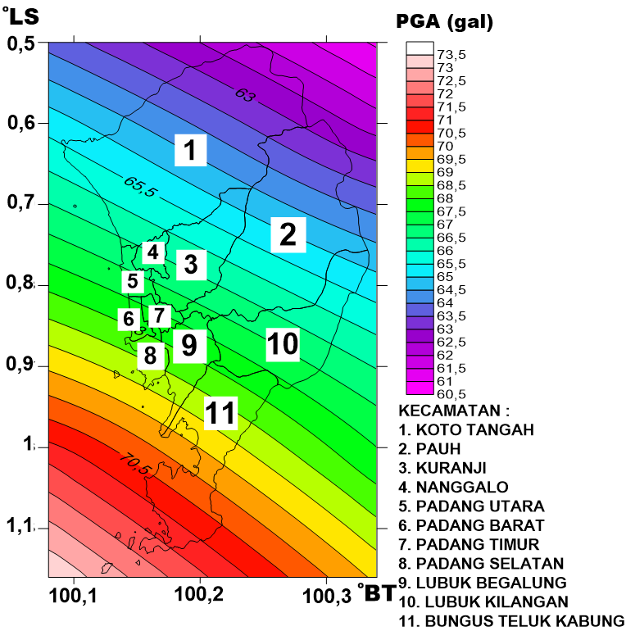
Fig.3. Map of the peak ground acceleration of the Padang City area
Figure 3 shows the distribution of the peak ground acceleration value for Padang City. Based on the map, it is known that the highest peak ground acceleration value is in Bungus Teluk Kabung District, which is 69-73 gal. While the lowest peak ground acceleration value is in Koto Tangah District, which is 60-65.5 gal. The peak ground acceleration value obtained from the calculation using the empirical formula is converted to the MMI scale to determine the level of intensity of the earthquake that occurred in the city of Padang. The distribution of earthquake intensity levels in Padang City is shown in Figure 4.
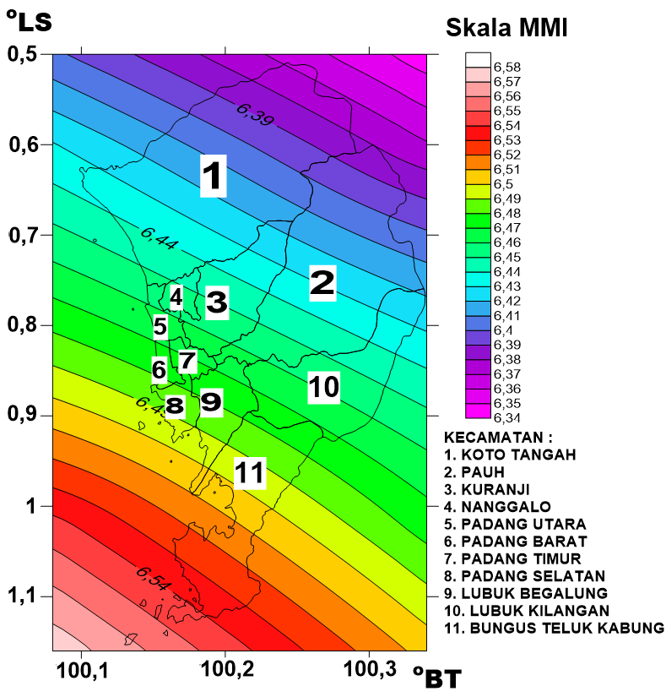
Fig.4. Map of earthquake intensity zones in Padang City
Figure 4 shows that Padang City has a fairly high level of earthquake intensity. The calculation results show that the intensity value in Padang City is on the VI MMI scale with symptoms caused by an earthquake that is felt by the community and has caused minor damage such as cracks in buildings. In addition, symptoms that arise are also in the form of light objects that are hung swaying and the glass windows vibrate. The greater the value of the peak ground acceleration, the higher the intensity scale due to the earthquake that occurred.
Based on the calculation of the peak ground acceleration value, the city of Padang is grouped into two areas, namely vulnerable and alert areas. The area that has the largest peak ground acceleration value is included in the vulnerable area group, while the area with the smallest ground acceleration value is included in the alert area group [4]. The vulnerable areas include the Bungus Teluk Kabung District, while the alert area includes part of Koto Tangah and Pauh Districts.
The value of peak ground acceleration and earthquake intensity that occurred in the Padang City area based on earthquake data originating from the Mentawai segment can be important information in planning for better spatial and regional development planning in Padang City. Buildings built in the Padang City area should have met the requirements for earthquake-resistant buildings because almost all areas are the VI MMI intensity. Likewise with areas that are classified as vulnerable areas, because this area has a fairly high peak ground acceleration value. So disaster mitigation is needed in this area to minimize the damage caused by the earthquake.

CONCLUSION
Based on the results and analysis obtained from this study, it can be concluded that the validation results between the peak ground acceleration values using recorded data from accelerographs using an empirical formula obtained the appropriate formula, namely the Fukushima-Tanaka formula, so that the Fukushima-Tanaka formula was used to determine the peak ground acceleration in the city of Padang. Based on the results of the calculation of the peak ground acceleration value using an empirical formula, it was found that Bungus Teluk Kabung District had the highest peak ground acceleration value in Padang City. The intensity of the earthquake in the city of Padang based on the peak ground acceleration value has a scale of VI MMI.

REFERENCES
- Sunarjo, Gunawan, M. T., & Pribadi, S. (2010). Gempabumi Edisi Populer. BMKG.
- Isra, A. M. (2010). Kajian Kebencanaan. Jurnal Teknik Arsitektur, Vol. 1, No. 1, Universitas Bung Hatta.
- Zalmi, N., Syafriani, Triyono, R., & Arifin, H. (2018). Pemetaan Bahaya Gempabumi Deterministik dengan Pendekatan Peak Ground Acceleration ( PGA ) di Kota Padang. Pillar Of Physics, 11(2), 41–48.
- Edwiza, D. (2008). Analisis terhadap intensitas dan percepatan tanah maksimum gempa sumbar. Teknika, 1(29), 73–79.
- Hadi, Farid, dan F. (2012). Pemetaan Percepatan Getaran Tanah Maksimum dan Kerentanan Seismik Akibat Gempabumi untuk Mendukung Rencana Tata Ruang dan Wilayah (RTRW) Kota Bengkulu. SIMETRI, Jurnal Ilmu Fisika Indonesia, 1(2D), 81–86.
- Kapojos, C. G., Tamuntuan, G., & Pasau, G. (2015). ANALISIS PERCEPATAN TANAH MAKSIMUM DENGAN MENGGUNAKAN RUMUSAN ESTEVA DAN DONOVAN (Studi Kasus Pada Semenanjung Utara Pulau Sulawesi). Jurnal Ilmiah Sains, 17(1), 99. https://doi.org/10.35799/jis.15.2.2015.9225.
- Lowrie, W. (2007). Fundamentals of Geophysics. In Fundamentals of Geophysics. https://doi.org/10.1017/cbo9780511807107.
- Linkimer, L. (2007). Relationship Between Peak Ground Acceleration and Modified Mercalli Intensity in Costa Rica. Revista Geológica de América Central, 38. https://doi.org/10.15517/rgac.v0i38.4218.
- Douglas, J. (2018). Ground motion prediction equations 1964-2018. Pacific Earthquake Engineering Research Center, 1964–2010, 629.
- SI, H., & MIDORIKAWA, S. (1999). New Attenuation Relationships for Peak Ground Acceleration and Velocity Considering Effects of Fault Type and Site Condition. Journal of Structural and Construction Engineering (Transactions of AIJ), 64(523), 63–70. https://doi.org/10.3130/aijs.64.63_2.
- Fukushima, Y., & Tanaka, T. (1990). A New Attenuation Relation for Peak Horizontal Acceleration of Strong Motion in Japan. Bulletin of the Seismological Society of America (1990), 80, 757–783. https://doi.org/https://doi.org/10.1785/BSSA0800040757
- Leviana, M., Syafriani, & Sabarani, A. Z. (2017). Estimasi Nilai Percepatan Tanah Maksimum Wilayah Sumatera Barat Berdasarkan Skenario Gempabumi M 8.8 Sr Menggunakan Rumusan Empiris Mc. Guire (1963) Dan Donovan (1973). Pillar of Physics, 10(1963), 55–62.

