**Whether There Effect of the Used Video on Group Guidance Services to Aggressive Behavior?**

Hariyani1, Yuda Syahputra2

1Guidance and Counseling Program, Madrasah Tsanawiyah Negeri 3 Medan, Jl. Melati XIII, Helvetia Tengah, Medan Helvetia 20124, Indonesia

2Guidance and Counseling Department, Universitas Negeri Padang, Jl. Prof. Dr. Hamka, Air Tawar Padang 25131, West Sumatera Indonesia

* e-mail: [mpsihariyani@gmail.com](mailto:mpsihariyani@gmail.com)

**Abstract**

The purpose of this study is to examine the effectiveness of Group Guidance with Video (G2-V) services in reducing aggressive behavior of junior high school students. The approach of this research is Pre-Experiment with the design of one group pretest-posttest design. The subjects in this study were 10 students (consisting of 5 male and 5 female) junior high schools in North Sumatra, which were obtained through purposive sampling. The instrument used was an aggressive behavior instrument with a scale Likert model. Data were analyzed using nonparametric statistical techniques using the Wilcoxon Signed Ranks Test and stacking Rasch models. The results of the analysis show that there is an influence of G2-V in reducing the aggressive behavior of junior high school students in North Sumatra. The implications of guidance and counseling services are discussed further.

**Keywords**: Aggressive Behaviour, Group Guidance with Video (G2-V), Stacking Rasch

**How to Cite:** Author 1, Author 2. Year. Title manuscript. Konselor, VV (N): pp. XX-XX, DOI: [10.24036/XXXXXXXXXX-X-XX](http://dx.doi.org/10.24036/02017617386-0-00)

|  |
| --- |
| This is an open access article distributed under the Creative Commons 4.0 Attribution License, which permits unrestricted use, distribution, and reproduction in any medium, provided the original work is properly cited. ©2018 by author. |

**Introduction**

Aggressive behavior that has happened lately in the world of education is very alarming. The experts define aggressive behavior is any form of action that intends to hurt or hurt others both physically and mentally (Berkowitz, 2005; Buss & Perry, 1992; Taylor, Peplau, & Sears, 2009). Furthermore, aggressive behavior is physical or verbal behavior that is intended to damage, destroy property, and hurt others (Atkinson. L.R, 2010; Myers, 2012).

Several studies have shown that many things cause individuals to behave aggressively, namely excessive drinking of alcohol (Denson et al., 2011; Hayley et al., 2017). Cognitive development, education levels, and degrees of exposure should be conducted (Cho, Lee, Choi, Choi, & Kim, 2016). Provocation, pain, stress, and heat (Groves & Anderson, 2017). Video games with the most blood activated (Hasan, Bègue, Scharkow, & Bushman, 2018). Personal condition of adolescents, family environment, community environment, and school environment (Willis, 2010). Anger, biological (genes, brain systems, and blood chemistry), generation gap, environment (poverty, anonymity, and hot temperatures), frustration, and erroneous disciplinary processes (Arifin, 2015).

Aggressive behavior is often carried out by individuals and groups in the form of brawl, insulting, beating, family violence, and emotional that causes violence and criminal acts (Afdal, Alizamar, Ifdil, Erlamsyah, & Taufik, 2017; Buss & Perry, 1992; Krahe, 2005; Myers, 2012; Statistik, 2016), and psychological aggression that is most often done is to shout with harsh words (96.2%) (Kwok, Gu, & Cheung, 2017). As a result of aggressive behavior, the results of the study found 69% of adolescent respondents had fights dominated by male teenage students (Su’ud, 2011), men were more likely to behave aggressively than women (Alizamar, Syahputra, Ardi, & Trizeta, 2018). Similarly, 56% of male students have attended the graduation (Siagian, 2011).

In addition, Chory (2004) revealed that exposure to comedy shows on television affected verbally aggressive behavior, as long as participant comedy shows produced statistically significant amounts of aggressive cognitive responses, with the preferred character being the example followed in verbally aggressive behavior. While the National Television Violence Study (NTVS) revealed that children's programs have more violent incidents (69%) than adult programs (57%) which pose a high risk for children to learn and imitate violent behavior (Lan, Abdullah, & Roslan, 2010). This condition was confirmed by Krahe (2005) who stated that if someone observes violence in the media, then that person will imitate what he sees in the media.

Aggressive behavior is very important to reduce in educational activities, to reduce aggressive behavior students certainly need the role of the teacher guidance and counseling or counselor (BK / Counselor) for the provision of guidance and counseling services. One of the services that can be provided to reduce aggressive behavior is group guidance services (Simanjuntak, 2012; Sukatrno, 2016). The type of media that will be used in assisting the process of implementing group guidance services will be video media, because the video can be repeated or dismissed, so the BK / Counselor teacher can invite students to discuss the contents/messages of the video being viewed, as well as questions and answers about the video which aired (R. H. Anderson, 1987).

Based on the above explanation aggressive students need to obtain appropriate educational services. Both from teachers in the field of study (through learning strategies) and by counselors (through guidance and counseling services that are independent). So the purpose of this study was to test the effectiveness of group guidance services coupled with video (G2-V) in reducing the aggressive behavior of junior high school students in North Sumatra.

**Method**

This research uses one-group pretest-posttest design. The subjects in this study were 10 students (consisting of 5 boys and 5 girls) in junior high school in North Sumatra, who were obtained through purposive sampling. The subjects in this study were students who had aggressive behavior with the following considerations: making fun of, hitting, kicking, snapping pocket money by threatening, getting angry for no reason, and hitting using a tie. Data is collected through aggressive instruments developed from theory (Abd-El-Fattah, 2007; Buss & Perry, 1992; Reyna, Ivacevich, Sanchez, & Brussino, 2011). The questionnaire uses 5 points with a Likert scale model including answer choices: always, often, sometimes, rarely, and never. The analysis technique used is nonparametric statistics using Wilcoxon Signed Ranks Test combined with Rasch Stacking Model (Sumintono, B., & Widhiarso, 2015). Furthermore, regarding the data before and after the G2-V treatment on the decline in aggressive behavior of students using the Wilcoxon Signed Rank Test and Stacking Rasch Model (Sumintono, B., & Widhiarso, 2015).

Group guidance services coupled with video (G2-V) includes four stages, namely: the stage of formation, the intermediate stage, the stage of activities, and the termination stage. At the stage of formation, explain the notion of group guidance, goals, principles, and explain the ways of group guidance that there are video shows at the stage of group guidance activities. At the transition stage, increasing the participation of group members to become a group that works closely with each other (Hartinah, 2009). At the activity stage, raising the problem and showing the video related to the specified topic in table 1. Then discussing the predetermined topic and question and answer in-depth by utilizing group dynamics, to provide encouragement, strength or influence resulting from an interaction between members the group that will influence the behavior of both parties, both individuals and group members as a whole (Forsyth, 2010). In the final stage, reflecting on BMB3 (Thinking, Feeling, Attitude, Acting, and Responsible) from each group member, related to PERPOSTUR (Structured Positive Behavior) and AKURS (Reference, Competence, Attempt, Sense, Earnestly) (Prayitno, 2017).

**Table 1. Format of Video Identification**

|  |  |  |
| --- | --- | --- |
| **Topic** | **Topic Video** | **Duration** |
| Tolerance | Tolerance | 7:04 |
| Assertive Behavior | Examples of assertiveness and understanding | 4:25 |
| Prosocial Behavior | The story of a sincere person, honest and kind, likes to help even though he is very lacking | 3:05 |
| Empathize | Empathize | 5:56 |
| Managing Emotions | Stress at work | 5:24 |
| Self-concept | Self-concept | 3:42 |

**Results and Discussion**

Discussion of the results of this study about testing the effects of the G2-V treatment to reduce the aggressive behavior of junior high school students in North Sumatra. Furthermore, the results of the Wilcoxon signed rank test analysis are presented in the following Table 2

Table 2. Aggressive Students in terms of G2-V treatment

|  |  |
| --- | --- |
| **Value** | **Wilcoxon Signed Rank Test** |
| Sig. (2-tailed) |
| **Pretest and Posttets Perlakuan G2V** | .000 |

In Table 2 above, shows the value of aggressive behavior (sig = 0.000), this states the p-value <0.05, which indicates that there are significant differences in aggressive behavior before and after G2-V treatment is given. This can be stated G2-V effect in reducing the aggressive behavior of students. The implementation of G2-V makes students active, especially at the stage of video shows, this is because the video stimulates students in giving opinions about aggressive behavior. The implementation of guidance and counseling has a lot to use video to improve services provided to students such as: prosocial video shows reduce aggressive behavior (Sugiyono, 2000), video media to improve social skills (Bakhtiar, 2015), video media for understanding the dangers of drugs (Rahayu & Pratiwi, 2013), some have even developed a video-based ethical guidance media (Anisah, 2016). Next, the researcher makes clear with a picture about the effectiveness of G2-V in reducing the aggressive behavior of students.

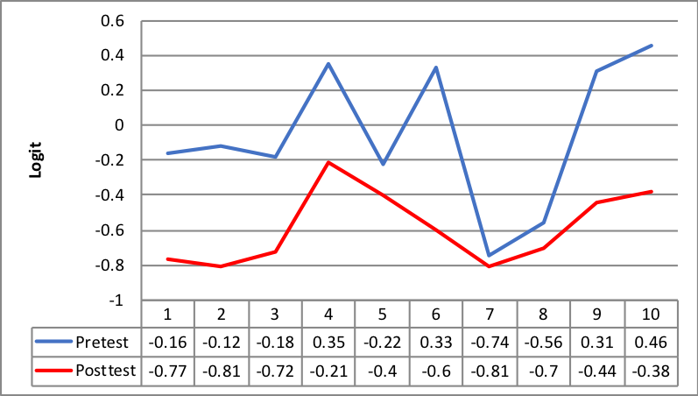

**Figure 1. Differences in Aggressive Behavior Before and After the G2-V Treatment**

In Figure 1 shows the differences in aggressive behavior of students after being given G2-V treatment, where the tendency of the red line (posttest) is lower than the blue line (pretest) which indicates the effect of G2-V affects aggressive behavior. The effect of structured positive behavior shows given by G2-V makes the student's aggressiveness decrease. However, different from some previous researchers Anderson & Dill (2000) prove that the subject shows an increase in cognitive and affective aggressiveness, after exposure to violent media that contain violence. Krahé & Möller (2004) explain the mechanism behind Anderson & Dill's (2000) findings, in his study it was proven that the more often the subject was exposed to violence, the more cognitively the subject looked at aggression as a normative matter. Based on the above explanation that the use of video media can also affect cognitive, affective, and psychomotor (R. H. Anderson, 1987). So that from some of the concepts and findings above the researchers changed the media violence shows with structured positive video shows to reduce the aggressive behavior of students.

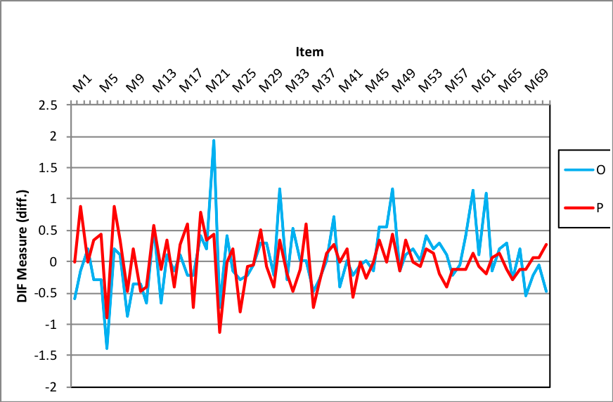

**Figure 2. Effects of G2V Before and After Treatment**

While Figure 2 shows the ability of students' aggressive behavior before and after the G2-V treatment. Before being given G2-V treatment the ability of students to respond to the instrument is still very low, this is due to high aggressive behavior and low aggressive understanding. However, different after being given G2-V treatment to students who behave aggressively, it is marked from the blue line (posttest) which starts to increase than the red line (pretest). Based on the above research results, the implementation of group guidance services using video can maximize treatment results in reducing aggressive behavior. The implementation of group guidance services with the addition of a positive video display provides a stimulus (Barone et al., 2005; Long, Angera, & Hakoyama, 2006) to all group members to discuss the positive behavior in the video, when it is done when the aggressive behavior occurs ?, With the stimulus provided by the leader makes the participants think, feel, and behave about the positive behavior. This research starts from the findings Anderson & Dill (2000) and Krahé & Möller (2004) who found an aggressive increase after being exposed to media violence, so when tested with positive video exposure, can it reduce students' aggressive behavior? The findings of the study indicate that the effects of positive video exposure on aggressive behavior of students, if repeated video exposure is done to form students' understanding of positive behavior, this is because the use of video media can also affect cognitive, affective, and psychomotor (R. H. Anderson, 1987). Based on the above results, it is stated that the effects caused by G2-V affect the aggressive behavior of junior high school students in North Sumatra. Video group guidance services influence students to rearrange wrong learning experiences as a result of the experience of being a victim or observer of aggressive behavior.

**Conclusion**

The findings show the influence of G2-V in reducing the aggressive behavior of junior high school students in North Sumatra, before being given G2-V treatment to students, the ability of students to respond to pretest is still very low, which results in pretest results are still high. However, different after being given G2-V treatment, students' ability to respond to answers at posttest was high, which resulted in low results. Based on the findings can be used by counselors to reduce the aggressive behavior of students in junior high school. However, it is not only with a group guidance service program with videos to reduce aggressive behavior, but with cooperation between counselors and subject teachers, school principals, and all school personnel. These findings can be input for BK/Counselor teachers is to include group guidance services with additional video display with assertive material, empathy, tolerance, prosocial into the BK program. Limitations in these study subjects tested with G2-V were still in one group only.

**References**

Abd-El-Fattah, S. M. (2007). Is the aggression Questionnaire bias free? A Rasch analysis. *International Education Journal*, *8*(2), 237–248.

Afdal, A., Alizamar, A., Ifdil, I., Erlamsyah, E., & Taufik, T. (2017). Guidance And Counseling Services For Women Victims Of Domestic Violence. *Advances in Social Science, Education and Humanities Research*, *118*(23), 935–939.

Alizamar, A., Syahputra, Y., Ardi, Z., & Trizeta, L. (2018). Differences in aggressive behavior of male and female students using Rasch stacking. *International Journal of Research in Counseling and Education*, *3*(1), 22–32. https://doi.org/10.24036/0051za0002

Anderson, C. A., & Dill, K. E. (2000). Video Games and Aggressive Thoughts, Feelings, and Behavior in the Laboratory and in Life. *Journal of Personality and Social Psychology*, *78*(4), 772–790. https://doi.org/10.1037//O022-3514.78.4.772

Anderson, R. H. (1987). *Selecting and Developing Media for Instruction*. Modison Wesconsin: American Society for Training an d Development.

Anisah, N. (2016). Pengembangan Media Bimbingan Etika Bergaul Berbasis Video Animasi Adobe Flash dalam Layanan Informasi Siswa Sekolah Menengah Pertama. *Jurnal BK UNESA*, *6*(3).

Arifin, B. S. (2015). *Psikologi Sosial*. Bandung: Pustaka Setia.

Atkinson. L.R. (2010). *Pengantar Psikologi jilid 2*. Jakarta: Interaksara.

Bakhtiar, M. I. (2015). Pengembangan Video Ice Breaking Sebagai Media Bimbingan Konseling Dalam Meningkatkan Keterampilan Sosial. *Jurnal Psikologi Pendidikan Dan Konseling: Jurnal Kajian Psikologi Pendidikan Dan Bimbingan Konseling*, *1*(2), 150–162.

Barlett, C. P., Harris, R. J., & Bruey, C. (2008). The effect of the amount of blood in a violent video game on aggression, hostility, and arousal. *Journal of Experimental Social Psychology*, *44*(3), 539–546. https://doi.org/10.1016/j.jesp.2007.10.003

Barone, D. F., Hutchings, P. S., Kimmel, H., Traub, H. L., Cooper, J. I., & Marshall, C. M. (2005). Increasing empathic accuracy through practice and feedback in a clinical interviewing course. *Journal of Social and Clinical Psychology*, *24*, 156–171.

Berkowitz, L. (2005). *Agresi I, Sebab dan Akibatnya. Terjemahan Hartati Woro Susiatni*. Jakarta: Pustaka Binaman Pressindo.

Buss, A. H., & Perry, M. (1992). Personality Processes and Individual The Aggression Questionnaire. *Journal of Personality and Social Psychology*, *63*(3), 452–459.

Cho, H., Lee, S., Choi, J., Choi, S., & Kim, D. (2016). An exploratory study on association between Internet game contents and aggression in Korean adolescents. *Computers in Human Behavior*. https://doi.org/10.1016/j.chb.2016.12.077

Chory‐Assad, R. M. (2004). Effects of television sitcom exposure on the accessibility of verbally aggressive thoughts. *Western Journal of Communication*, *68*(4), 431–453. https://doi.org/10.1080/10570310409374812

Denson, T. F., Spanovic, M., Aviles, F. E., Pollock, V. E., Earleywine, M., & Miller, N. (2011). The Effects of Acute Alcohol Intoxication and Self-Focused Rumination on Triggered Displaced Aggression. *Journal of Aggression, Maltreatment & Trauma*, *20*(2), 128–147. https://doi.org/10.1080/10926771.2011.546750

Forsyth, D. R. (2010). *Group Dynamics: Fourth Editon*. Belmont: Thompson Wadsworth.

Groves, C. L., & Anderson, C. A. (2017). ScienceDirect Aversive events and aggression. *Current Opinion in Psychology*, *19*, 144–148. https://doi.org/10.1016/j.copsyc.2017.03.027

Hartinah, S. (2009). *Konsep Dasar Bimbingan Kelompok*. Bandung: Refika Aditama.

Hasan, Y., Bègue, L., Scharkow, M., & Bushman, B. J. (2018). Corrigendum to “The more you play, the more aggressive you become: A long-term experimental study of cumulative violent video game effects on hostile expectations and aggressive behavior” (J. Exp. Soc. Psychol. (2013) 49 (224–227)(S0022103112002259)(10.10. *Journal of Experimental Social Psychology*, *74*(2), 328. https://doi.org/10.1016/j.jesp.2017.08.009

Hayley, A., Cox, E., Zinkiewica, L., Graham, K., Wells, S., Zhou, J., & Miller, P. G. (2017). Barroom aggression among Australian women: associations with heavy episodic drinking, trait aggression, and conformity to gender norms. *Journal of Substance Use*, *22*(3), 1–8. https://doi.org/10.1080/14659891.2016.1184334

Krahe, B. (2005). *Perilaku Agresi*. Yogyakarta: Pustaka Pelajar.

Krahé, B., & Möller, I. (2004). Playing violent electronic games, hostile attributional style, and aggression-related norms in German adolescents. *Journal of Adolescence*, *27*(1), 53–69.

Kwok, S. Y. C. L., Gu, M., & Cheung, A. P. S. (2017). A longitudinal study of the role of children’s altruism and forgiveness in the relation between parental aggressive discipline and anxiety of preschoolers in China. *Child Abuse and Neglect*, *65*, 236–247. https://doi.org/10.1016/j.chiabu.2017.02.004

Lan, K. L., Abdullah, M. C., & Roslan, S. (2010). Understanding media violence and the development of aggressive behaviour of school children. *Procedia - Social and Behavioral Sciences*, *7*(2), 522–527. https://doi.org/10.1016/j.sbspro.2010.10.070

Long, E. C. J., Angera, J. J., & Hakoyama, M. (2006). Using videotaped feedback during intervention with married couples: A qualitative assessment. *Family Relations*, *55*, 428–438.

Myers, D. G. (2012). *Psikolog Sosial Edisi 10. Terjemahan oleh Aliya Tusyani, dkk*. Jakarta: Salemba Humanika.

Prayitno. (2017). *Konseling Profesional yang Berhasil: Layanan dan Kegiatan Pendukung*. Jakarta: Rajawali Pers.

Rahayu, Y. P., & Pratiwi, T. I. (2013). Penerapan Bimbingan Kelompok dengan Media Video untuk Meningkatkan Pemahaman Siswa tentang Bahaya Narkoba pada Siswa KelaS VIII-D SMP Negeri 2 Ngoro. *Jurnal BK UNESA*, *4*(1), 127–134.

Reyna, C., Ivacevich, M. G. L., Sanchez, A., & Brussino, S. (2011). The Buss-Perry Aggression Questionnaire: Construct Validity and Gender Invariance Among Argentinean Adolescents. *International Journal of Psychological Research*, *4*(2), 30–37.

Siagian, J. (2011). Tinjauan tentang Perilaku Menyimpang Remaja di Kelurahan Titi Rantai Kecamatan Medan Baru Kota Medan (online). *Jurnal Psikologi*, *1*(1).

Simanjuntak, J. (2012). *Mengurangi Perilaku Agresif melalui Layanan Bimbingan Kelompok Siswa Kelas VIII SMP Negeri 2 Siabu Kabupaten Mandailing Natal Tahun Ajaran 2011/2012*. Doctoral dissertation, UNIMED.

Statistik, B. P. (2016). *Statistik Kriminal 2016*. Jakarta: Badan Pusat Statistik.

Su’ud, S. (2011). Remaja dan Perilaku Menyimpang Studi Kasus pada Masyarakat Boepinang, Bombana. Jurnal Psikologi (Online). *Jurnal Psychology*, *1*(34).

Sugiyono, J. (2000). *“Pengaruh Diskusi Tayangan Film Prososial terhadap Perilaku Agresif Anak”. Thesis tidak diterbitkan. Yogyakarta: S2 Psikologi Pendidikan UGM. diakses 11 September 2018.*

Sukatrno, S. (2016). Group Counseling Services Effectiveness In Reducing Student Behavior Aggressive SMA 6 Padangsidimpuan State Academic Year 2015-2016. *Jurnal Bimbingan Dan Konseling*, *1*(2), 1–7.

Sumintono, B., & Widhiarso, W. (2015). *Aplikasi Pemodelan Rasch pada Asessment Pendidikan*. Bandung: Trim Komunikata.

Taylor, S. E., Peplau, L. A., & Sears, D. O. (2009). *Psikologi Sosial Edisi Kedua Belas*. Jakarta: Kencana Prenada Media Group.

Willis, S. (2010). *Remaja dan Masalahnya*. Bandung: Alfabeta.