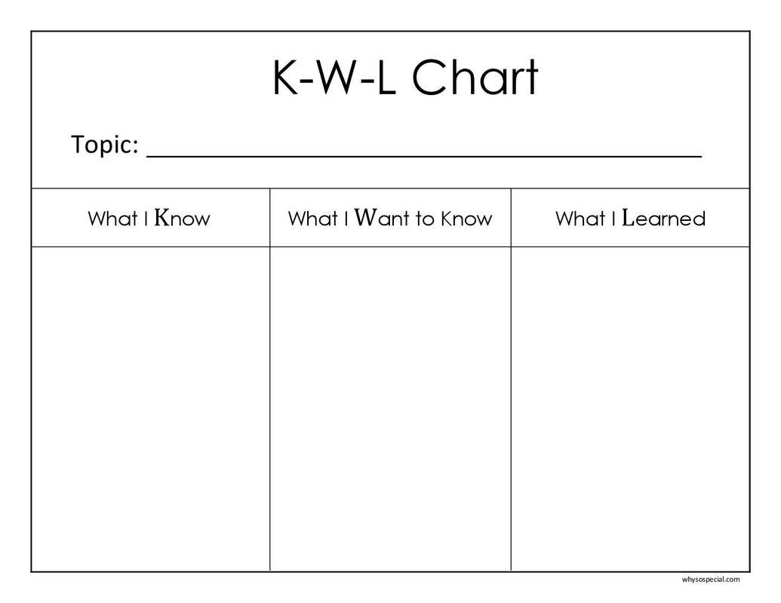
K | The step Know (K) refers to what students know about the topic, which was done before the students began to read. In this step, the students wrote down the words or phrases that they already knew related to the topic. The more things they knew, the better the chance for them to comprehend the content of the text given.
W | The step Want (W) means what students want to learn more about the topic. In this step, the students made a list of questions about what they expected to learn in the topic during the reading activity. If they were curious about something related to the topic, they were supposed to write down the question.
L | The last step Learned (L) indicates what students have learned. In this step, they paraphrased the important information, such as surprising or interesting ideas obtained from the text. Then, they checked the ideas against those in the W column. The L step occurred after the students had finished their reading.

K | W | L
What I Know | What I Want to Know | What I Learned
Introduce the topic and brainstorm it. A note is needed. | Note any questions the class has about the topic and/or turn textbook subheadings into questions. | After reading or listening text, students note what they have learned, and they are able to answer the questions column W.

Exercise’s example:

Title: Bat
K | W | L
What I Know | What I Want to Know | What I Learned
- Cold-blooded animal  - Living in cave  - Supersonic sounds | - What class are they?  - What is their food?  - How many species are they?  - How do their supersonic sounds work? | After reading, they will find the answer for W

Title: How A Tsunami Happens

K | W | L
What I Know | What I Want to Know | What I Learned
- Huge waves  - Earthquake | - What is a tsunami definition?  - Are there any reasons how it happens?

Answers:
Title: Bat
K | W | L
What I Know | What I Want to Know | What I Learned
- Cold-blooded animal.  - Living in the cave.  - Supersonic sounds.  - Eating fruits | - What class are they?  - How many species are they?  - How do their supersonic sounds work? | - They are from the order Chiroptera.  - There are around 1.200 species of bats in the world.  - They manage to fly in a dark cave without crashing to something.

Title: How A Tsunami Happens

K | W | L
What I Know | What I Want to Know | What I Learned
- Huge waves.  - Earthquake | - What is a tsunami definition?  - Is there any reason how it happens? | - A series of waves generated when water in a lake or a sea is rapidly displaced on a massive scale.  - Such large vertical movements of the earth’s crust can occur at plate boundaries

